|  |
| --- |
| Cloud  Security |
| AWS Cloud Security Builder |
| **Securing and Monitoring Resources**  Unraveling the Power of Cloud Computing with AWS | E-Tribe Digital -  Digital Services Agency  **Group Members:**  Zeeshan Ali 20i-2465 B  USAYED Ather 20i-0907 B  Bilal Mustafa 20i-0901 A  **Instructor:**  Dr. Abid Rauf  **Submission:**  MaY 12, 2024 |

Contents

Scenario 4

Solution requirements 4

Approach 4

Phase 1: Securing data stored in S3 5

Phase 2: Securing VPCs 18

Phase 3: Securing AWS Resources with KMS 47

Phase 4: Monitoring and logging 57

Table of Figures

**Figure 1: Bucket Creation Successful** 5

**Figure 2: Upload Files in Bucket.** 6

**Figure 3: Generate Policy** 6

**Figure 4: Edited Bucket Policy Successfully.** 7

**Figure 5: Paulo Access to Data Bucket** 7

**Figure 6: Paulo Access to Config Bucket** 8

**Figure 7: Marry Access to Data Bucket.** 8

**Figure 8: Enable Versioning.** 9

**Figure 9: Enabling Server Access Logging.** 9

**Figure 10: Update S3 Bucket Policy.** 10

**Figure 11: S3 Inventory Created Successfully.** 10

**Figure 12: Uploaded File Successfully.** 11

**Figure 13: Version of Data File.** 11

**Figure 14: Marry Access to Data Bucket.** 12

**Figure 15: S3 object access logs.** 12

**Figure 16: Athena Table Creation & View Table** 13

**Figure 17: Query to view 10 Bucket Access logs.** 13

**Figure 18: Query Result.** 14

**Figure 19: Query to get IAM Users Actions** 14

**Figure 20: Query Results.** 15

**Figure 21: S3 Inventory Report** 15

**Figure 22: Create Query to get Results.** 16

**Figure 23: Query to preview 5 Objects in Bucket** 16

**Figure 24: Query Results.** 17

**Figure 25: LabVPC Resource Map** 18

**Figure 26: VPC Flow Logs** 19

**Figure 27: WebServer Security Details** 19

**Figure 28: WebServer Networking Details** 20

**Figure 29: Lab VPPC Flow Logs** 20

**Figure 30: webserver publicly not accessible.** 21

**Figure 31: Connection Time-Out** 22

**Figure 32: Access Logs** 22

**Figure 33: check the particular Ip logs.** 23

**Figure 34: check the particular Ip logs.** 23

**Figure 35: Attach the Internet Gateway to local network.** 24

**Figure 36: Connection Time-out** 25

**Figure 37: Configuring the Inbound Traffic.** 25

**Figure 38: Discover IP-range.** 26

**Figure 39: Network Connected.** 26

**Figure 40: Message from the WebServer.** 27

**Figure 41: 3 response Messages.** 27

**Figure 42: Deny all traffic.** 28

**Figure 43: Connection Timeout result.** 28

**Figure 44: Connection access denied.** 29

**Figure 45: Allow the one rule in inbound traffic.** 29

**Figure 46: Connected to the Network** 30

**Figure 47: Allow more traffic from different port.** 30

**Figure 48: Message from WebServer.** 31

**Figure 49: Resource Map** 31

**Figure 50: ACL Inbound Rule.** 32

**Figure 51: Webserver Networking** 32

**Figure 52: Webserver Security** 33

**Figure 53: Message from webserver.** 33

**Figure 54: Connection Status** 34

**Figure 55: Running the web server on port 8080.** 34

**Figure 56: Message Response from port 8080.** 35

**Figure 57: Network Firewall Creation.** 35

**Figure 58: Route Table Creation & Add Internet Gateway.** 36

**Figure 59: Add an edge Associations.** 36

**Figure 60: Firewall table & edge associations.** 37

**Figure 61: Webserver table & Associations.** 37

**Figure 62: Network Firewall Logs Creation.** 38

**Figure 63: Alert & Flow Firewall Details** 39

**Figure 64: Denied Access** 39

**Figure 65: Network Firewall VPC logs.** 40

**Figure 66: search the system IP logs.** 40

**Figure 67: Message Details** 41

**Figure 68: Add Rules to the Group.** 42

**Figure 69: Rule Policy Group Created.** 42

**Figure 70: Message from Webserver.** 43

**Figure 71: Connected to the Network.** 43

**Figure 72: ping status.** 44

**Figure 73: Connection request time-out.** 44

**Figure 74: Log stream to capture Message.** 45

**Figure 75: Diagramming Activity.** 45

**Figure 76: Case Sceniro to build and configure VPC.** 46

**Figure 77: Cost Estimation of the above Configuration.** 46

**Figure 78: MYKMSKEY!** 47

**Figure 79: Key Rotation** 48

**Figure 80: Edit Policy.** 48

**Figure 81: Financial Advisor Policy** 49

**Figure 82: Policy Permissions.** 49

**Figure 83: Edit Default Encryption.** 50

**Figure 84: Loan-data.csv uploaded.** 50

**Figure 85: Bucket Server-side encryption.** 51

**Figure 86: Paulo IAM console-sign-in link.** 51

**Figure 87: Access Denied to Paulo.** 52

**Figure 88: Successfully Launched Encrypted Instance** 52

**Figure 89: Storage Configurations** 53

**Figure 90: EC2 Encrypted Instance Connect** 53

**Figure 91: List AWS KMS Keys** 54

**Figure 92: View & Remove unencrypted data.** 54

**Figure 93: Create Secrete Key** 55

**Figure 94: Get Secret Key** 55

**Figure 95: Create Trail** 57

**Figure 96: Upload the Customers-data.csv file.** 58

**Figure 97: Athena Table Creation.** 58

**Figure 98: Query to View top 10 results.** 59

**Figure 99: Query Result.** 59

**Figure 100: Query to View PutObject Results.** 60

**Figure 101: Query Results** 60

**Figure 102: Query to View GetObject Results** 61

**Figure 103: Query Results.** 61

**Figure 104: Create logs.** 62

**Figure 105: EC2 Instance** 62

**Figure 106: AWS cloud Agent Config,json.** 63

**Figure 107: Cloud Watch Agents Logs & view secure logs.** 63

**Figure 108: Login with invalid User.** 64

**Figure 109: Logs Result to Decline Invalid user.** 64

**Figure 110: Instance Secure logs.** 65

**Figure 111: EC2-user accepted public key.** 65

**Figure 112: Invalid Ubuntu user.** 66

**Figure 113: Created Metric Filter of Invalid user.** 66

**Figure 114: Alaram Created.** 67

**Figure 115: Alaram Actions Enabled.** 67

**Figure 116: Multiple users accessing it.** 68

**Figure 117: Invalid Users logs.** 68

**Figure 118: STATE is in "In-Alaram.”** 69

**Figure 119: Email Notification.** 69

**Figure 120: AWS Config Role** 70

**Figure 121: Compliance Bucket.** 70

**Figure 122: AWS Config Rules** 71

**Figure 123: SE Bucket Logging Enabled.** 71

**Figure 124: Server Access Log Disabled.** 72

**Figure 125: Configure Remediation Actions.** 72

**Figure 126: Action Enabled Successfully.** 73

**Figure 127: Server Access Logs Enabled.** 73

# Scenario

In this project, we work as a cloud security specialist at Any Company Financial bank.

The company has locations throughout the country. The company provides checking and savings accounts, credit cards, loans, and investment products. All products require the use of personally identifiable information (PII), such as account numbers, contact information, and personal IDs. Your manager, the Director of IT, has tasked you to ensure the security of the company's resources in the AWS Cloud.

Key areas of the AWS infrastructure that need to be secured include S3 buckets, the network that hosts web servers, and keys that are used to encrypt data. Your manager also wants you to monitor and analyze access to these resources so that the bank can improve its security posture as changes and potential security incidents occur.

Your task within this project is to secure these AWS resources based on AWS best practices that are associated with the AWS Well-Architected Framework, the principle of least privilege, and internal company IT standards.

Throughout the project, you will test access to resources as two test users, *Paulo* and *Mary*, who are members of the Account Manager Group. In some cases, Paulo has more privileged access than Mary to certain resources stored in the AWS account. You will compare his access to Mary's access. By comparing their access, you will be able to verify if specific resources have been secured by using mechanisms beyond AWS Identity and Access Management (IAM) policies. In the AWS KMS phase of the project, you will use a test user named *Sofia*, who is a member of the Financial Advisor Group.

# Solution requirements

The solution must meet the following requirements:

* Design (phase 2)
* Cost Optimize (phase 2)
* Restrict access.
* Enforce compliance.
* Encrypt data.
* Withstand penetration testing.
* Monitor and log user activity.
* Generate alert and change management notifications.

# Approach

The following table provides an overview of the phases of this project.

|  |  |
| --- | --- |
| Phase | Detail |
| 1 | Securing data stored in S3 |
| 2 | Securing VPCs |
| 3 | Securing AWS Resources with KMS |
| 4 | System-wide monitoring and logging |

# Phase 1: Securing data stored in S3

In this phase you begin implementing security settings in the AWS account. You have been asked to secure customer Personally Identifiable Information (PII) stored in S3. Any Company Financials' leadership team has heard about recent data breaches and wants to ensure that customer data is protected from unauthorized access. The company wants to:

* Limit access to buckets to certain Account Managers in the Account Manager group.
* Enable versioning on S3 buckets, and all objects within them.
* Enable object-logging within all S3 buckets.
* Encrypt all buckets with Amazon S3 managed keys (SS3-S3).
* Implement Amazon S3 inventory, so that they may keep a running inventory on all files stored in S3.

**Task-01: Create a bucket, apply a bucket policy, and test access.**

1. Access AWS Management Console as voclabs IAM role, noted in top right corner. Copy unique ID from existing buckets in S3 console for future reference.
2. Create a new bucket named data-bucket-<unique-id> in us-east-1, following default settings.
3. Upload an object to the new bucket, like a text file named myfile.txt with "hello world" content.
4. Author a bucket policy for the new bucket allowing S3 actions for voclabs and Paulo and denying for others. Test access as Paulo and Mary, ensuring permissions are as expected.

Q: Why Marry gets an error "Insufficient permissions to list objects"?

It is because of

1. Mary doesn’t have the s3: List Bucket permission as part of her IAM user policy.
2. Users don’t have permissions through a bucket policy.
3. Resource policies, such as a bucket policy, provide an additional security tool to permit or deny access to resources.

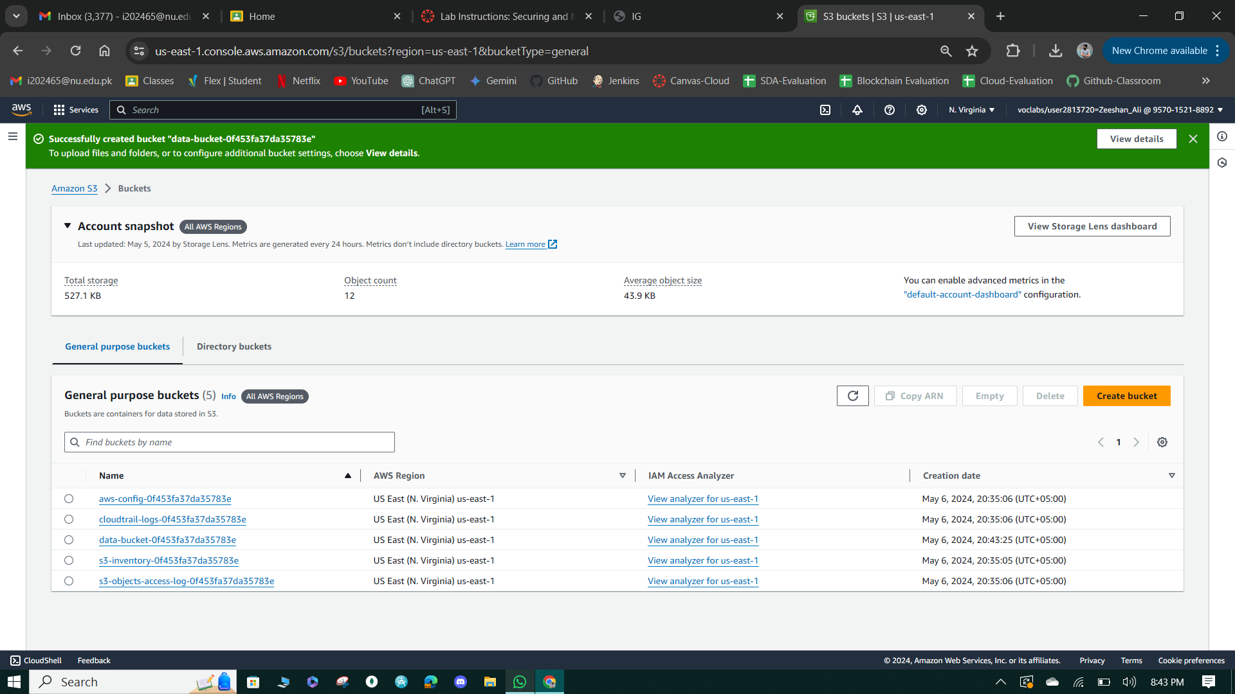

**Figure 1: Bucket Creation Successful**

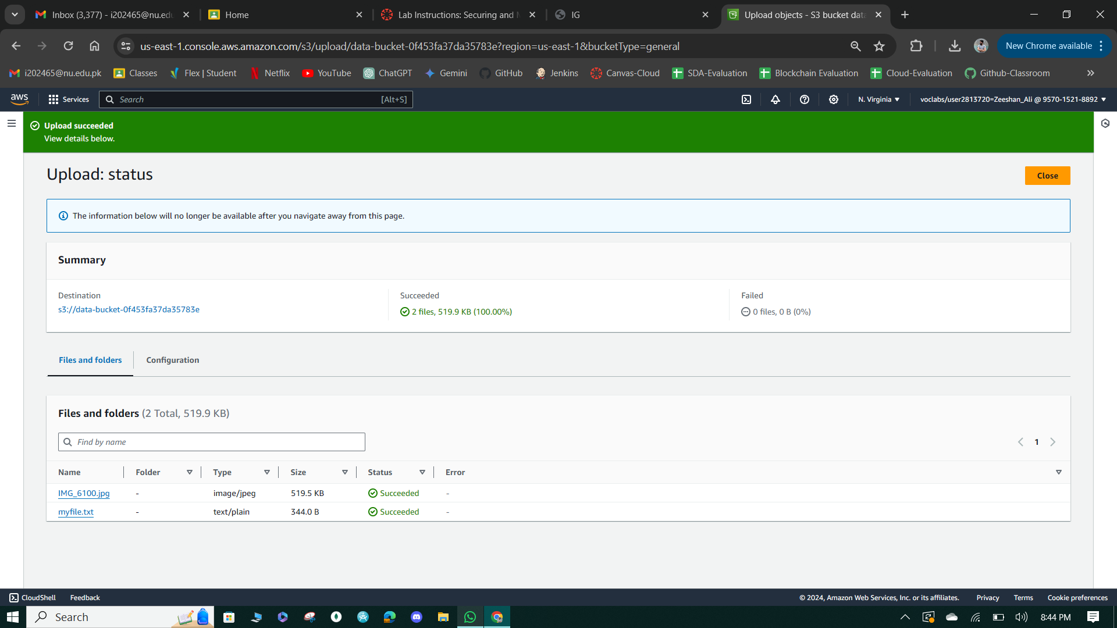

**Figure 2: Upload Files in Bucket.**

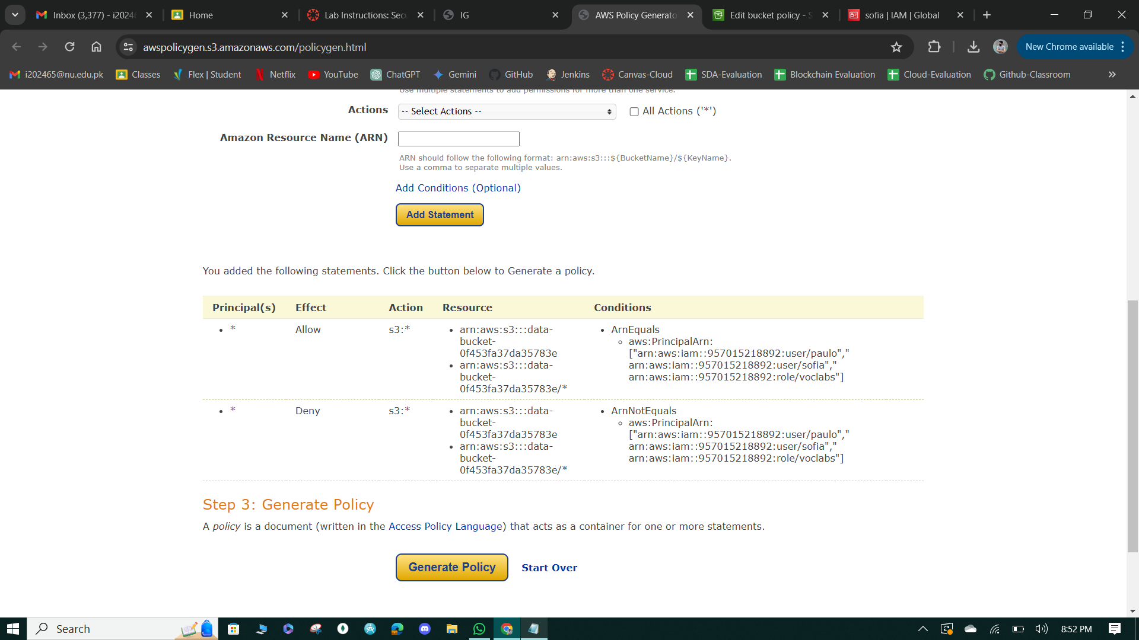

**Figure 3: Generate Policy**

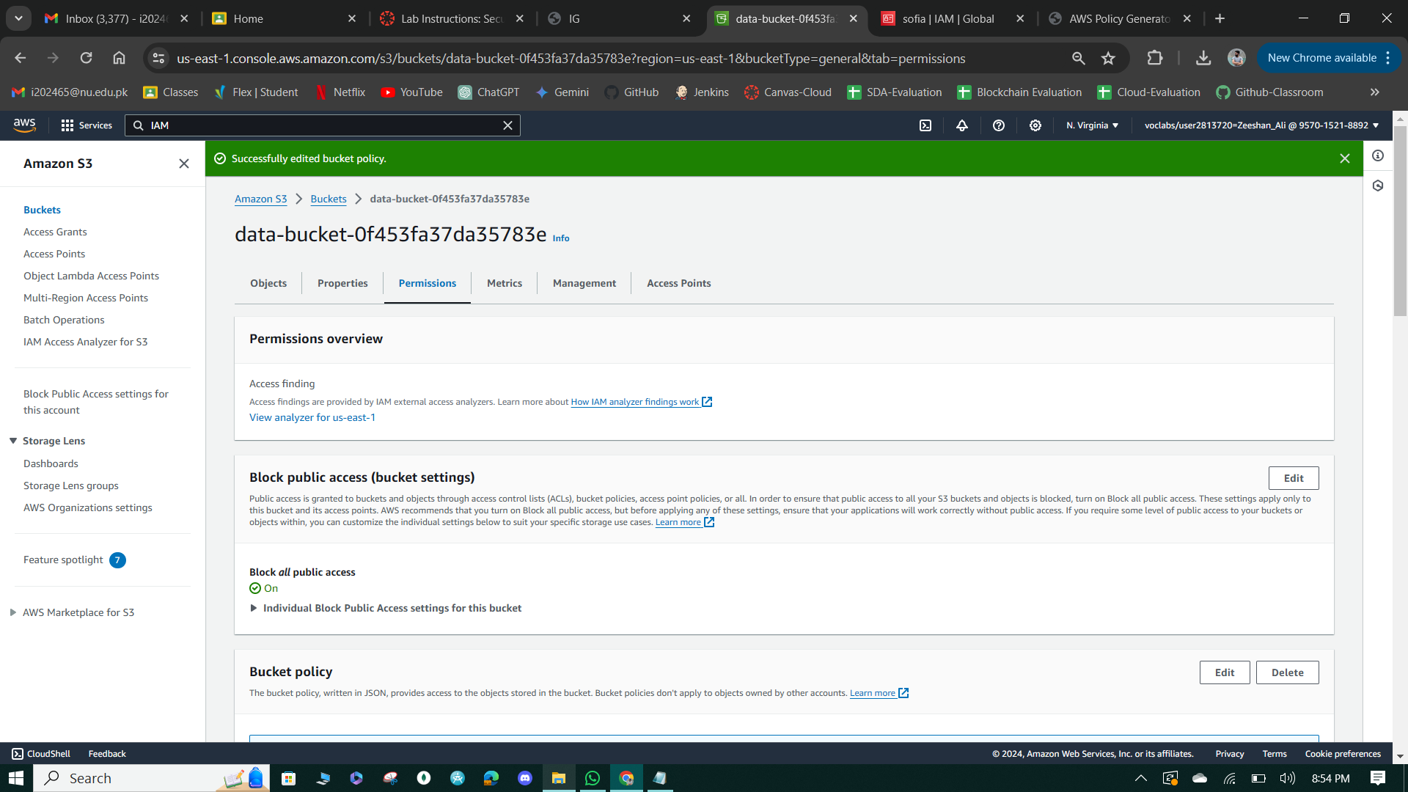

**Figure 4: Edited Bucket Policy Successfully.**

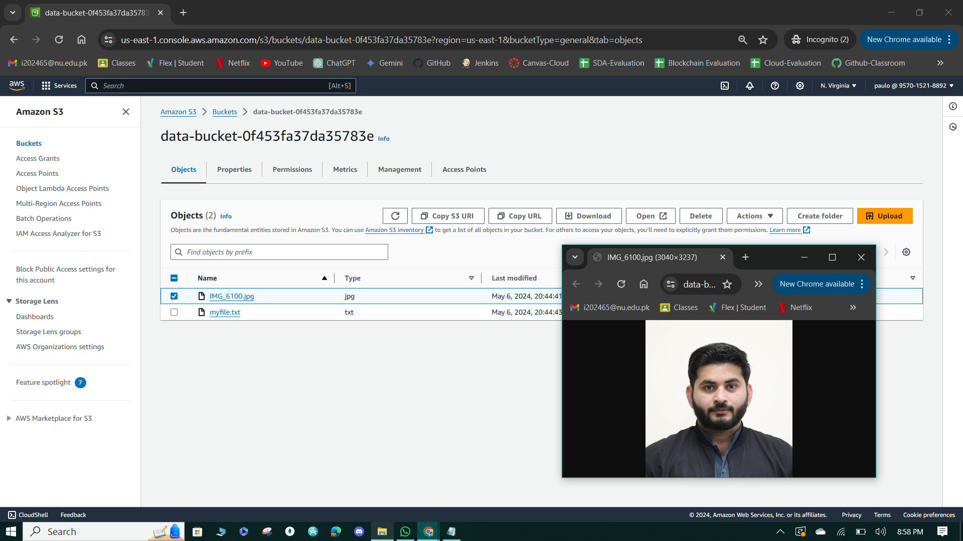

**Figure 5: Paulo Access to Data Bucket**

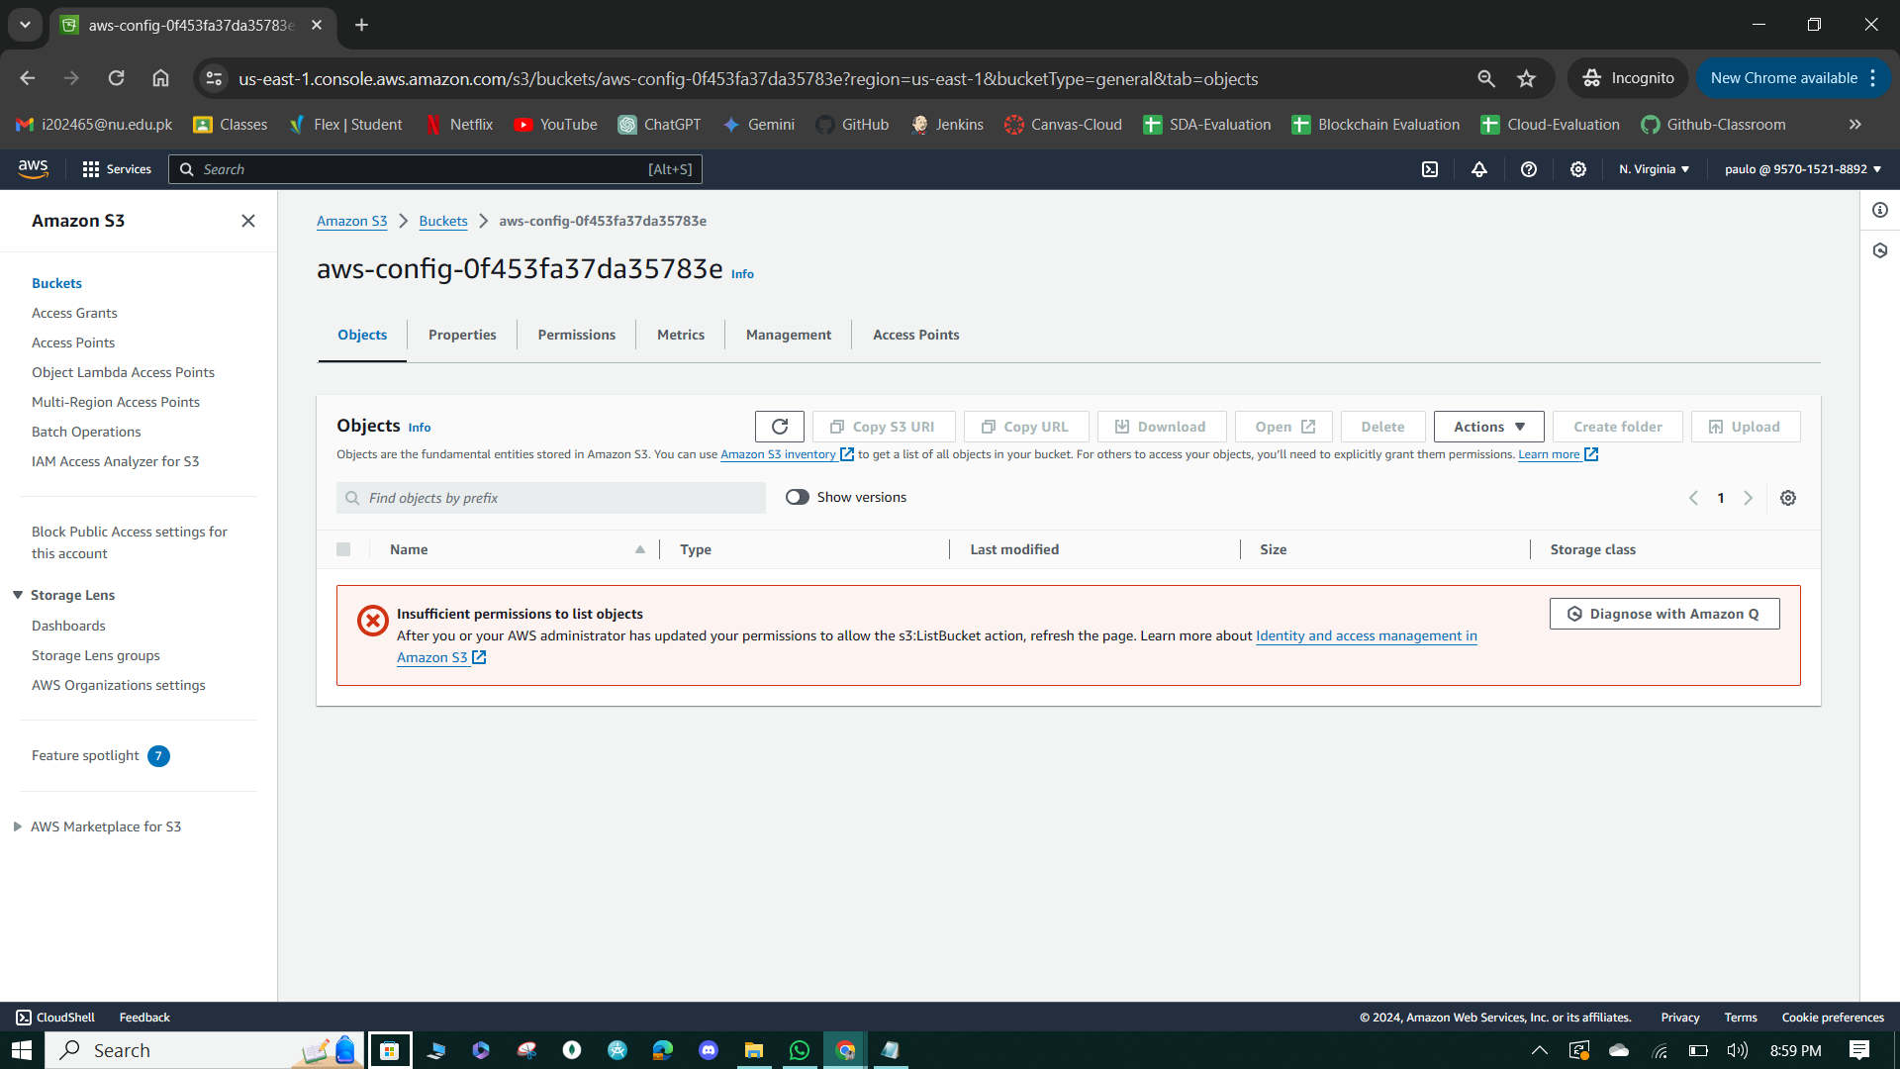

**Figure 6: Paulo Access to Config Bucket**

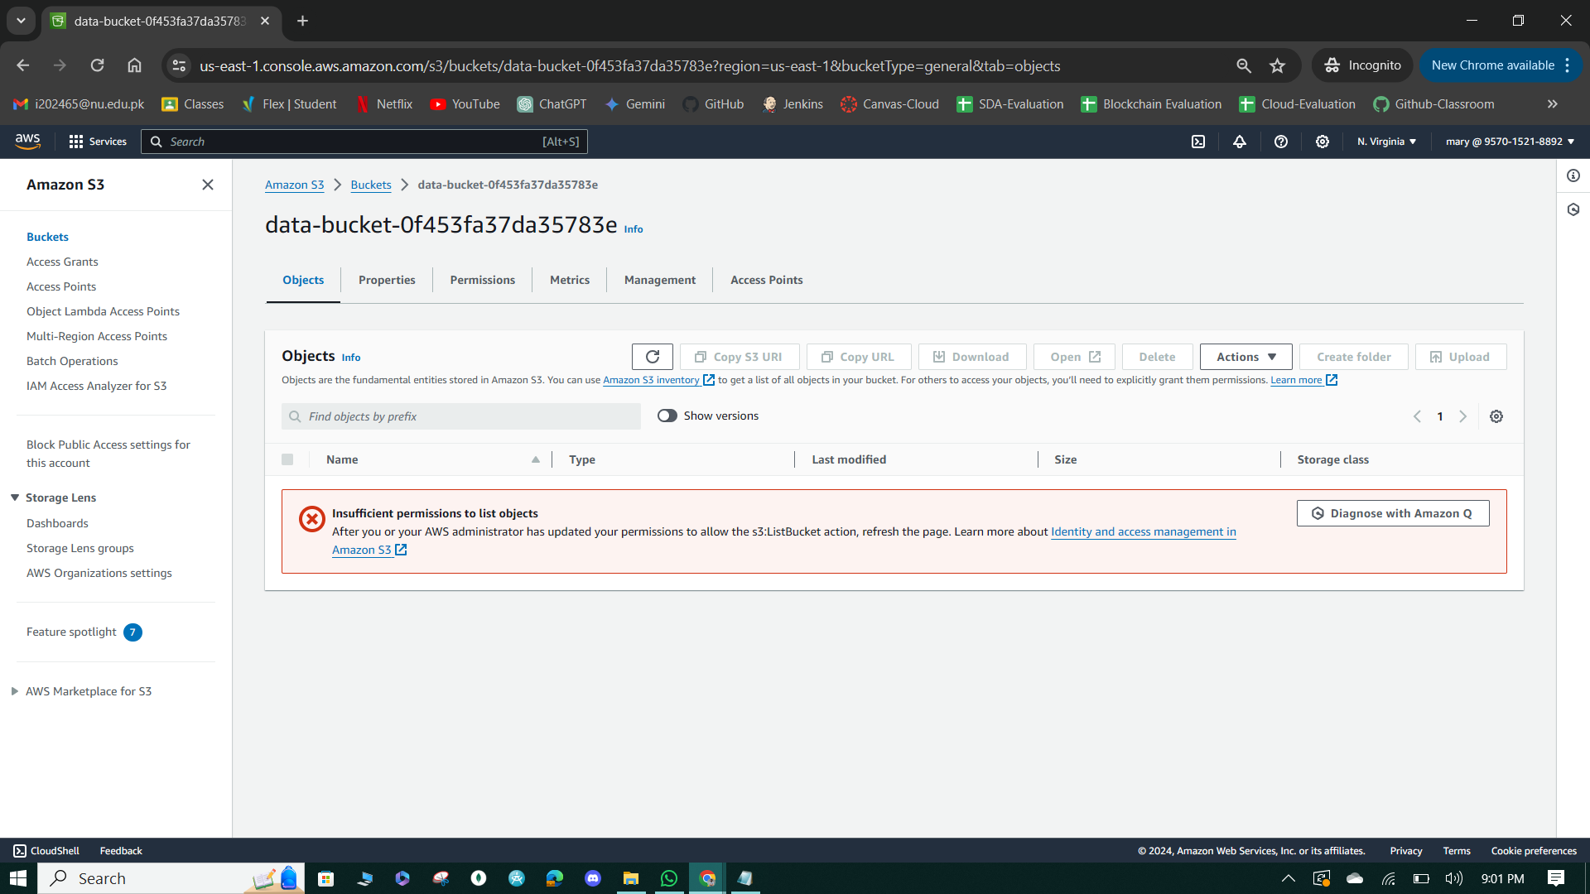

**Figure 7: Marry Access to Data Bucket.**

**Task-02: Enable versioning and object-level logging on a bucket.**

1. Enable versioning and object-level logging on the data-bucket S3 bucket, allowing tracking of changes and creating an audit trail for security incidents.
2. Configure server access logging to write logs to the s3-objects-access-log- bucket with a specific prefix and verify the bucket policy includes permissions for the S3 logging service to write objects.

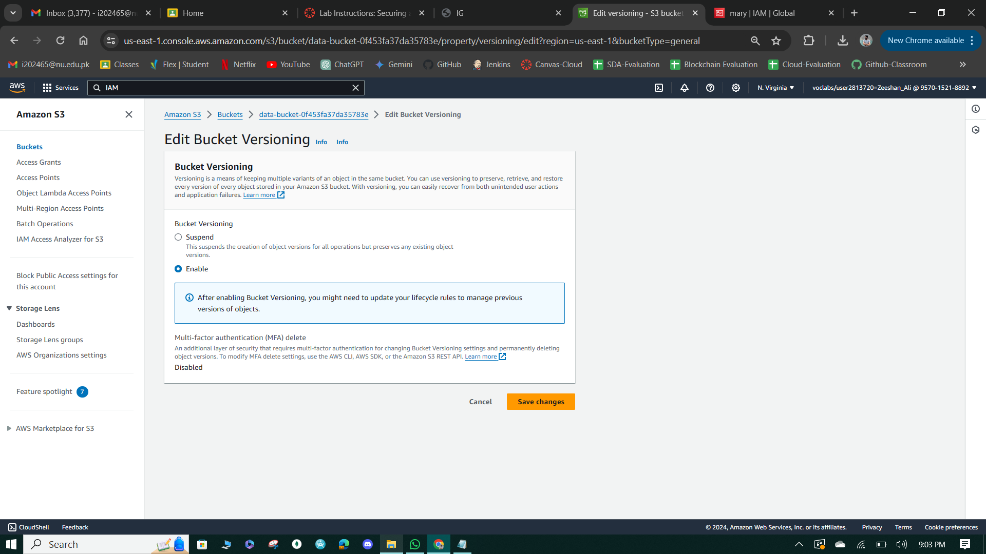

**Figure 8: Enable Versioning.**

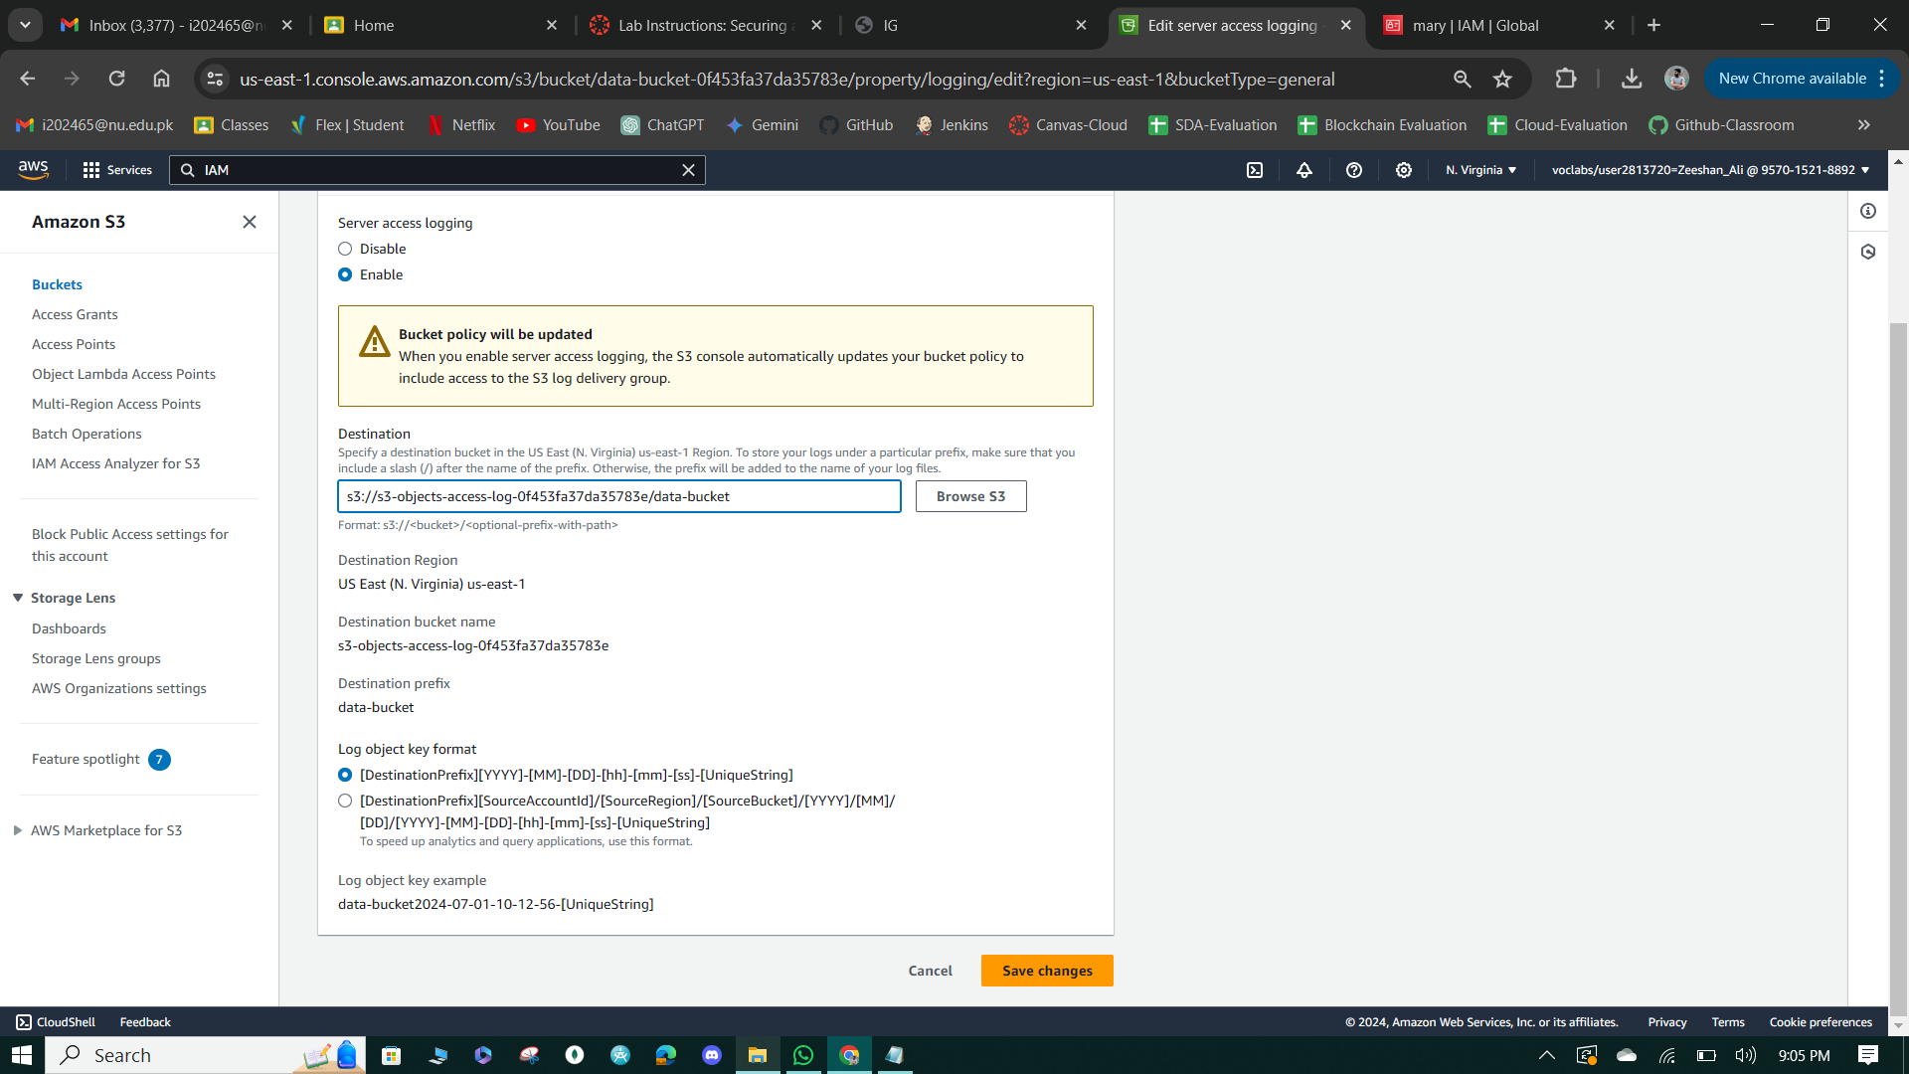

**Figure 9: Enabling Server Access Logging.**

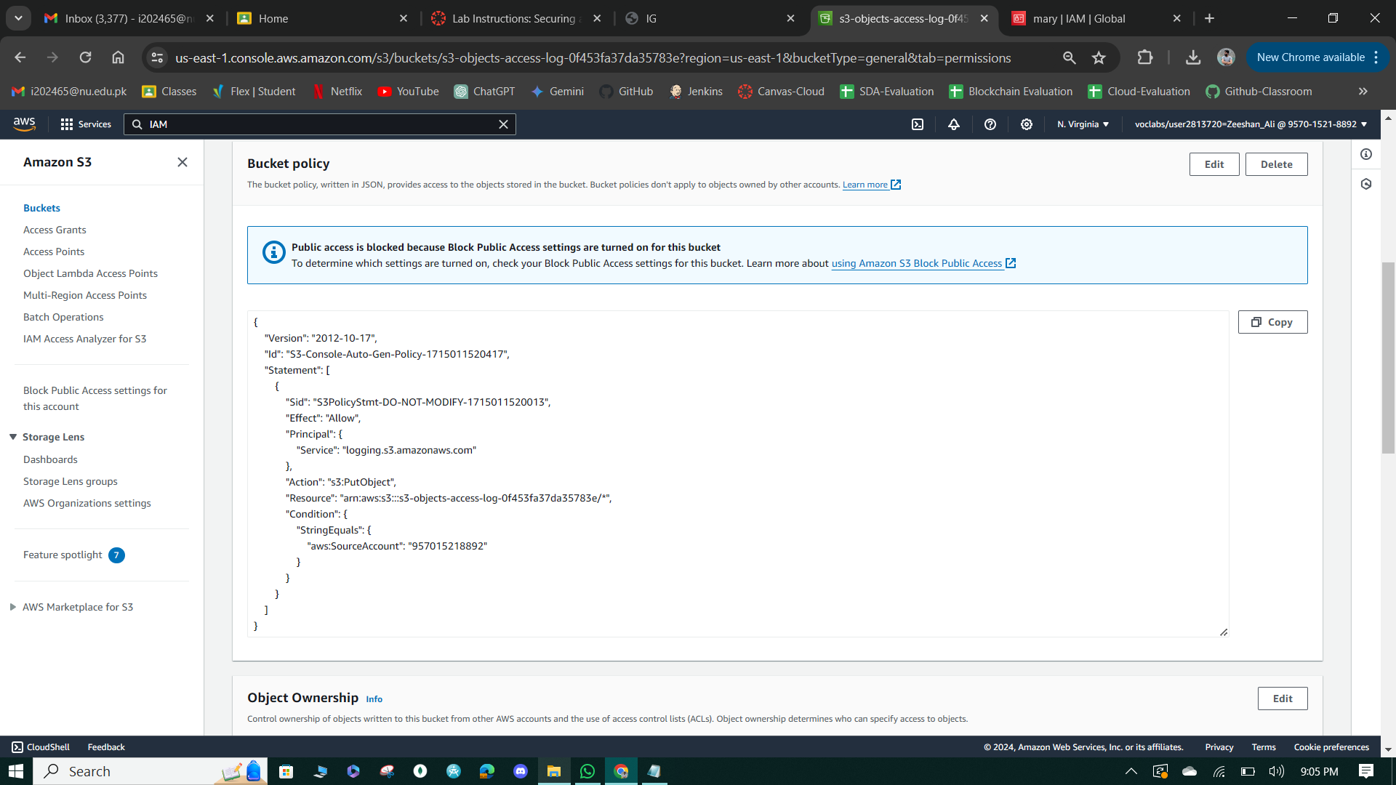

**Figure 10: Update S3 Bucket Policy.**

**Task 3: Implement the S3 Inventory feature on the data bucket.**

Enable S3 Inventory on the data-bucket to receive scheduled reports detailing metadata and object-level changes, aiding in tracking changes and detecting security incidents, with the report details directed to the specified destination bucket in Apache Parquet format along with selected additional metadata fields.

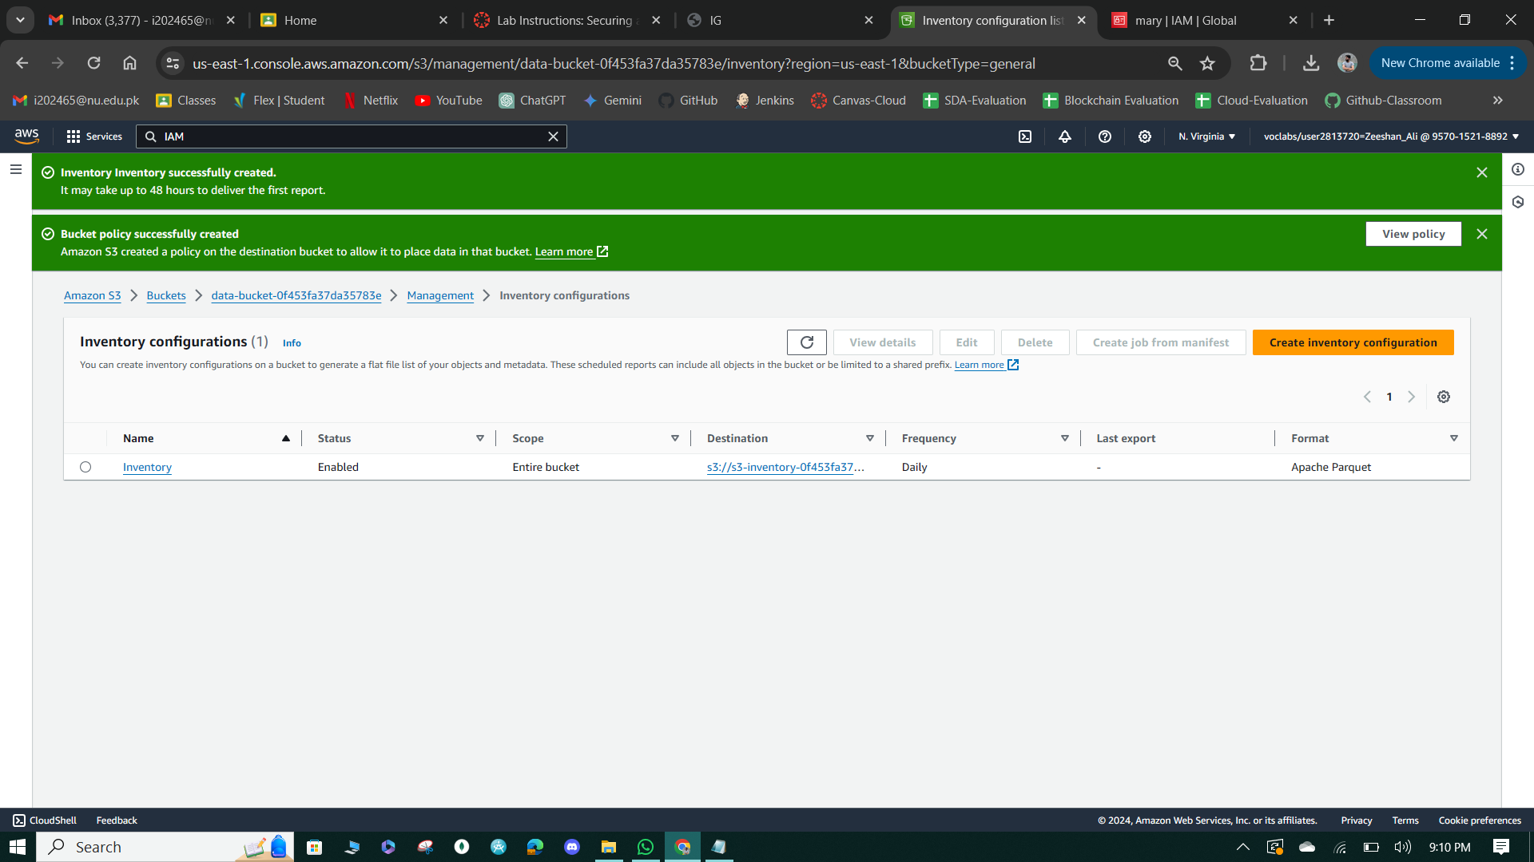

**Figure 11: S3 Inventory Created Successfully.**

**Task 4: Confirm versioning works as intended.**

1. Create customer.csv with data and upload to data-bucket as paulo, ensuring server-side encryption with SSE-S3.
2. Verify versioning on S3 console, then add more data to the file, upload as a new version, and confirm versions.
3. Test accessing both current and prior versions in S3 console to generate access logs.
4. Logout as paulo, login as mary, and confirm inability to access data-bucket, validating access control measures.

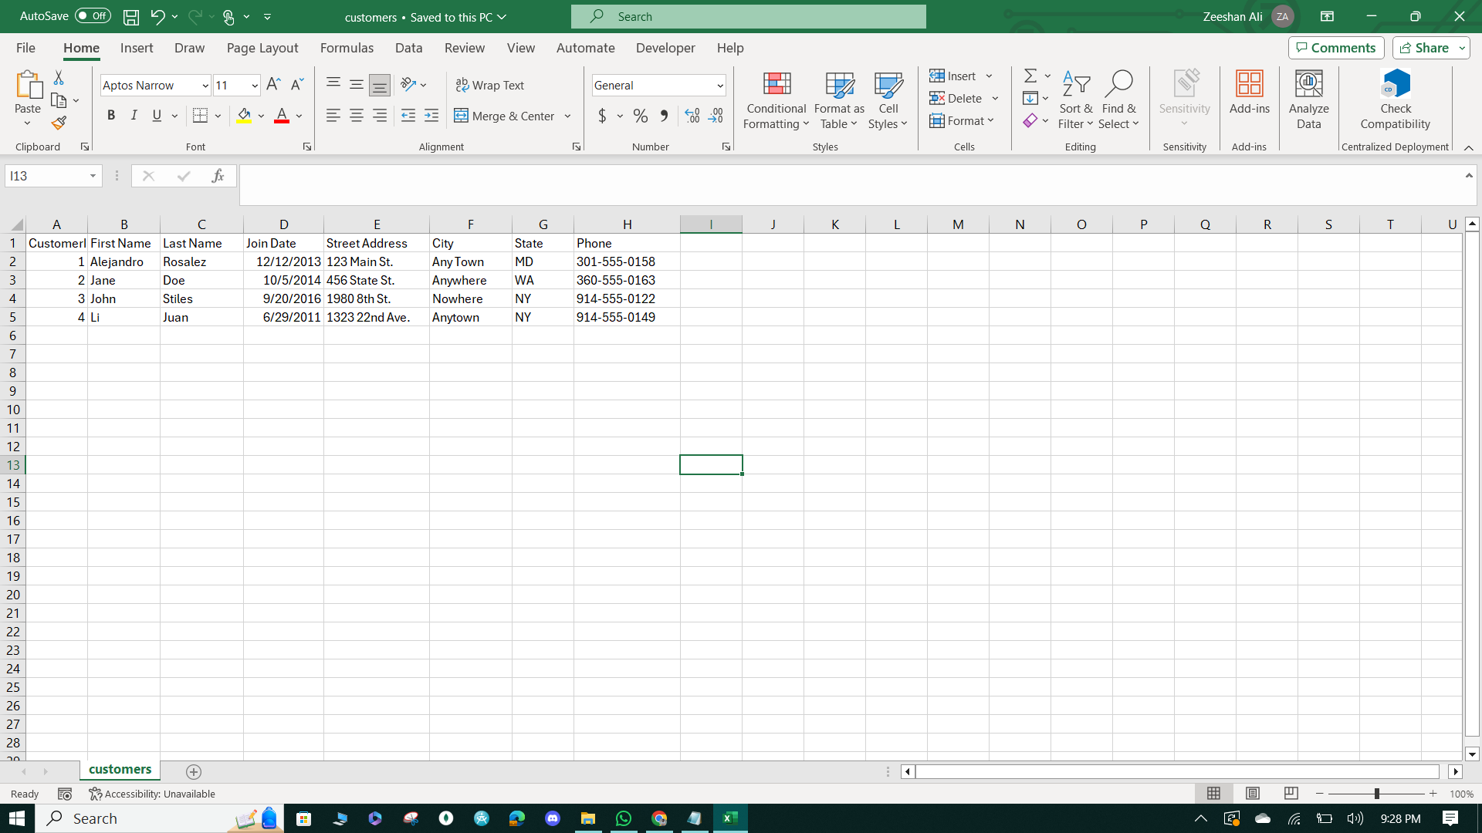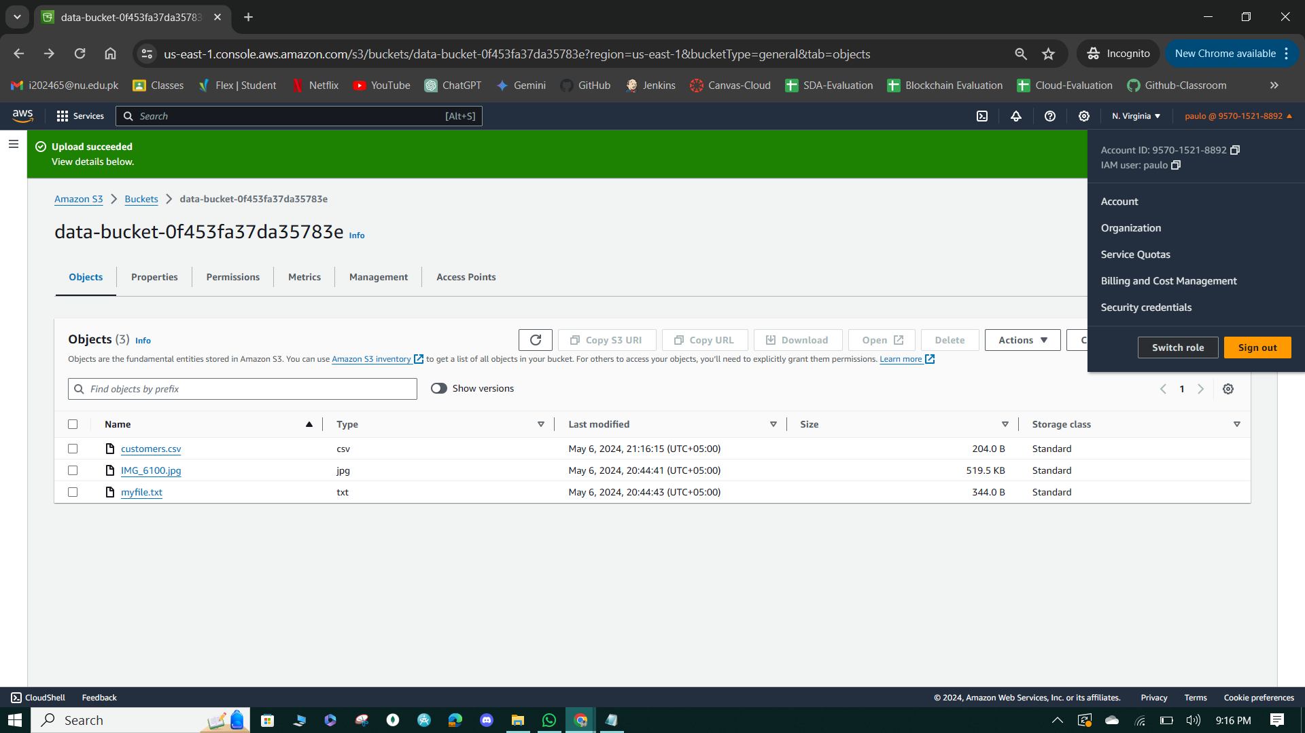

**Figure 12: Uploaded File Successfully.**

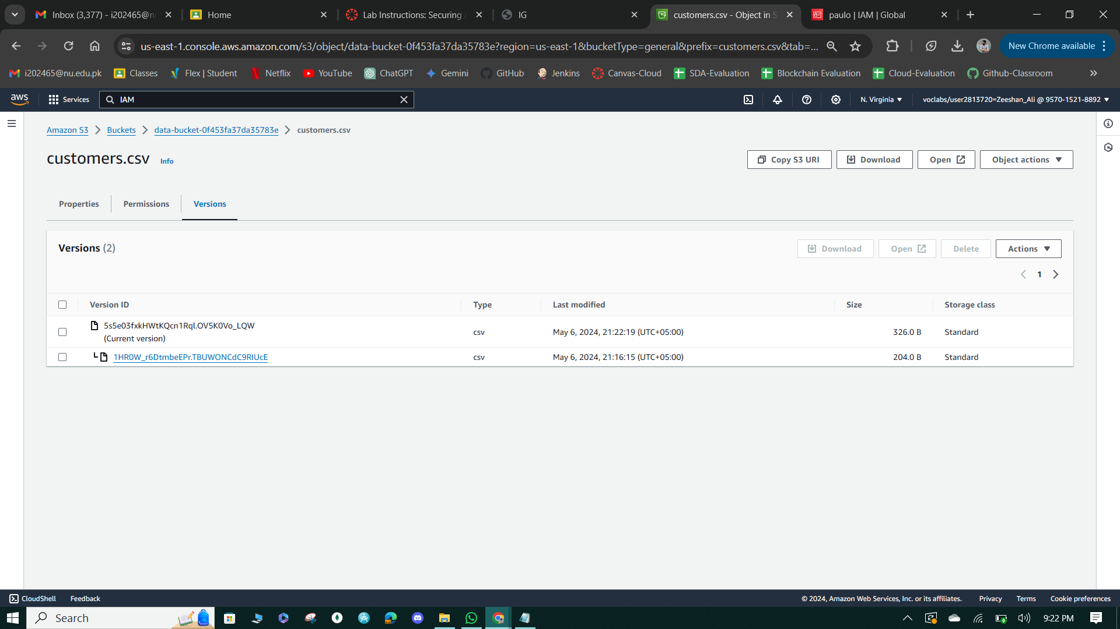

**Figure 13: Version of Data File.**

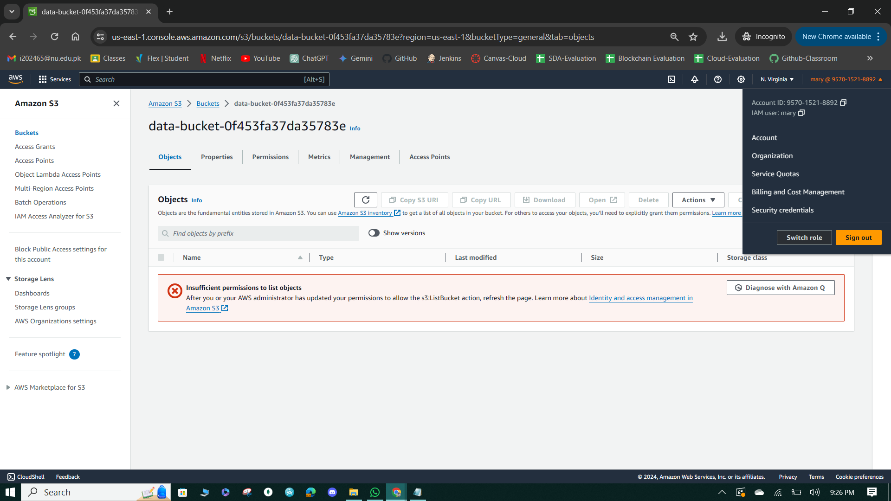

**Figure 14: Marry Access to Data Bucket.**

**Task 5: Confirm object-level logging and query the access logs using Athena.**

1. Access the S3 objects-access-log- bucket as voclabs, download logs, and create an Athena table for querying.
2. Create a new S3 bucket for Athena query results and configure Athena query editor.
3. Define an external table in Athena with log file format and location, replacing placeholders with actual unique ID.
4. Query the bucket logs table in Athena to filter IAM user actions, observing successful requests by Paulo and access denied requests by Mary with appropriate HTTP status codes.

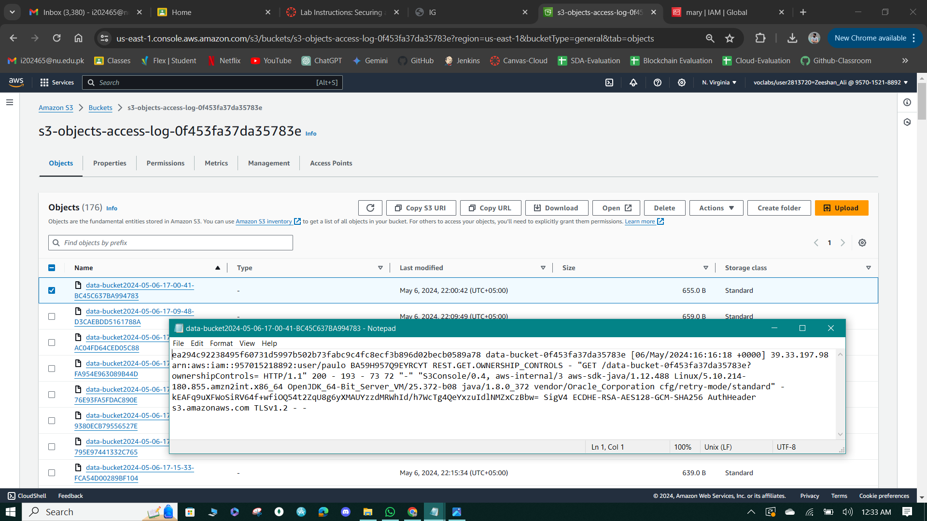

**Figure 15: S3 object access logs.**

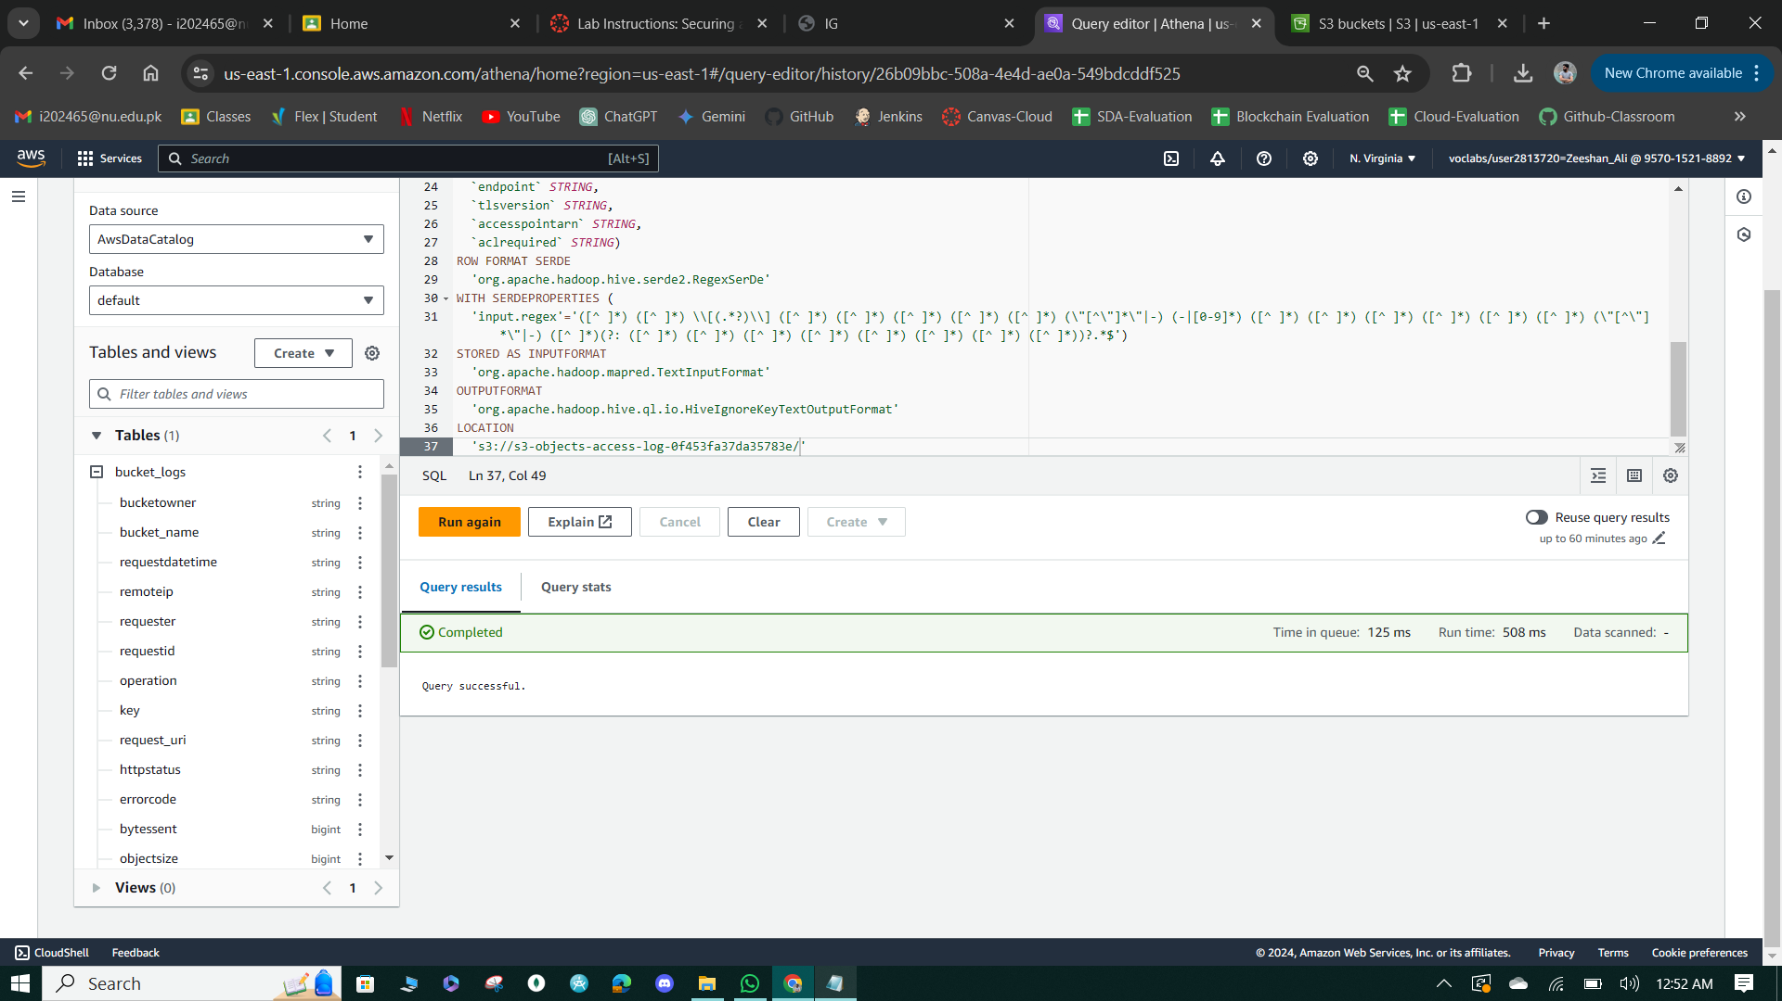

**Figure 16: Athena Table Creation & View Table**

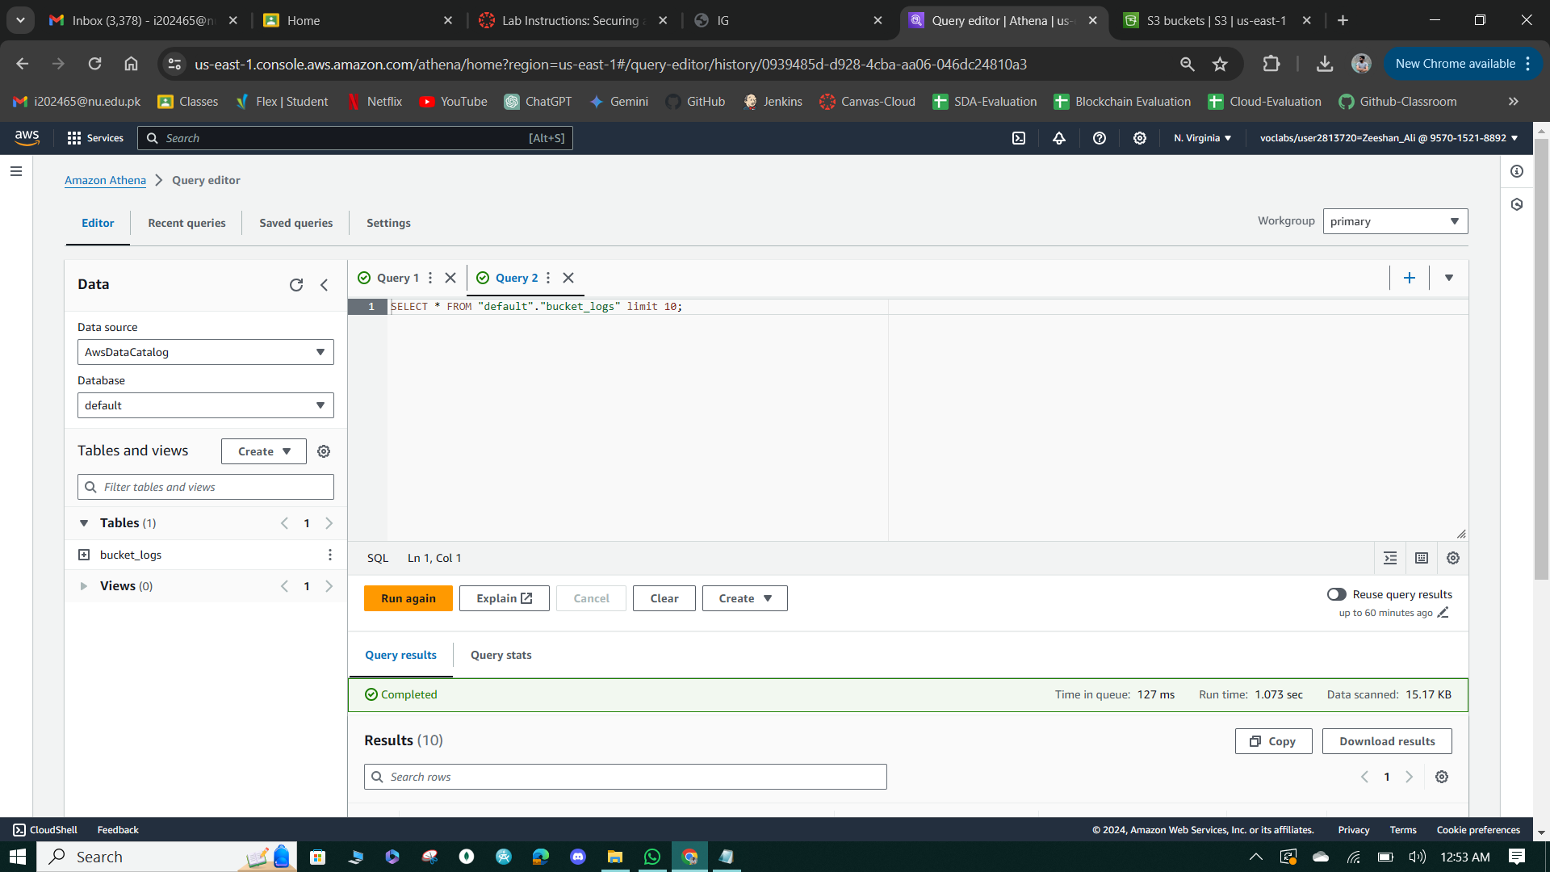

**Figure 17: Query to view 10 Bucket Access logs.**

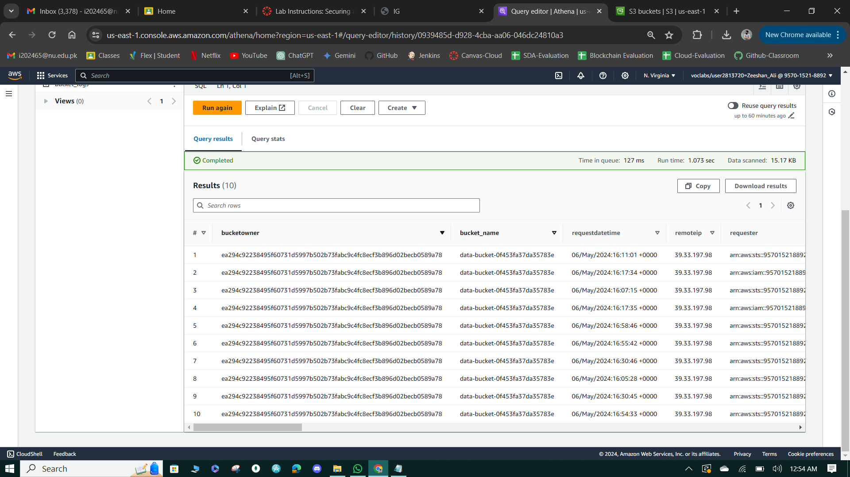

**Figure 18: Query Result.**

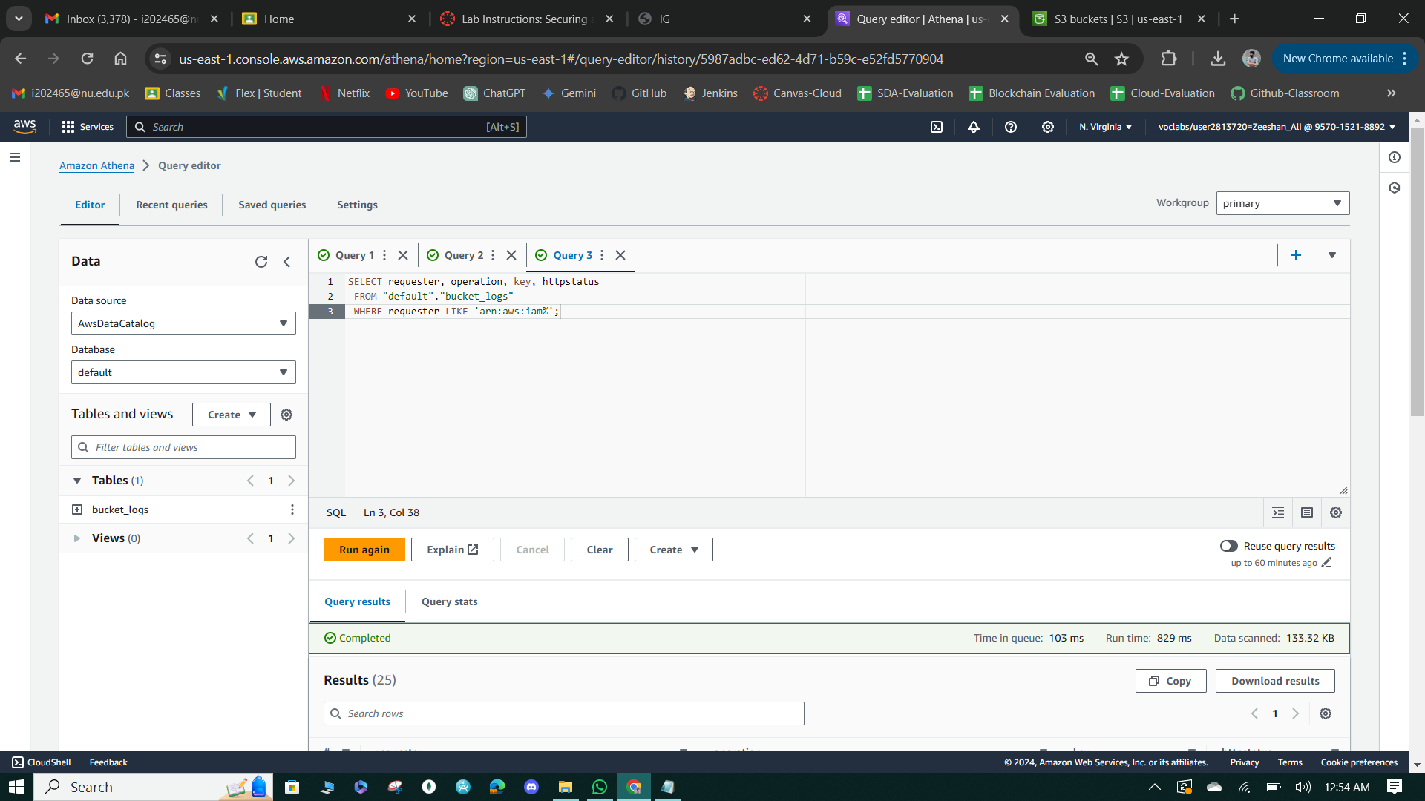

**Figure 19: Query to get IAM Users Actions**

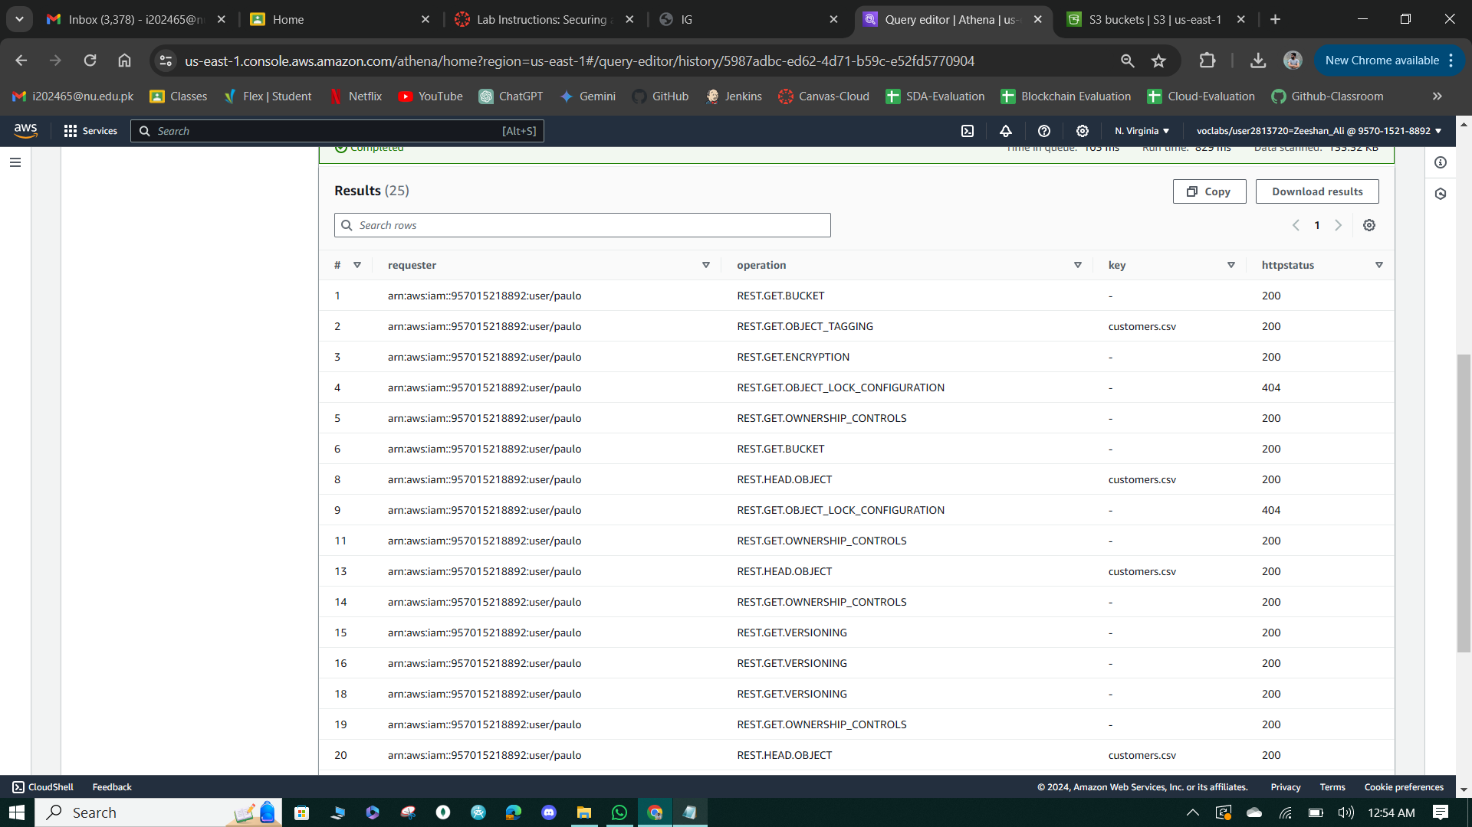

**Figure 20: Query Results.**

**Task 6: Review the S3 Inventory report using S3 Select**

1. Access the S3 Management tab for the data-bucket, locate the inventory configuration, and navigate to the designated destination bucket.
2. Use S3 Select to query the Parquet file in the inventory bucket, expecting at least 3 entries including myfile.txt from Task 1 and additional entries for each version of customer.csv uploaded.

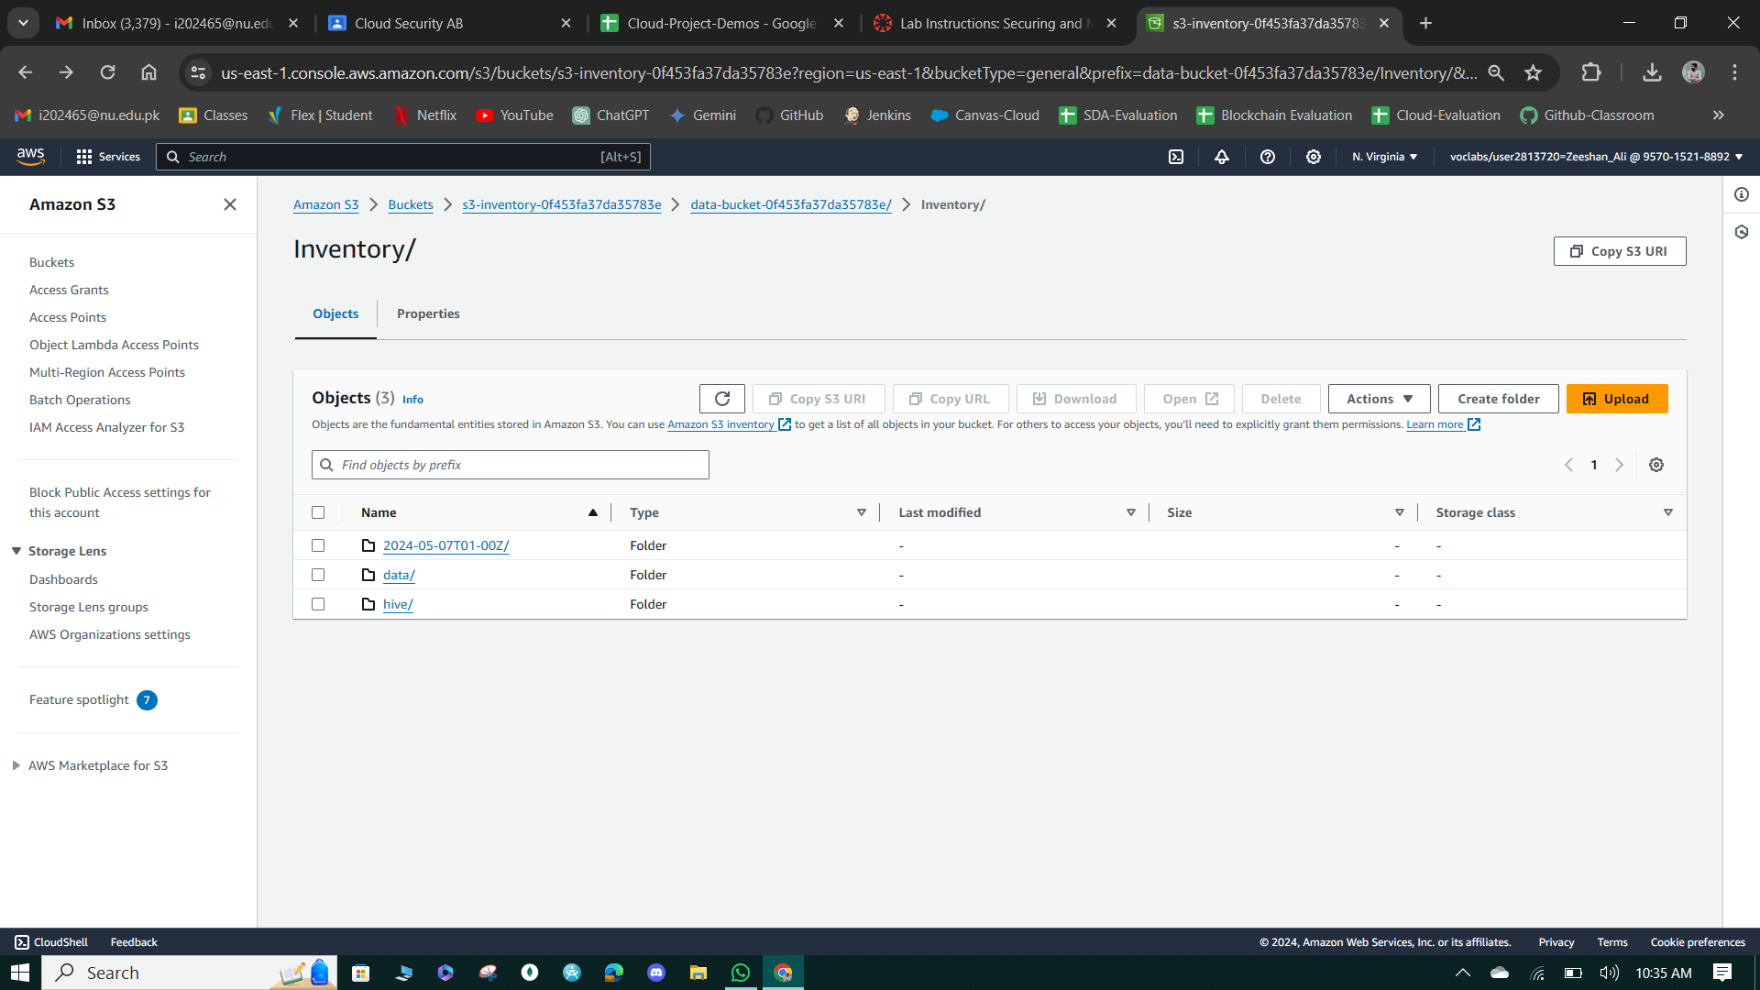

**Figure 21: S3 Inventory Report**

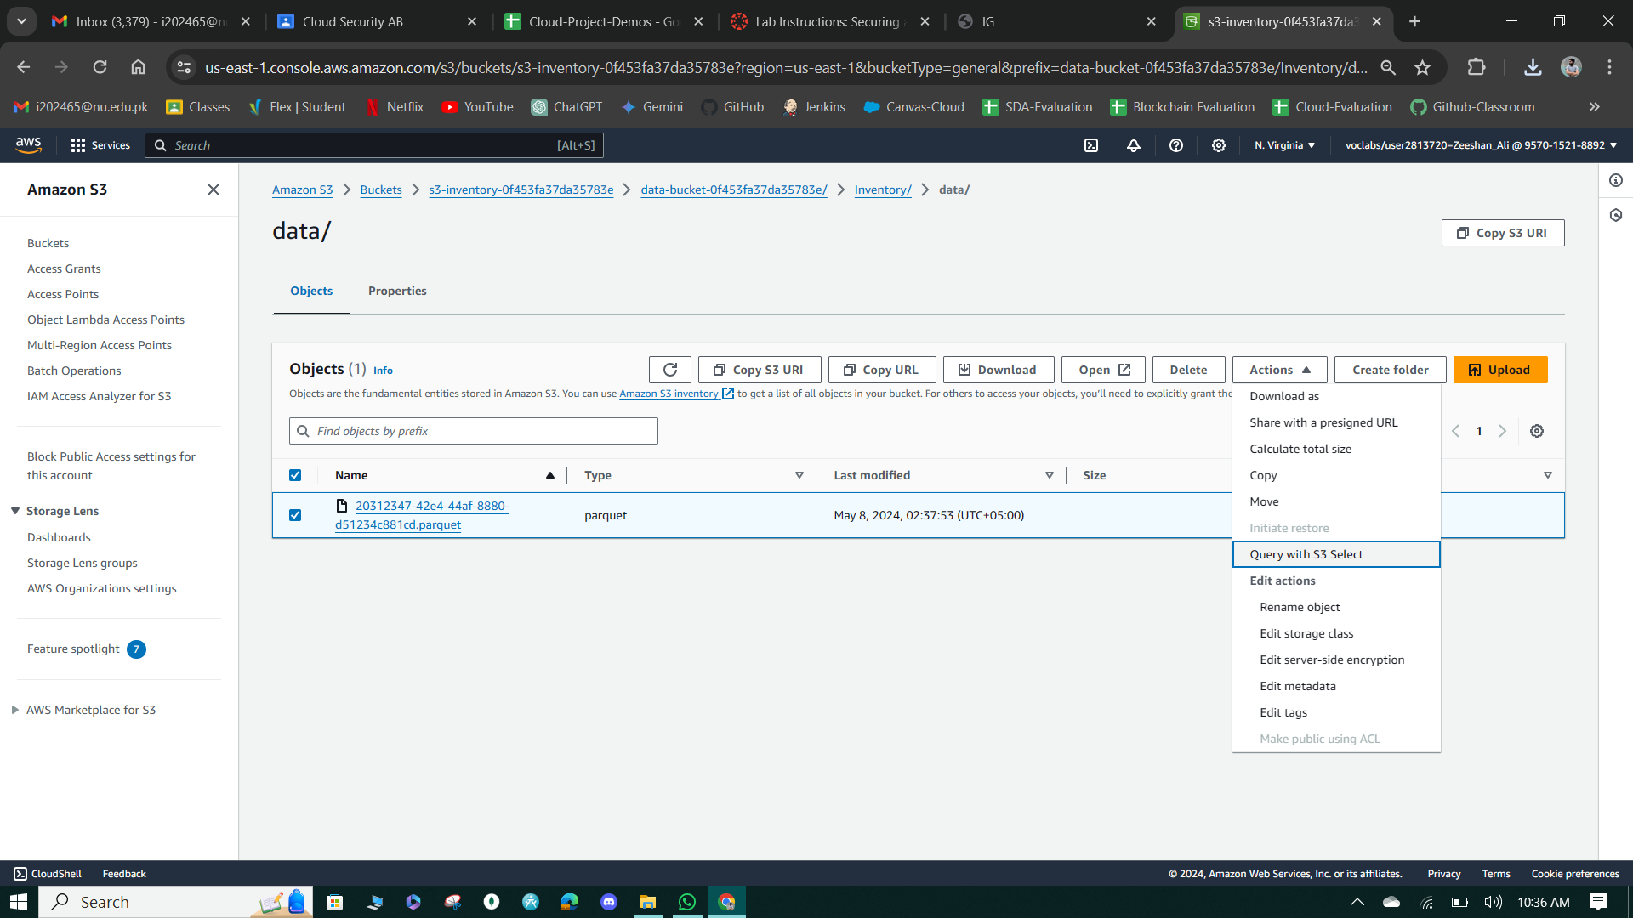

**Figure 22: Create Query to get Results.**

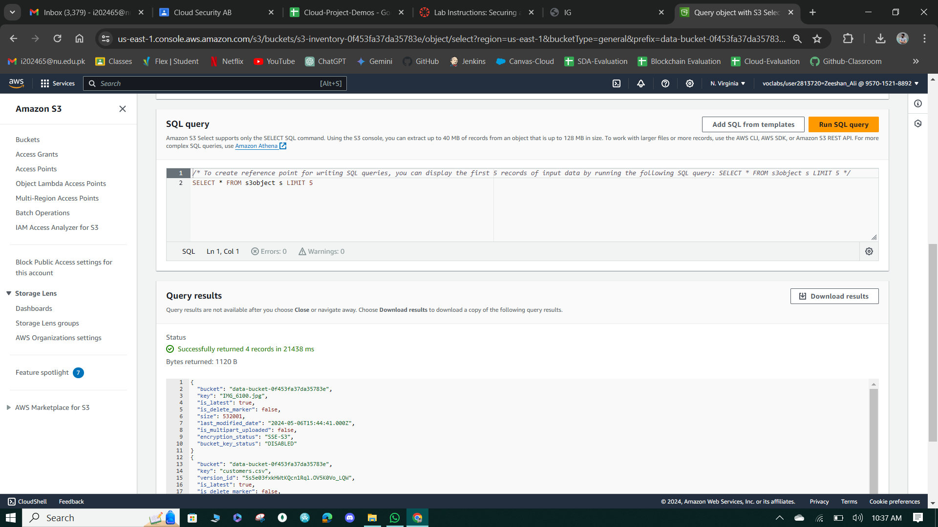

**Figure 23: Query to preview 5 Objects in Bucket**

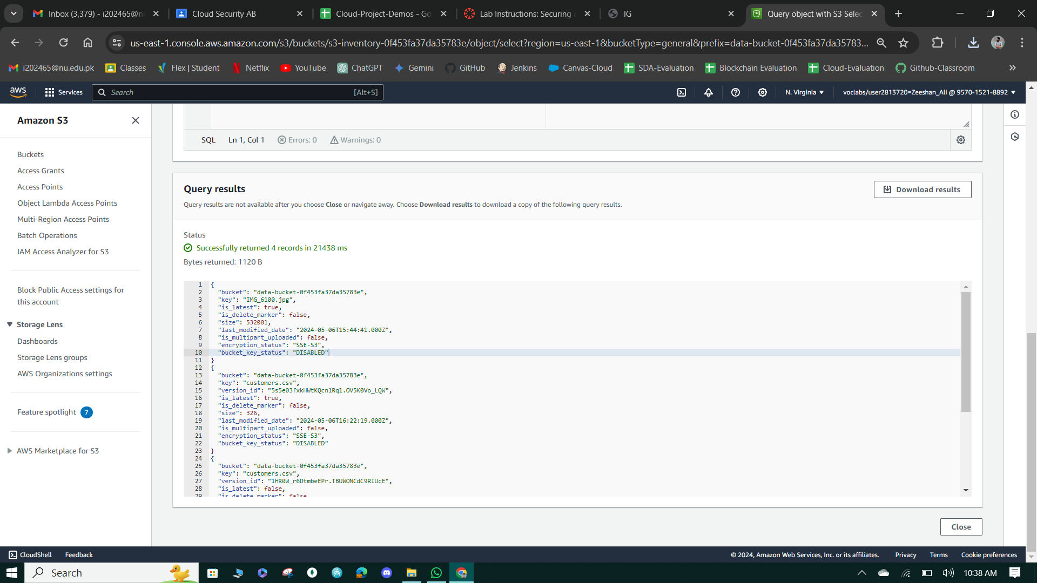

**Figure 24: Query Results.**

**Cost assessment to secure Amazon S3**

**Question:** In this lab, does your use of these Amazon S3 security features result in additional cost in the account? If so, how much do you estimate that it will cost?

**Answer:** Three costs are associated with this phase:

* **Storage:** In this lab, we have used the S3 Standard storage class. The other storage classes (such as S3 Intelligent-Tiering and S3 Glacier) have different costs and considerations. The rate that is charged depends on object size, how long objects are stored, and storage class. The fact that we enabled versioning means there may be multiple versions of some objects and so that can increase storage costs.
* **Data transfer:** You pay for all bandwidth into and out of Amazon S3. Querying the logs stored in S3 could incur a data transfer cost.
* **Management and insights:** The S3 Inventory feature incurs a cost (per million objects listed) when enabled.

# Phase 2: Securing VPCs

In this phase, you focused on securing the VPCs hosting AnyCompany Financial's critical applications. You reviewed the existing resources in the LabVPC, created VPC Flow logs, tested access to the WebServer instance, configured route tables and security groups, and secured the WebServerSubnet with a NACL. Then, you moved on to the NetworkFirewallVPC, observed its resources and configurations, and created a network firewall with associated route tables and logging configurations. Finally, you configured the network firewall policy, tested access, and developed a cost estimate for using AWS Network Firewall based on the planned usage provided by AnyCompany Financial.

**Task 1: Review LabVPC and its associated resources**

The WebServer instance is deployed within the WebServerSubnet, which is a subnet residing within the LabVPC. Additionally, the instance has a Public IPv4 address assigned to it, indicating that it is intended to be accessible from the public internet.

The instance is associated with an IAM role, granting it specific permissions to interact with other AWS services. Furthermore, it is protected by the Webserver Security Group, which defines inbound and outbound traffic rules to control access to the instance based on specified protocols, ports, and IP addresses.

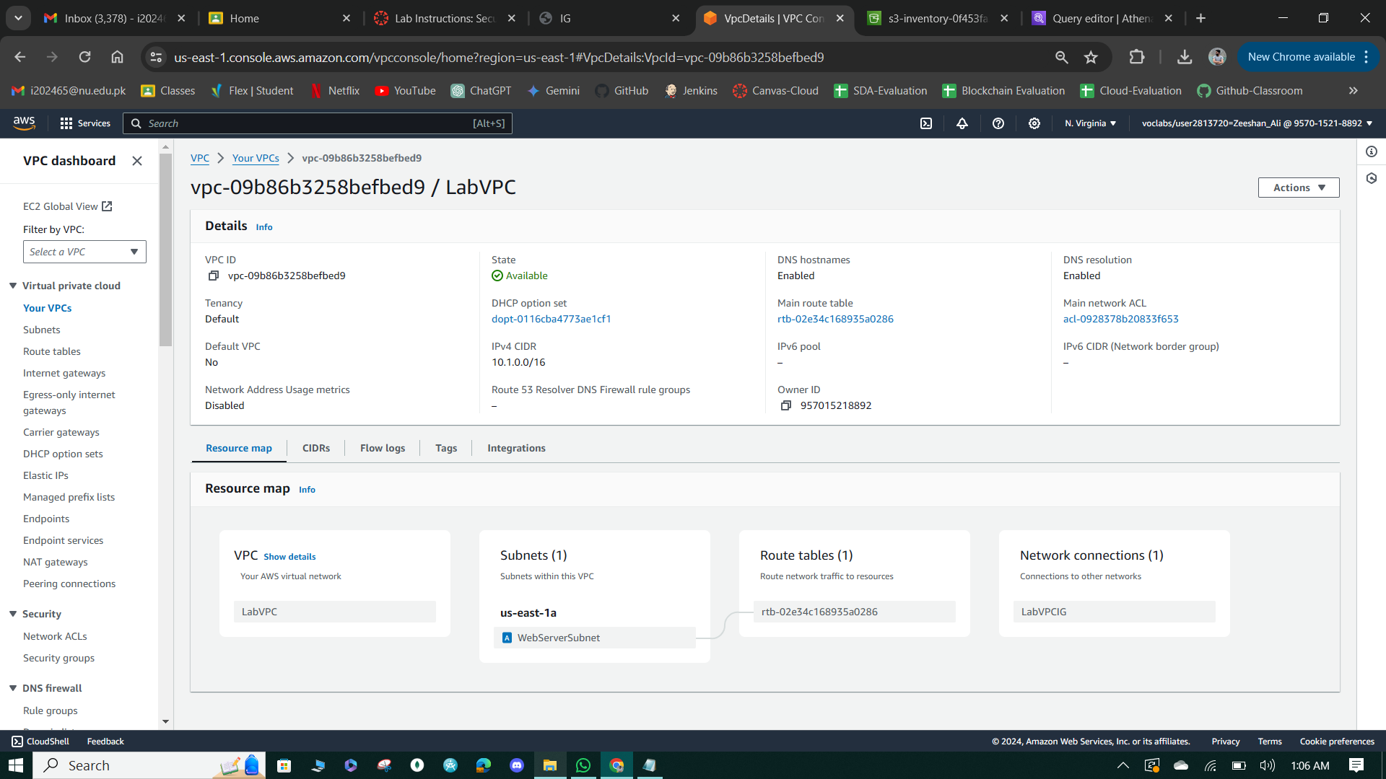

**Figure 25: LabVPC Resource Map**

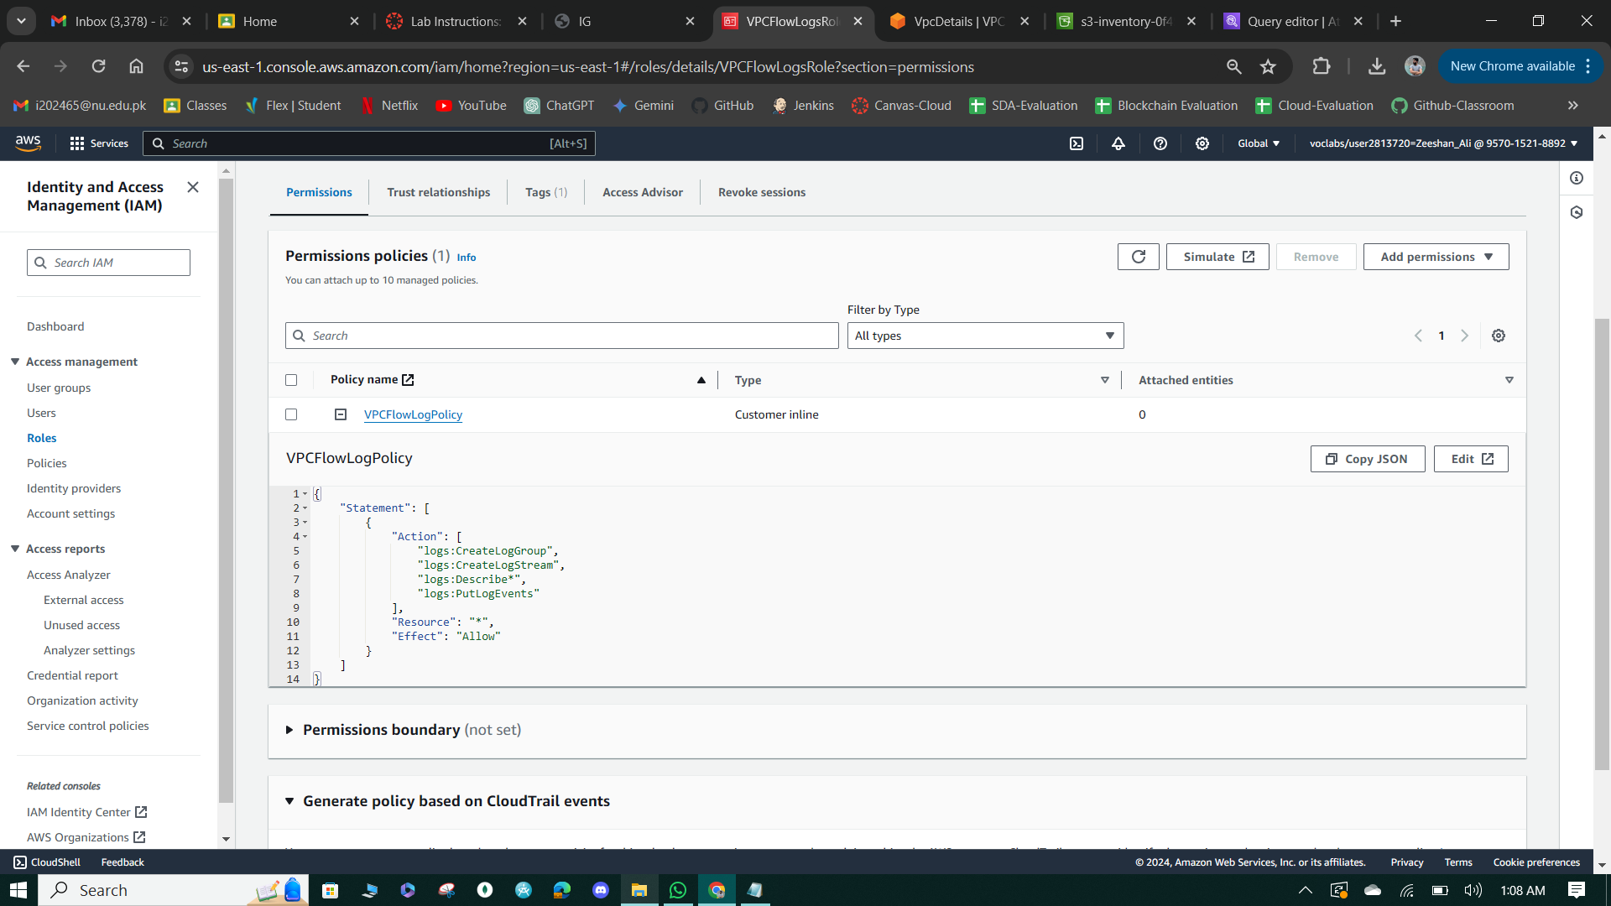

**Figure 26: VPC Flow Logs**

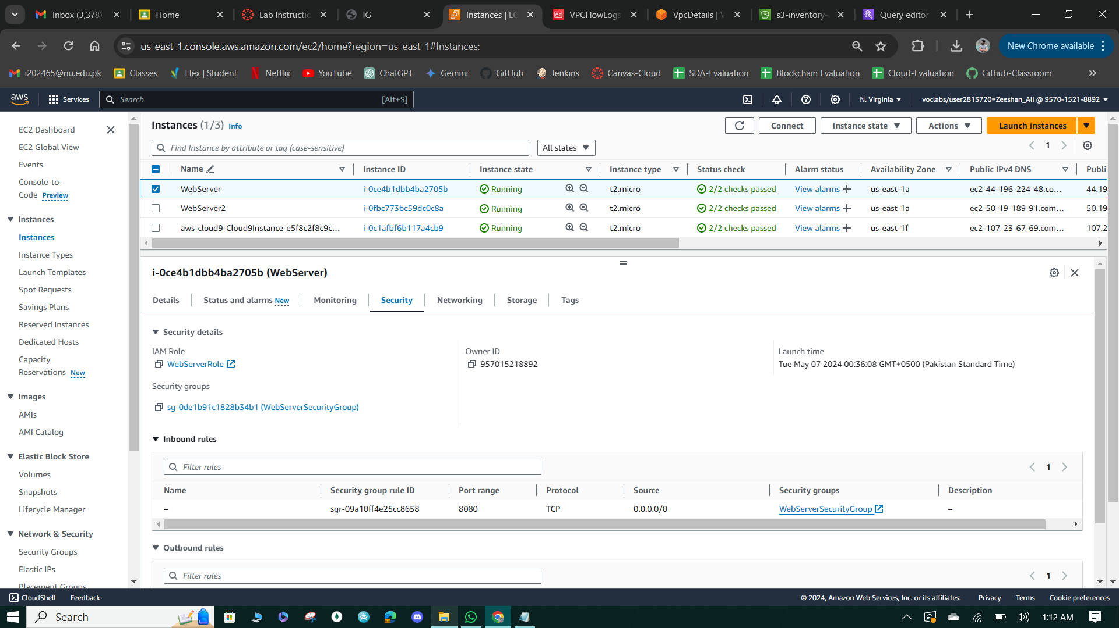

**Figure 27: WebServer Security Details**

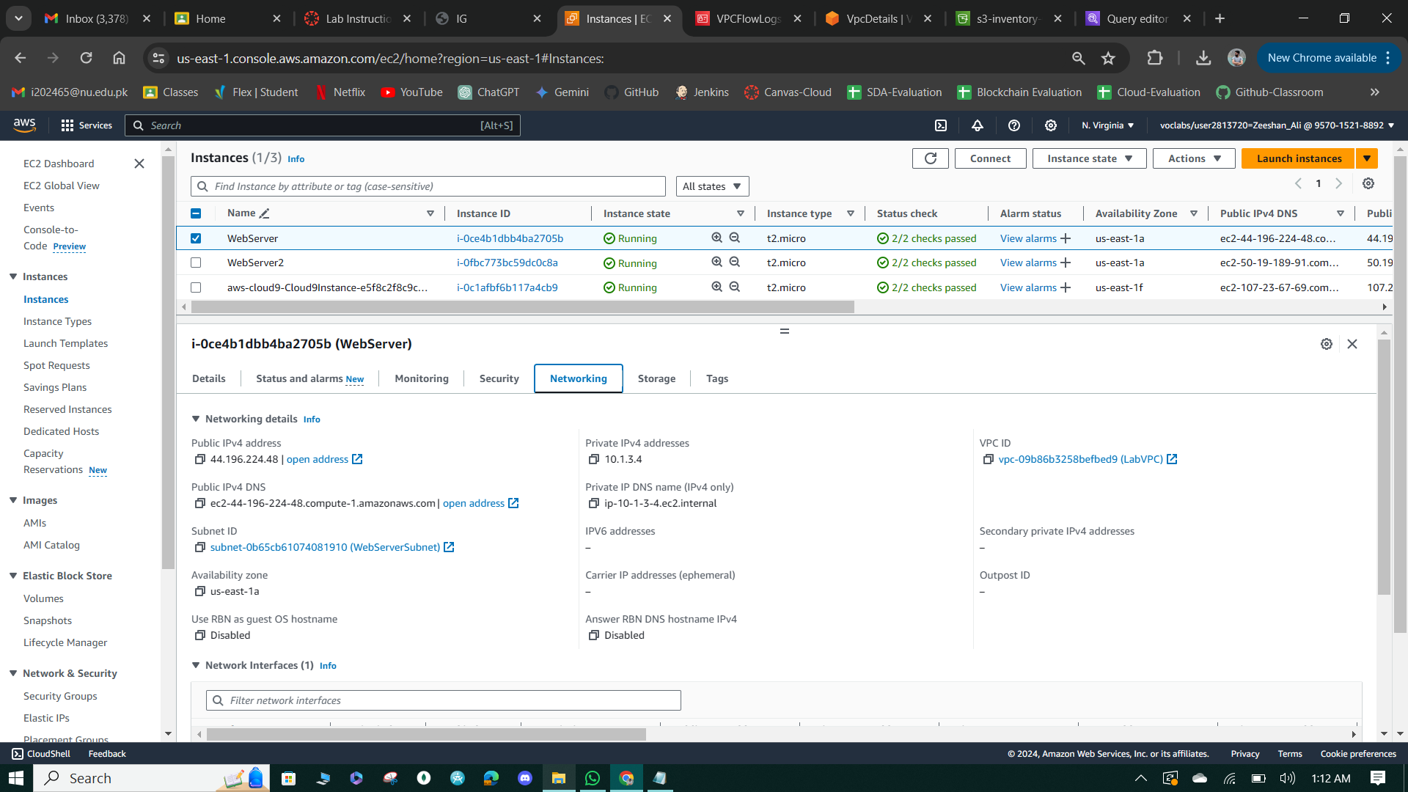

**Figure 28: WebServer Networking Details**

**Task 2: Create a VPC flow log**

Created a VPC Flow log named LabVPCFlowLog for the LabVPC, configured to capture all types of traffic and send all log data to CloudWatch Logs with a maximum aggregation interval of 1 minute. The flow log utilizes the IAM role VPCFlowLogsRole observed in the previous task and directs the log data to a new destination log group named LabVPCFlowLogs.

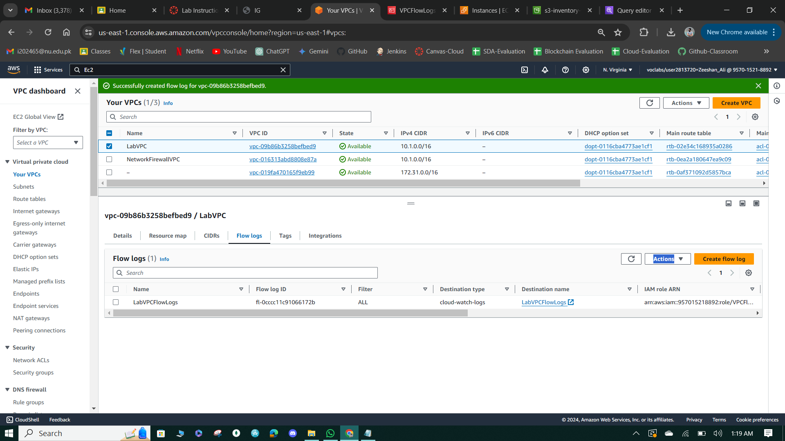

**Figure 29: Lab VPPC Flow Logs**

**Task 3: Access the WebServer instance from the internet and review VPC flow logs in CloudWatch**

* Attempted to access the WebServer instance from a browser using its public IPv4 address, resulting in failed attempts to load the webpage over HTTP (port 80) and SSH (port 22).
* Used the `netcat` command in the Cloud9 IDE terminal to test HTTP and SSH access to the WebServer instance from the internet, confirming that both attempts failed or timed out.
* Reviewed the VPC flow logs in the CloudWatch console, observing entries indicating "REJECT" in the Message field for all events, signifying that the attempted connections were rejected by the network. The log entries displayed details such as the port numbers (e.g., 80 or 22) on which the attempts were made, providing insights into the traffic flow within the VPC.

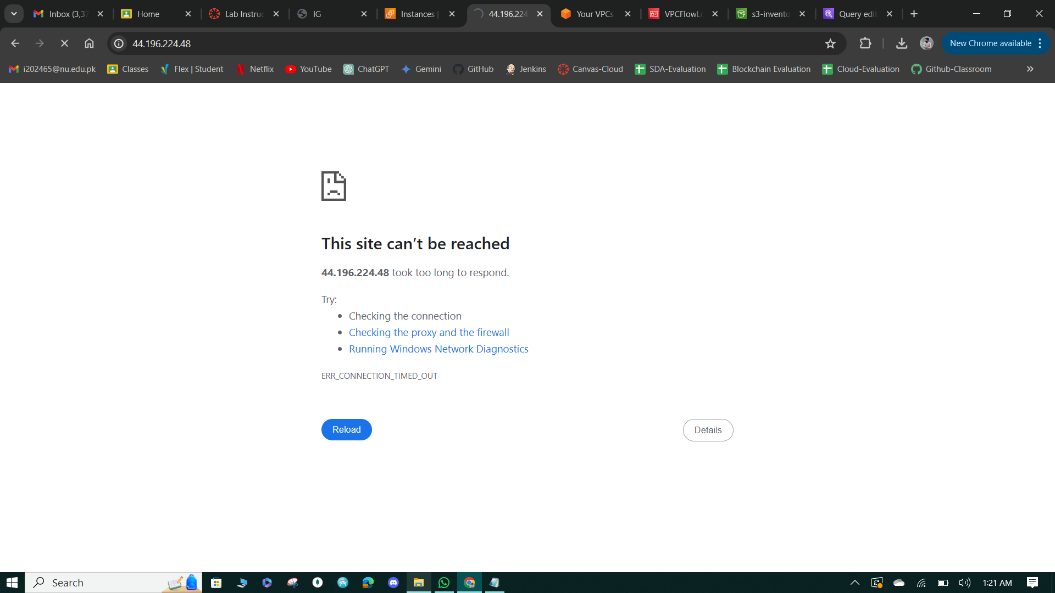

**Figure 30: webserver publicly not accessible.**

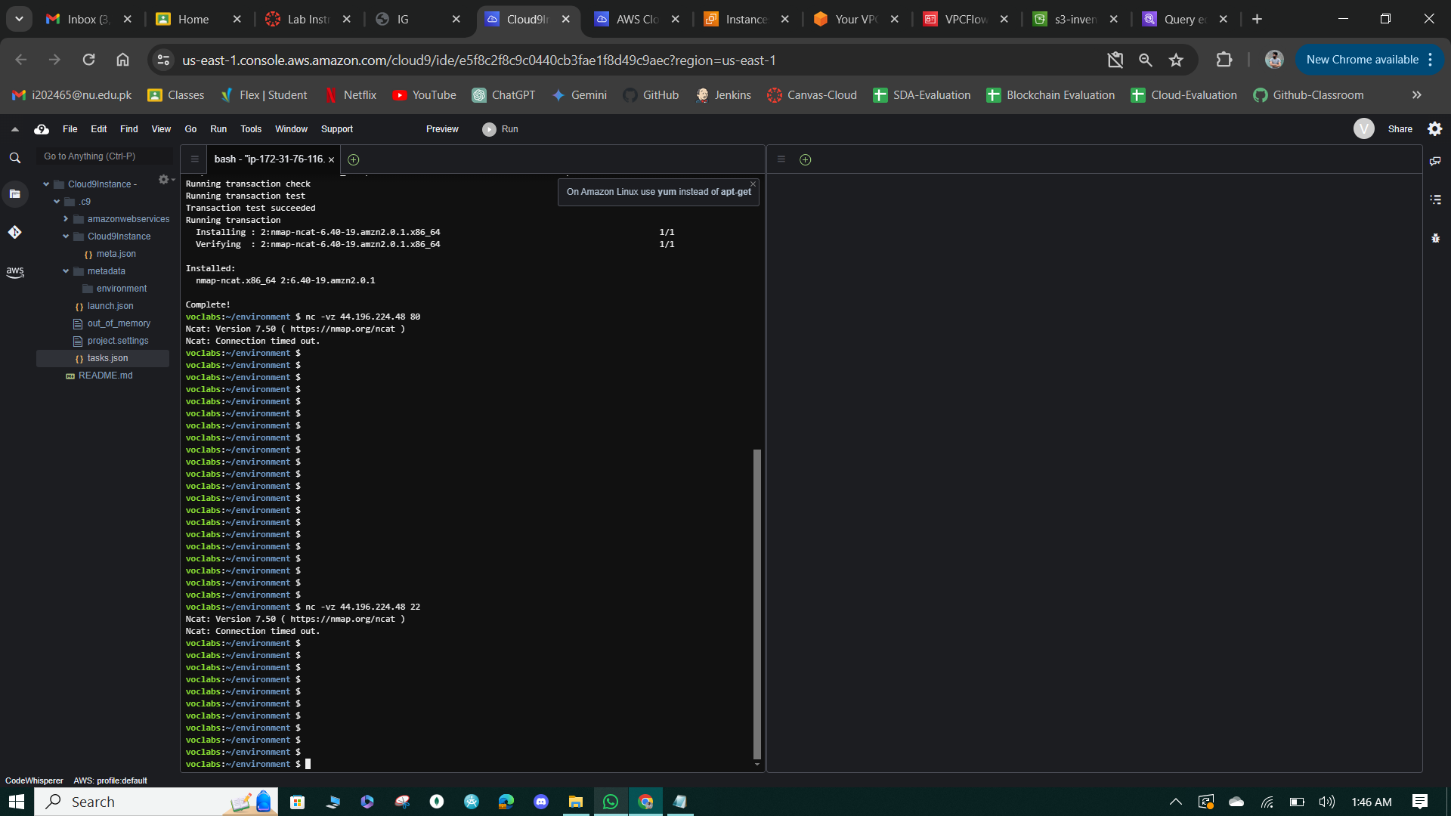

**Figure 31: Connection Time-Out**

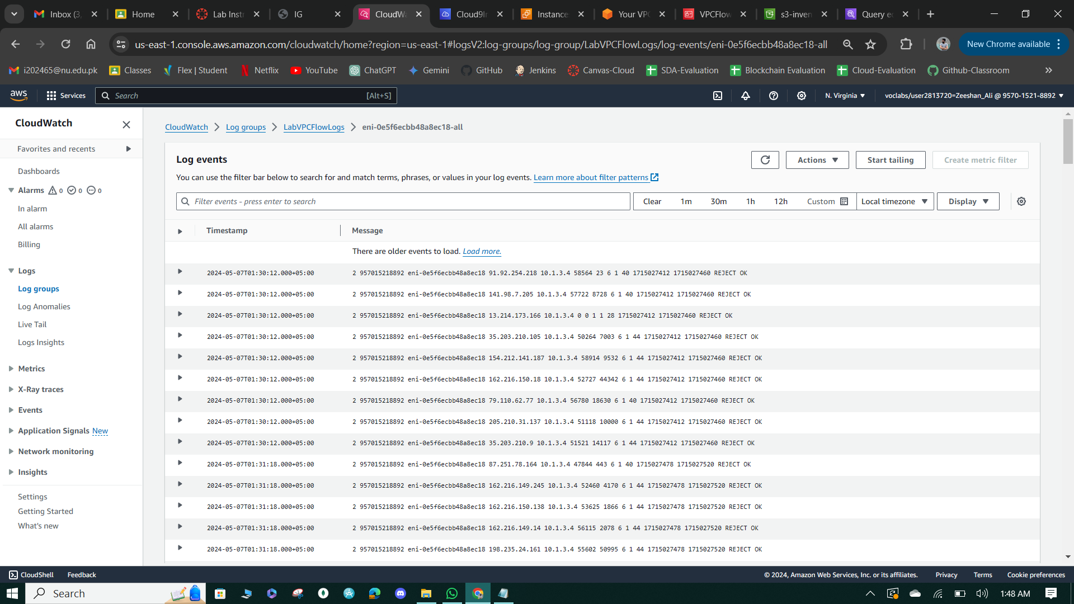

**Figure 32: Access Logs**

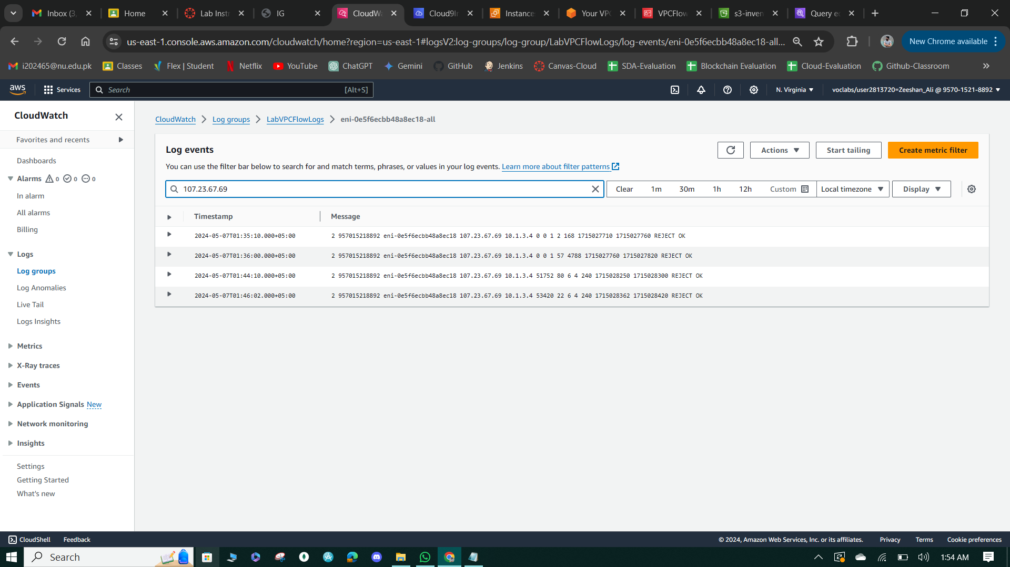

**Figure 33: check the particular Ip logs.**

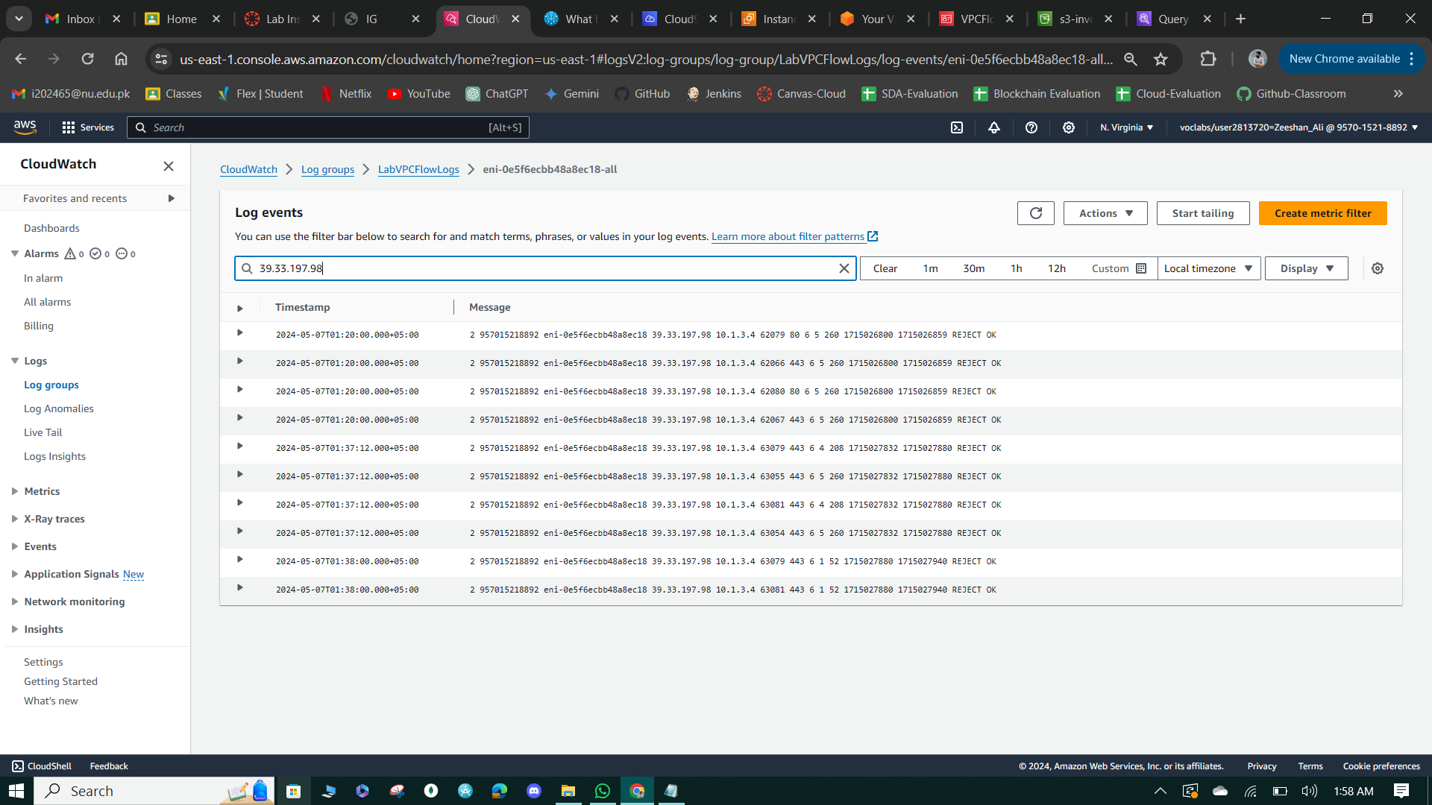

**Figure 34: check the particular Ip logs.**

**Task 4: Configure route table and security group settings**

* Updated the route table associated with the WebServerSubnet in the VPC console to add a route directing traffic to and from the internet (0.0.0.0/0) to the existing Internet Gateway (LabVPCIG), enabling inbound HTTP traffic to reach the WebServer instance.
* Modified the inbound rules of the security group associated with the WebServer instance in the EC2 console. Deleted existing inbound rules except those allowing traffic to ports 22 (SSH) and 80 (HTTP), ensuring a clean and secure configuration.
* Added an inbound rule to allow HTTP traffic from IPv4 anywhere to TCP port 80, enabling access to the WebServer instance's webpage from the internet.
* Added an inbound rule to allow SSH access to the WebServer from the Cloud9 instance. Specified the source IP address range for the rule to match the Public IPv4 address of the Cloud9 instance, enhancing security by restricting SSH access to specific sources. Additionally, added an inbound rule to allow SSH access via EC2 Instance Connect, following security best practices.

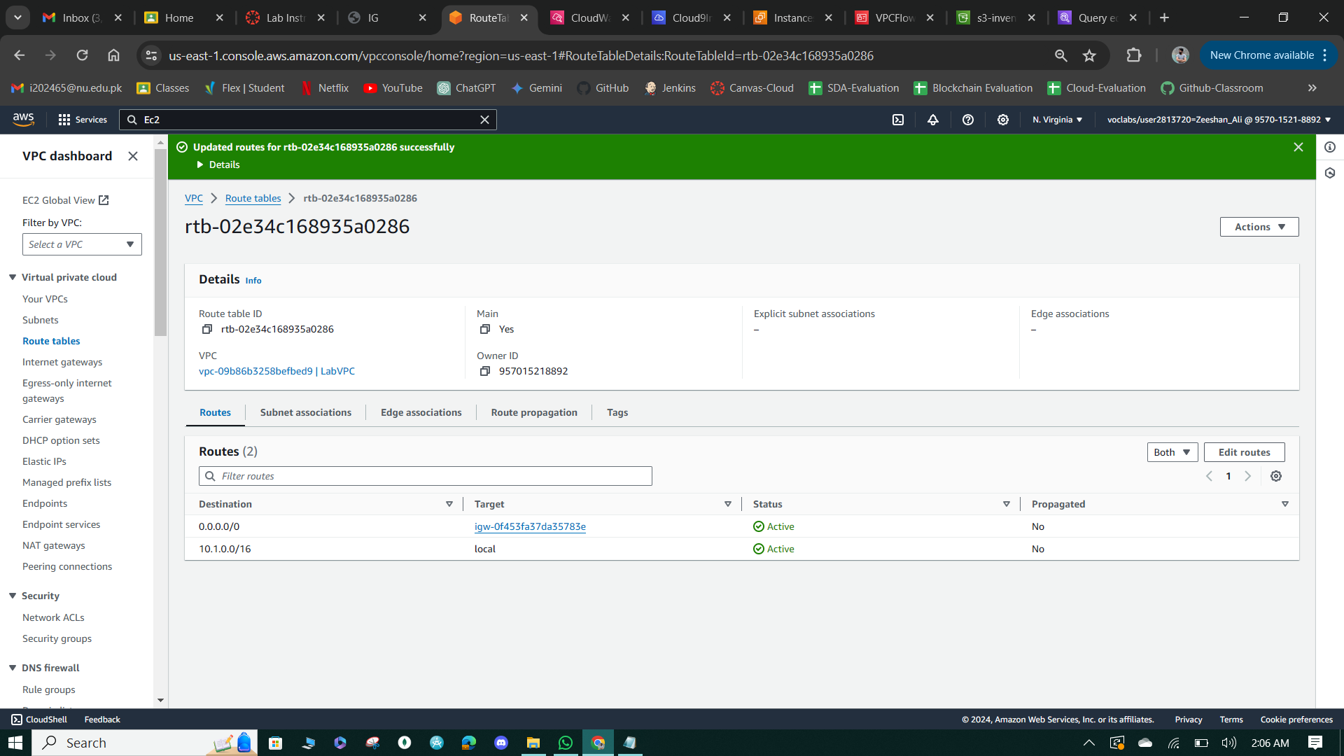

**Figure 35: Attach the Internet Gateway to local network.**

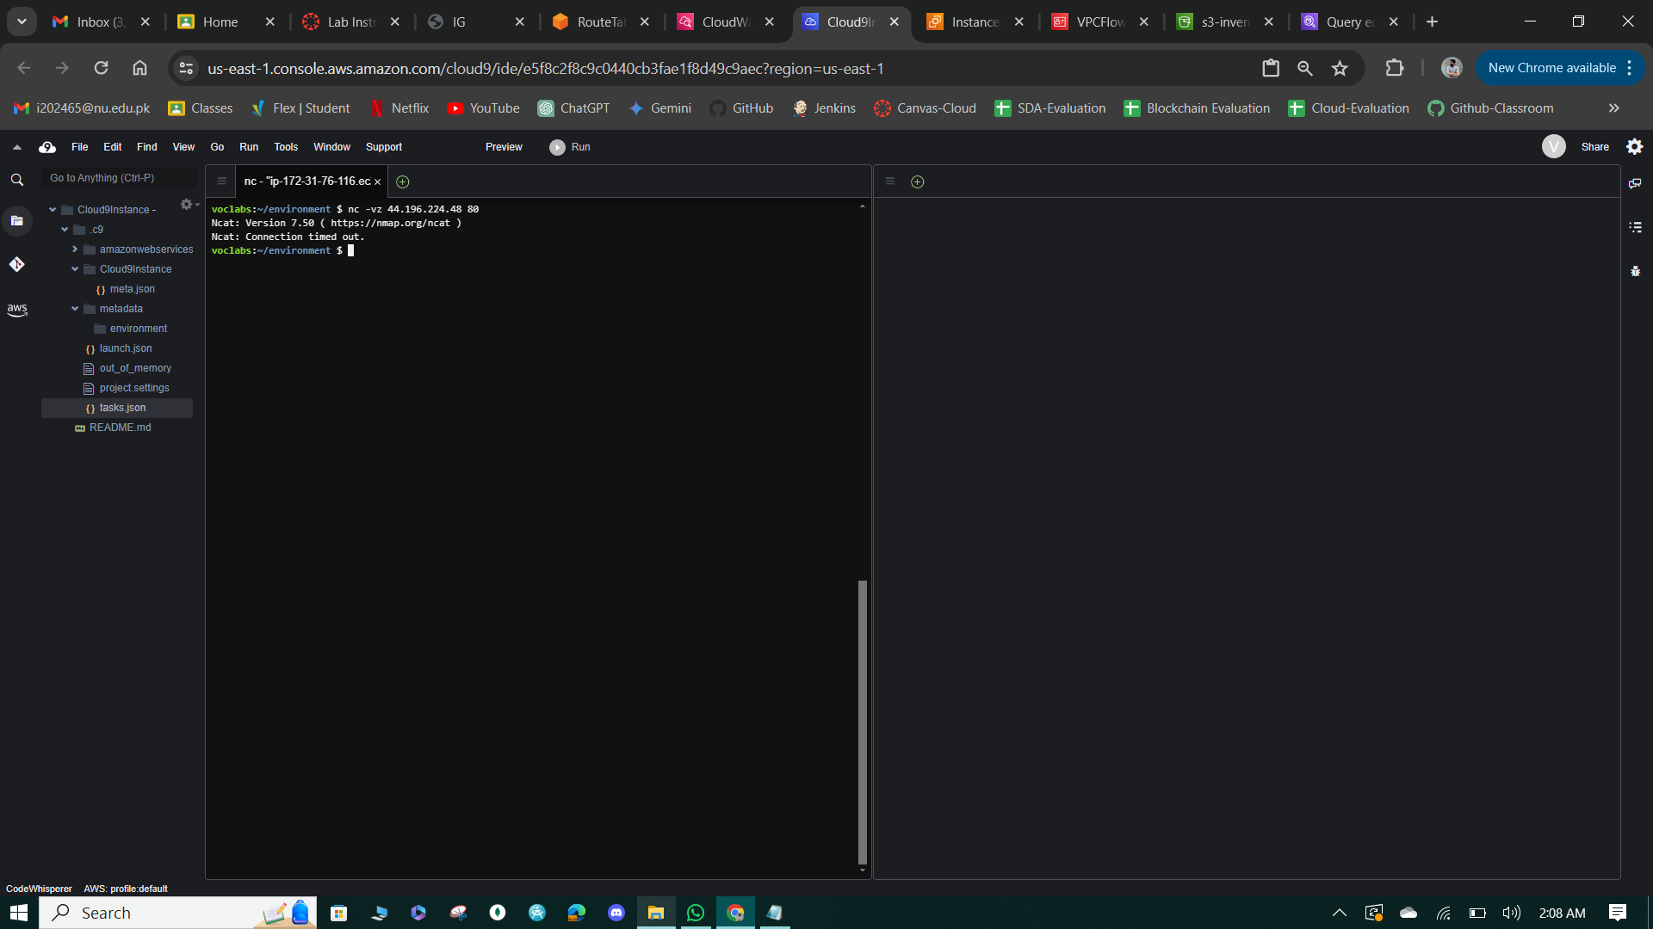

**Figure 36: Connection Time-out**

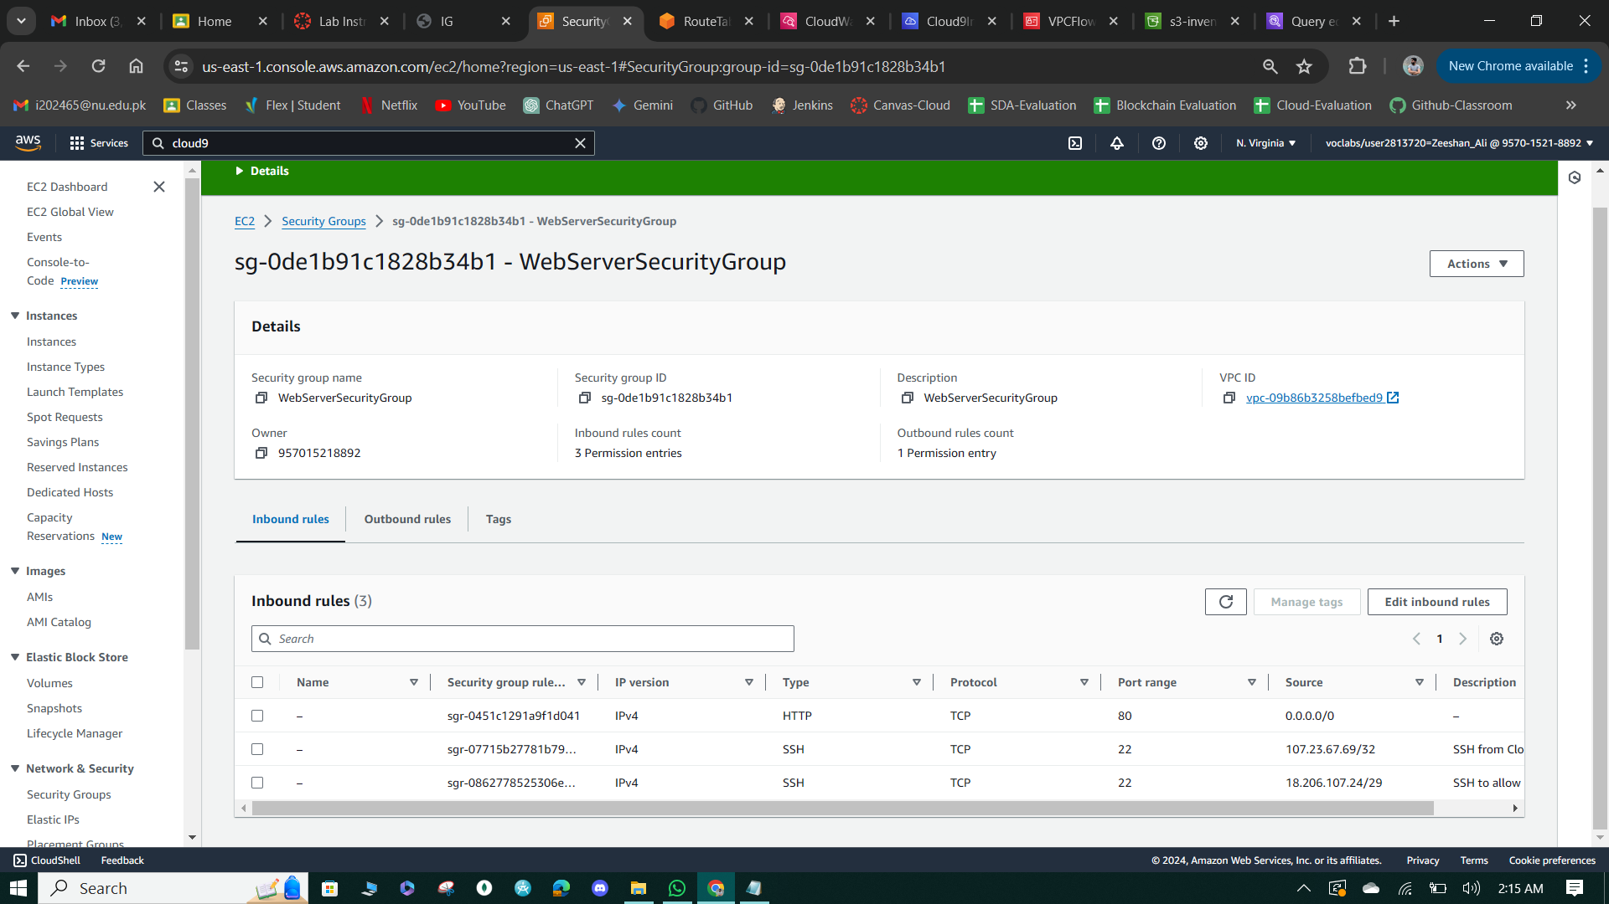

**Figure 37: Configuring the Inbound Traffic.**

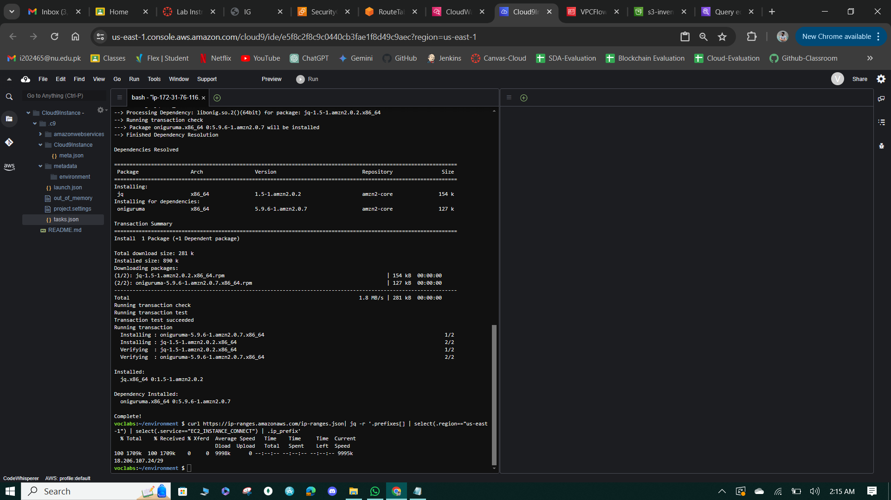

**Figure 38: Discover IP-range.**

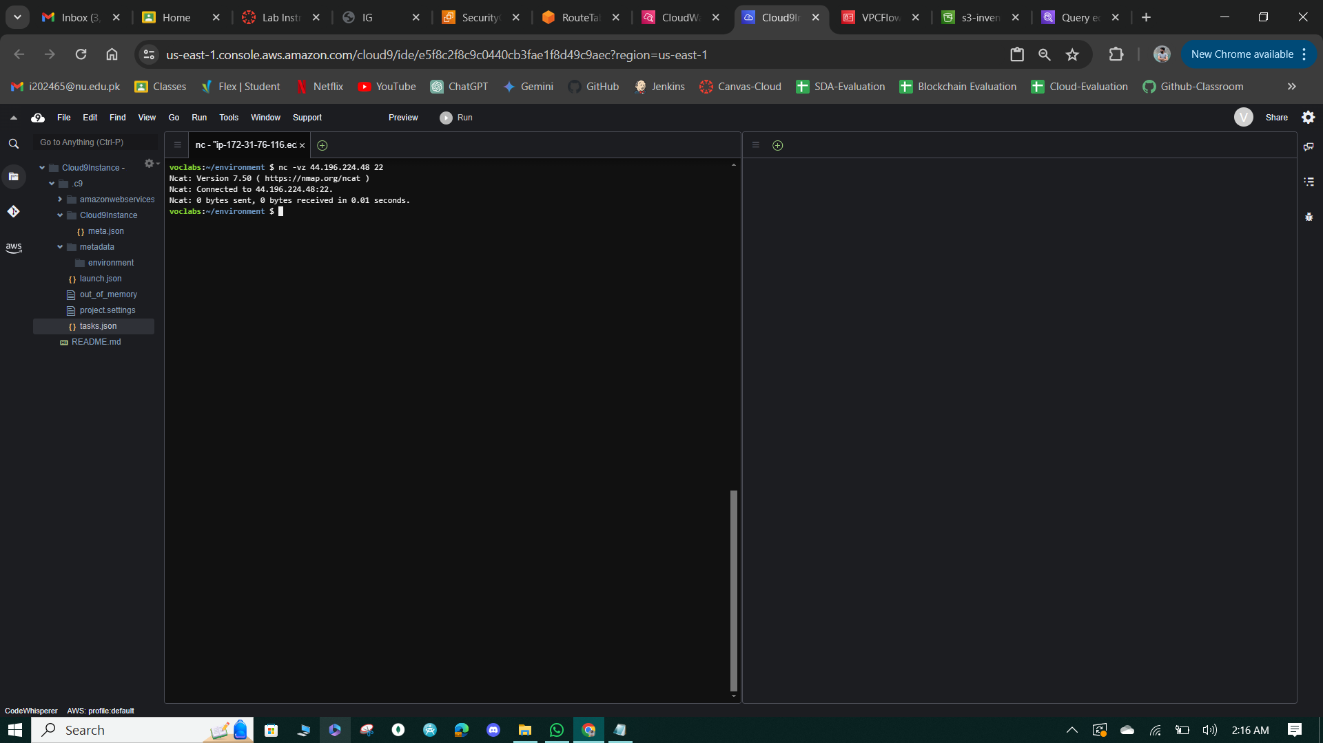

**Figure 39: Network Connected.**

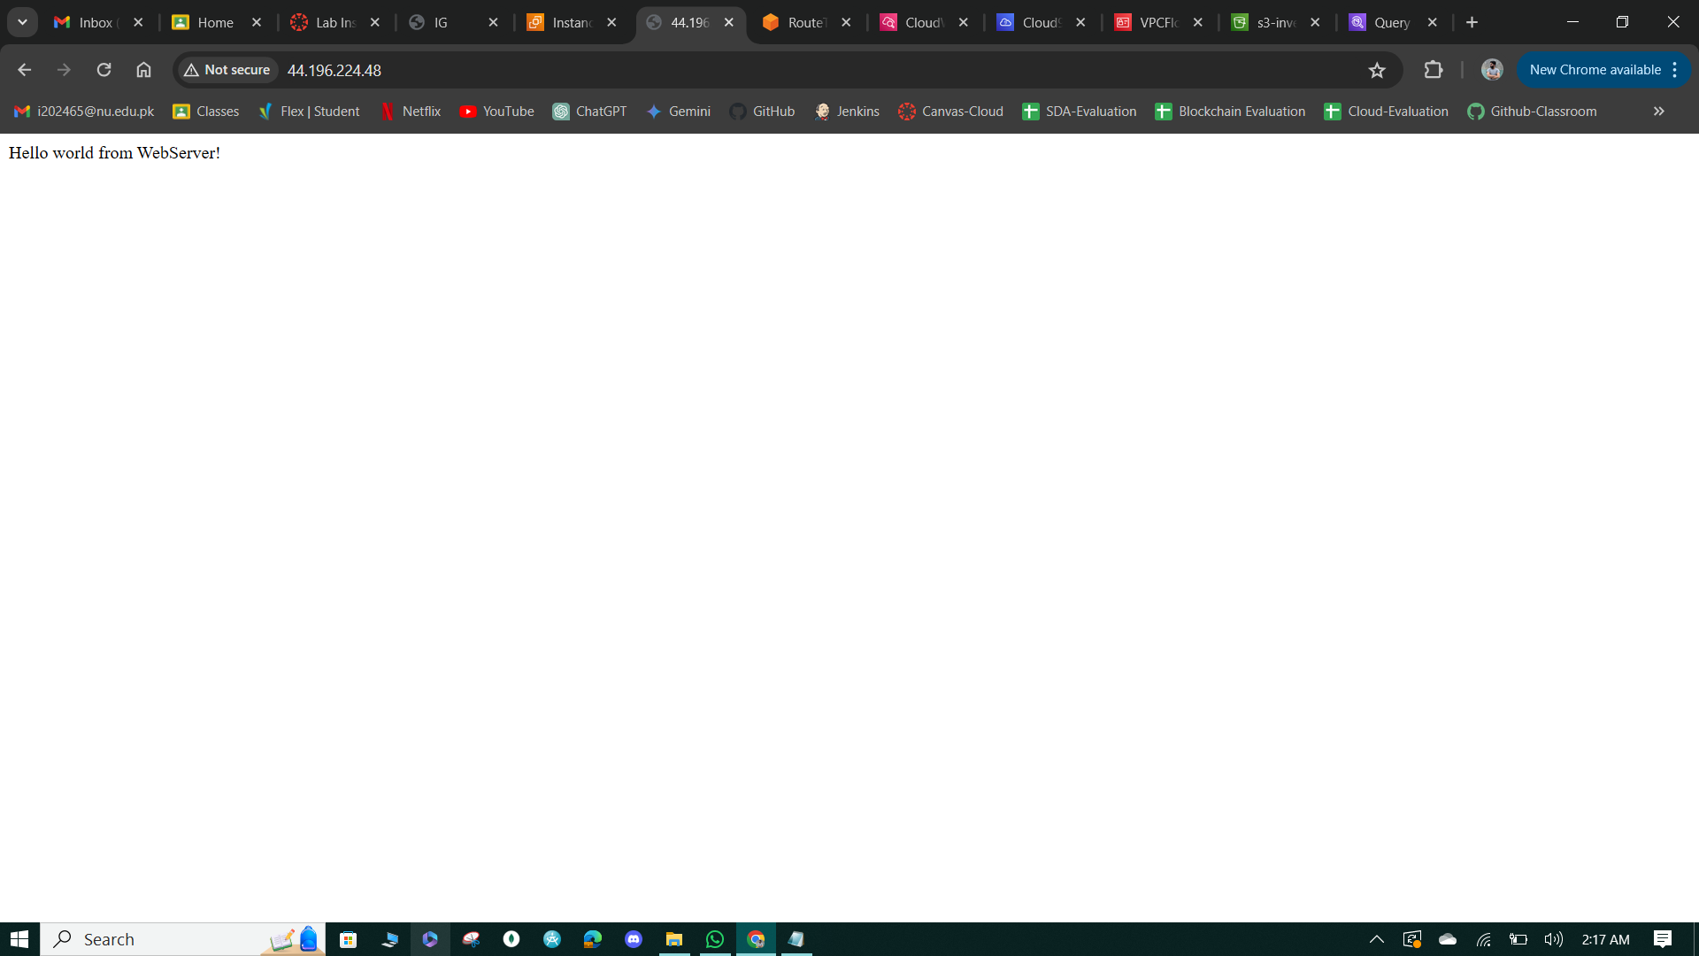

**Figure 40: Message from the WebServer.**

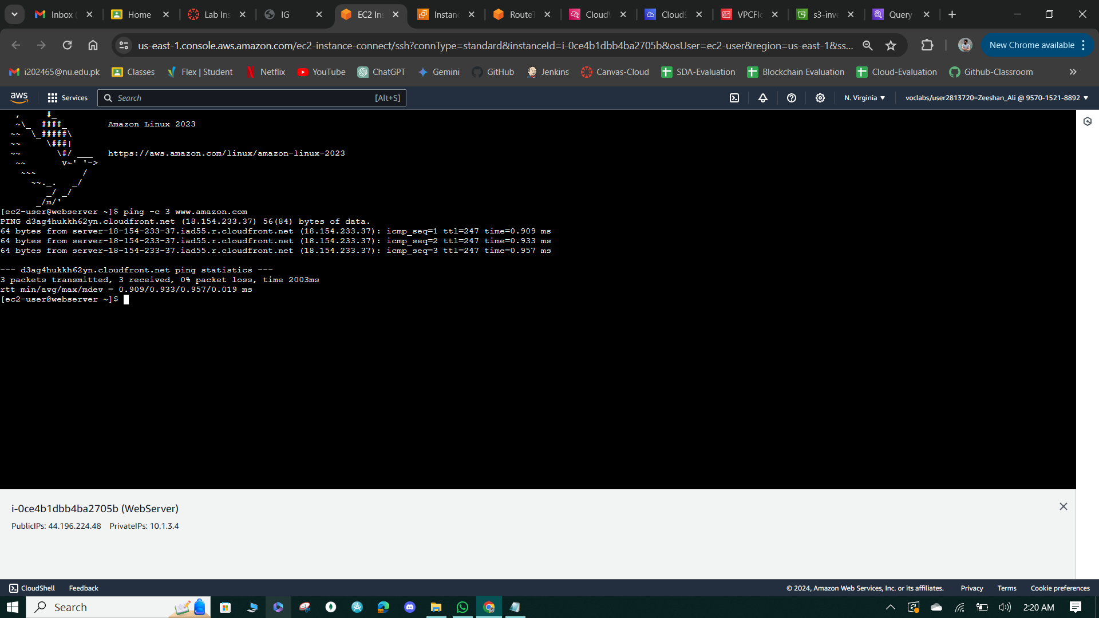

**Figure 41: 3 response Messages.**

**Task 5: Secure the WebServerSubnet with a network ACL**

Modified the existing rule number 100 in the Network Access Control List (NACL) associated with the WebServerSubnet from "Allow" to "Deny", effectively blocking inbound network traffic, including SSH access on port 22. Tested access to port 22 access was no longer allowed, demonstrating the impact of NACL rules on network traffic even when security group inbound rules allow access. Additionally, attempted to access the website which also failed due to the modified NACL rule.

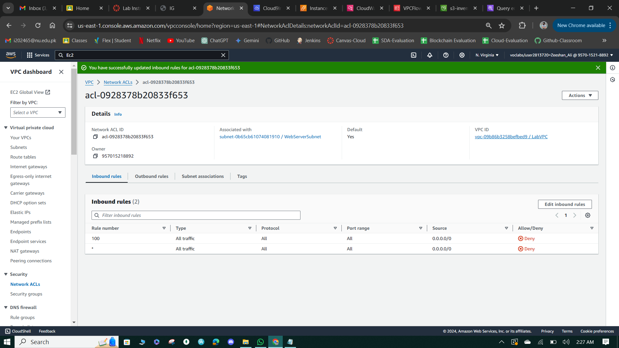

**Figure 42: Deny all traffic.**

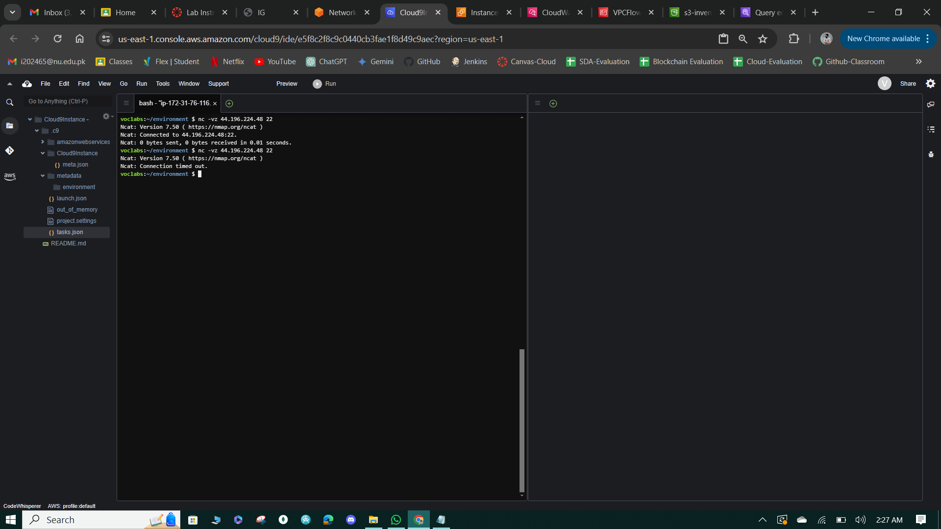

**Figure 43: Connection Timeout result.**

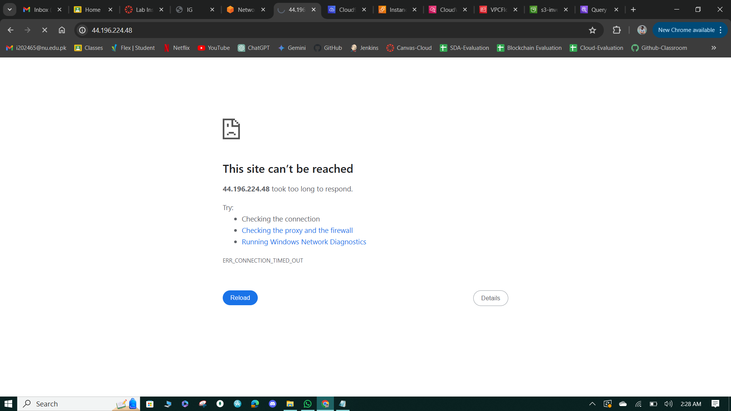

**Figure 44: Connection access denied.**

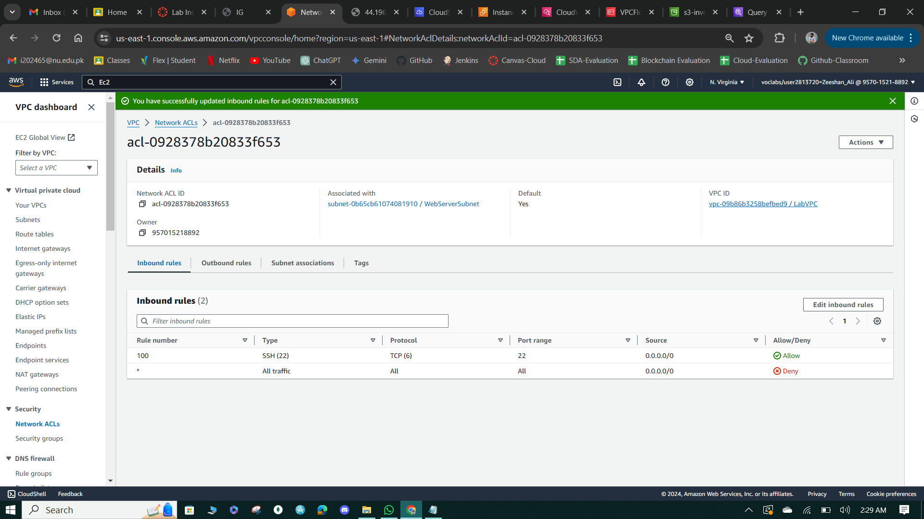

**Figure 45: Allow the one rule in inbound traffic.**

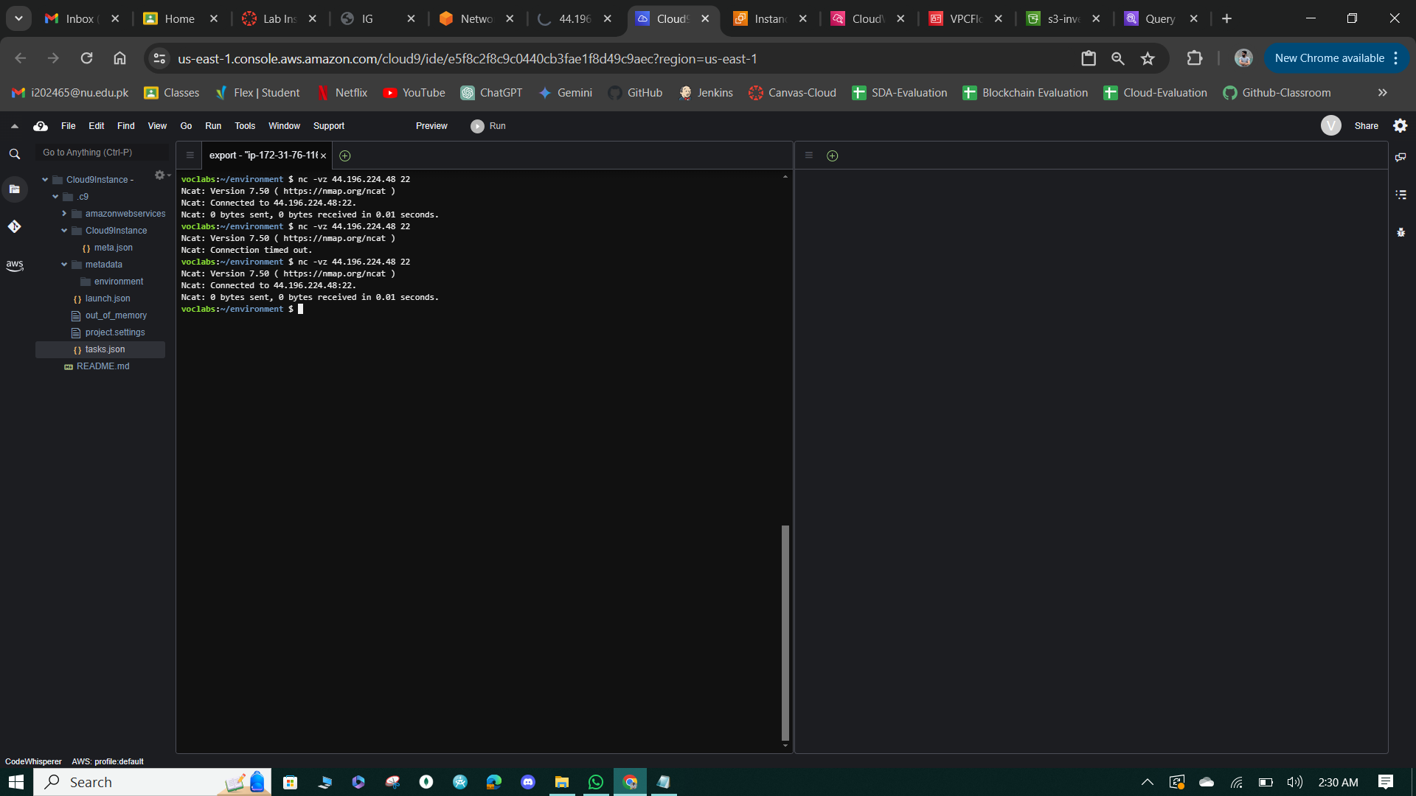

**Figure 46: Connected to the Network**

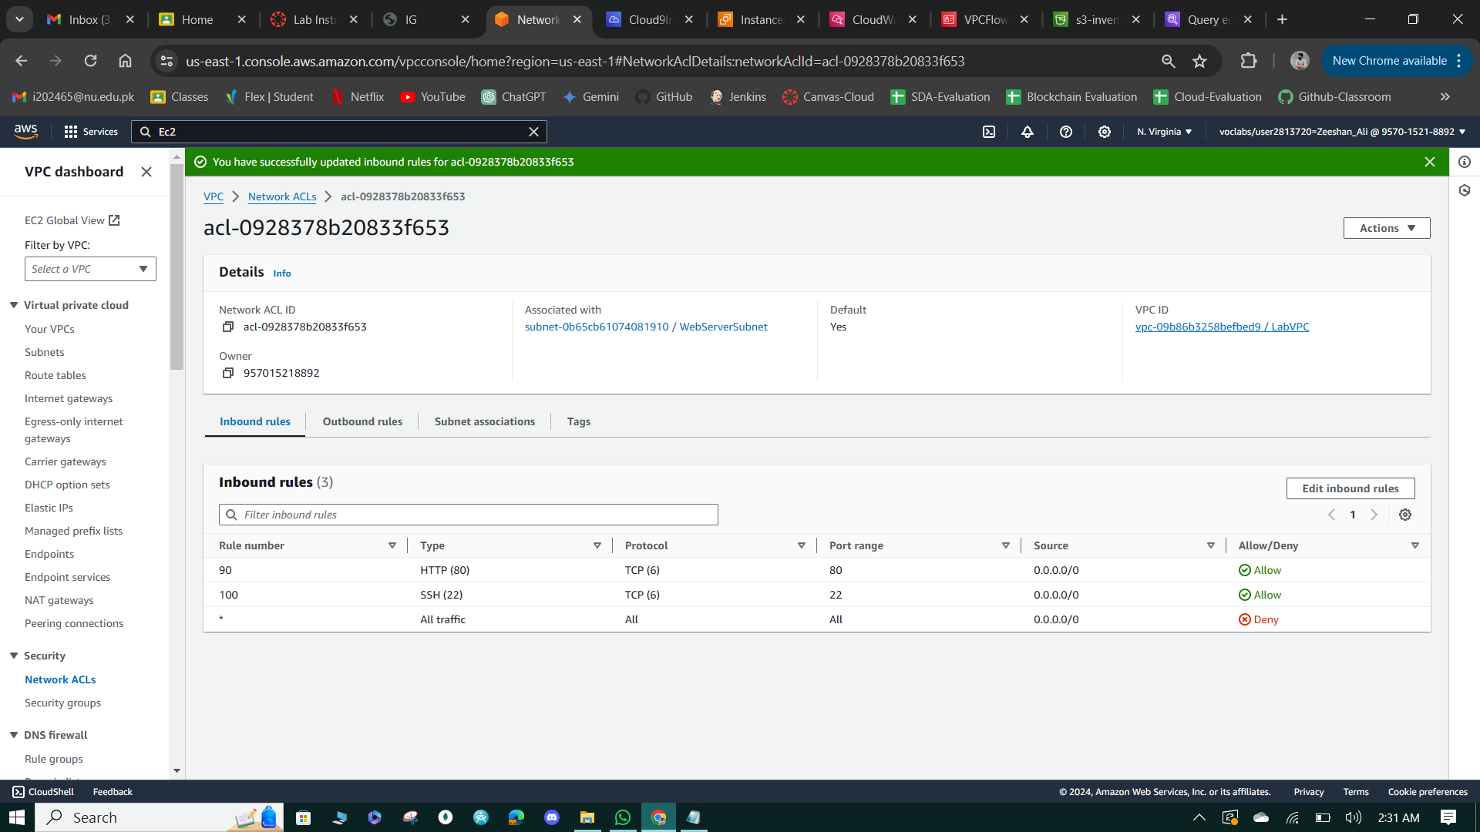

**Figure 47: Allow more traffic from different port.**

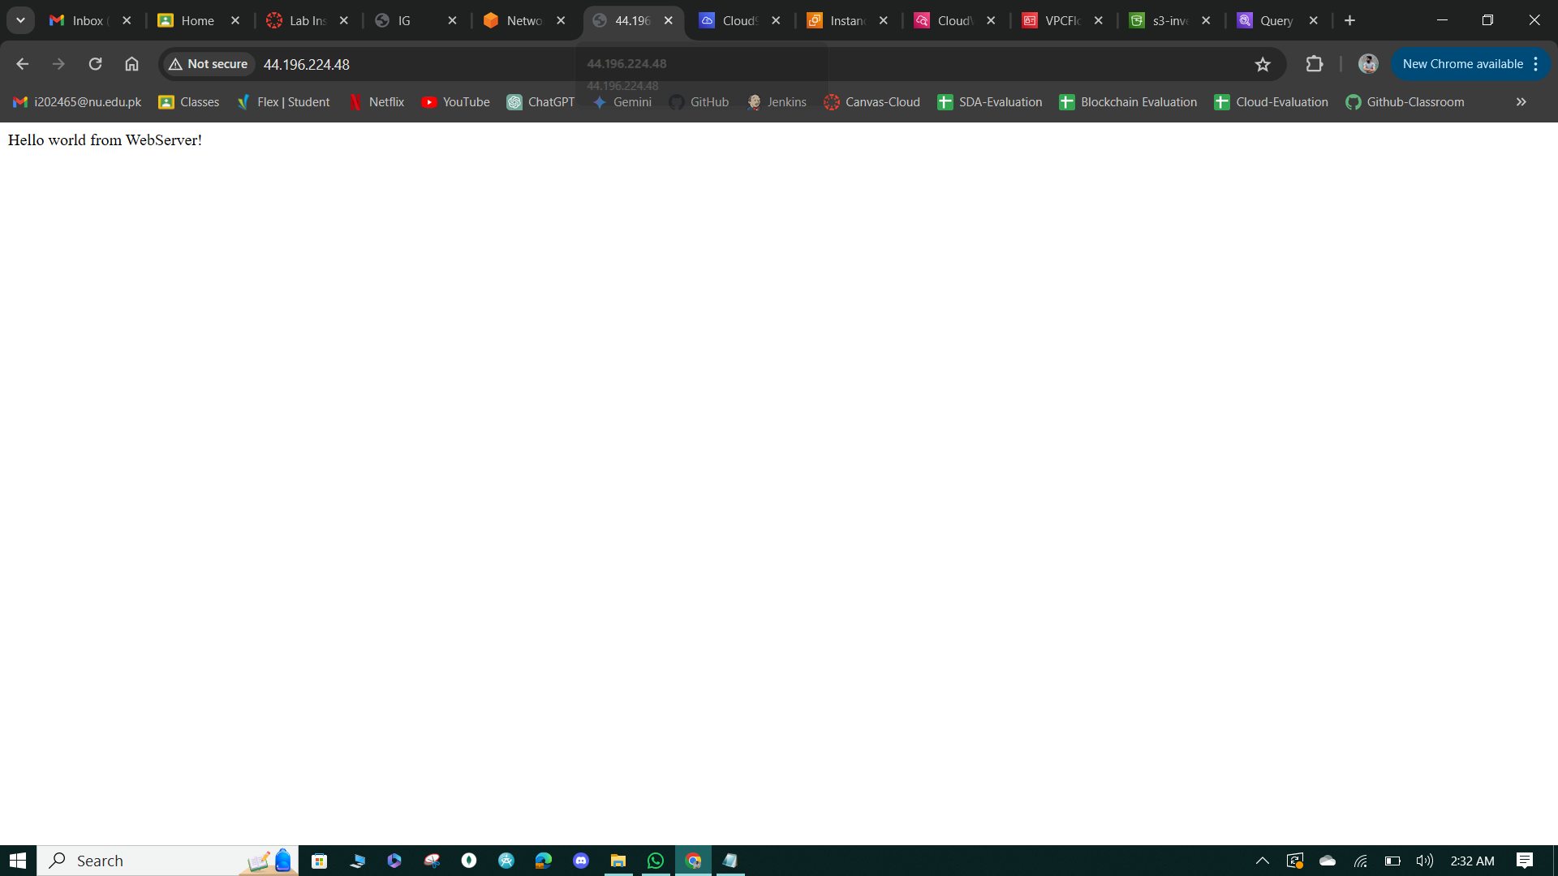

**Figure 48: Message from WebServer.**

**Task 6: Review NetworkFirewallVPC and associated resources**

* Reviewed the resources and configurations of the NetworkFirewallVPC, noting the presence of a WebServer2Subnet and a FirewallSubnet, along with an Internet Gateway and a default route table already configured to route traffic between the WebServer2Subnet and the internet.
* Verified the accessibility of ports 80 (HTTP) and 22 (SSH) on the WebServer2 instance before implementing the Network Firewall, confirming successful access to the webpage at http://<WebServer2-public-ip> and testing SSH port access using the netcat utility from the Cloud9 IDE.
* Started an additional website running on port 8080 of the WebServer2 instance and confirmed access by loading the webpage at http://<WebServer2-public-ip>:8080, displaying the "Hello world from WebServer2 port 8080!" message.

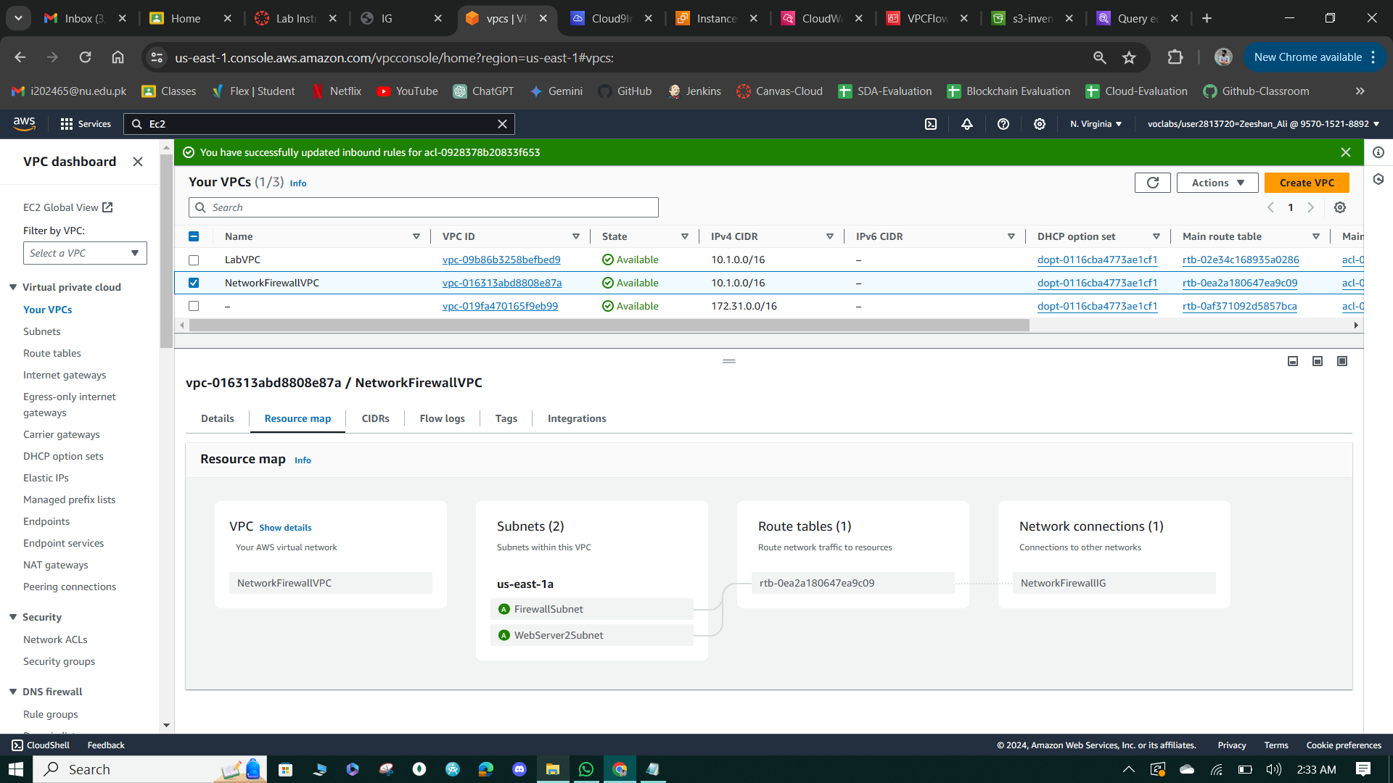

**Figure 49: Resource Map**

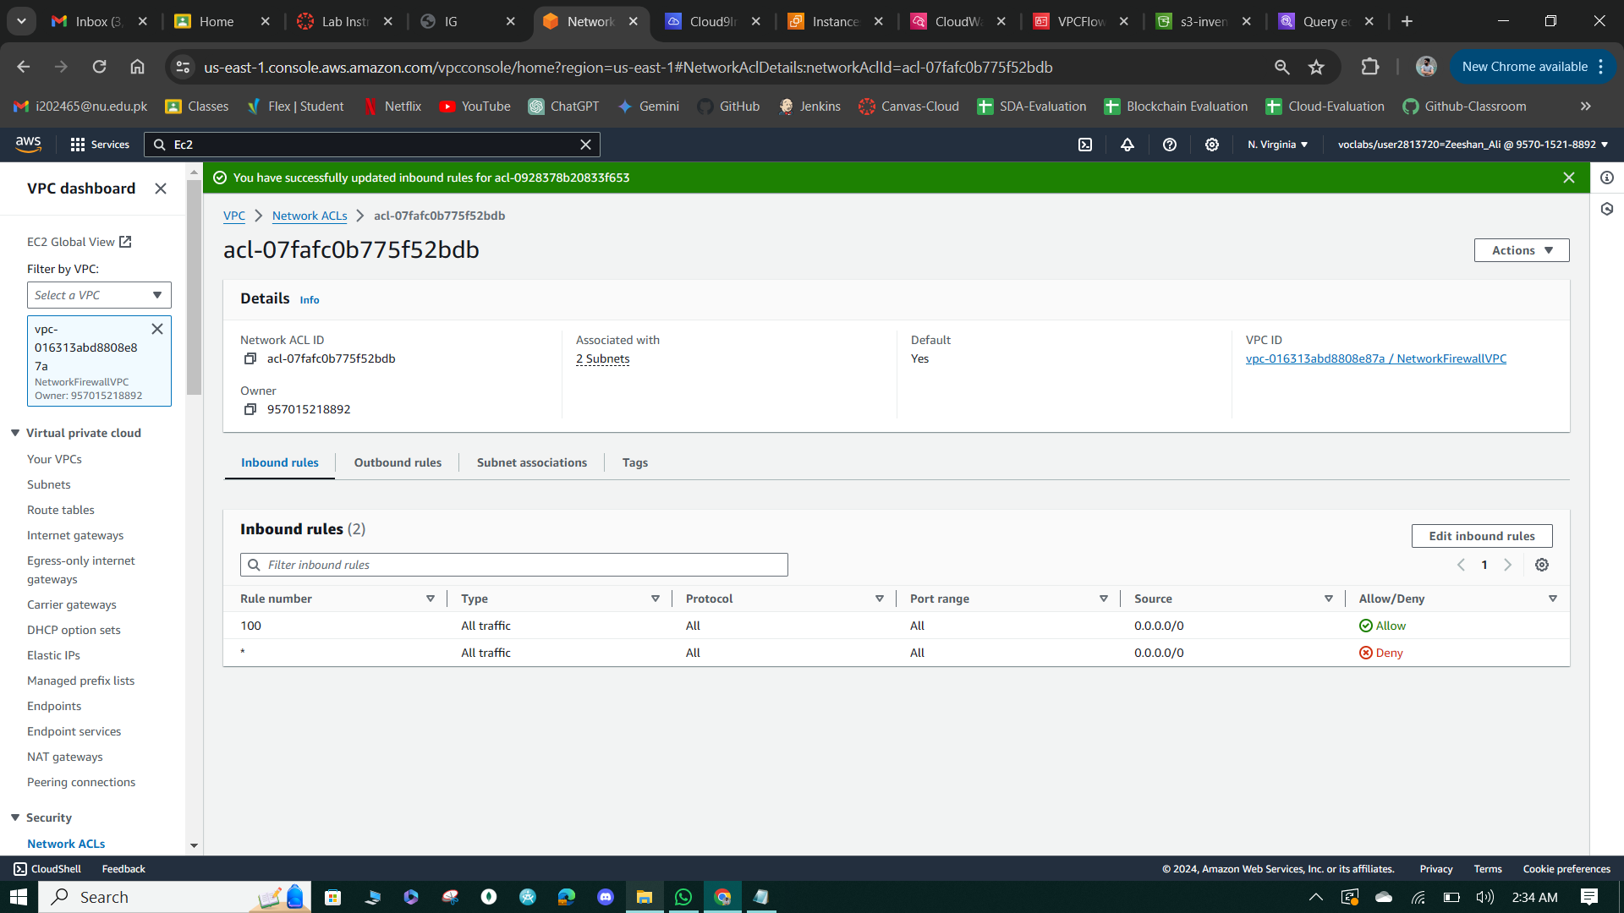

**Figure 50: ACL Inbound Rule.**

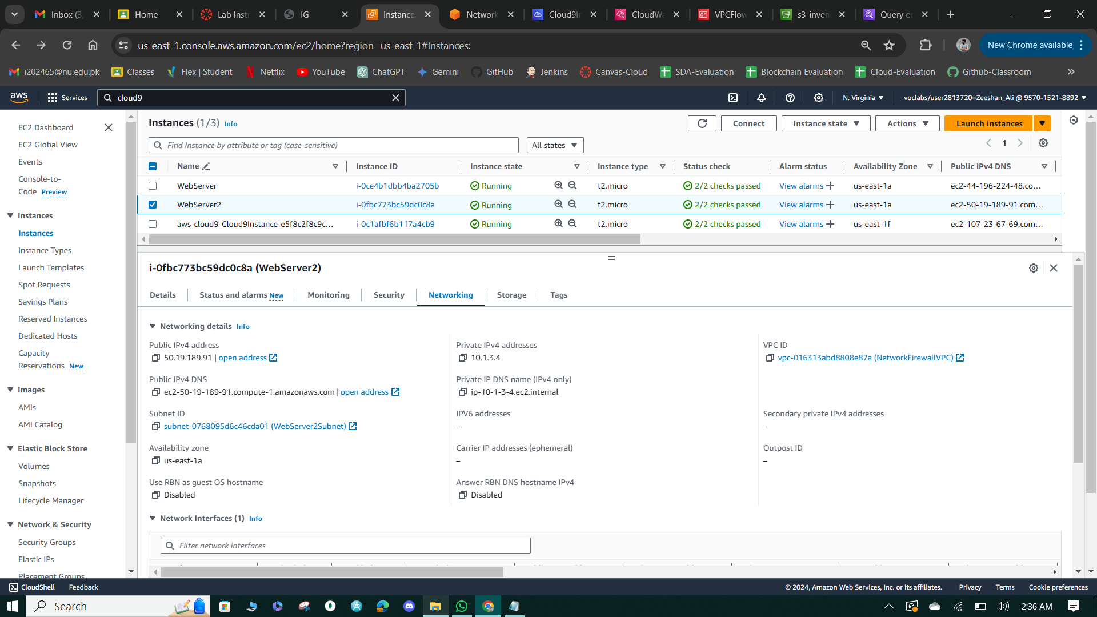

**Figure 51: Webserver Networking**

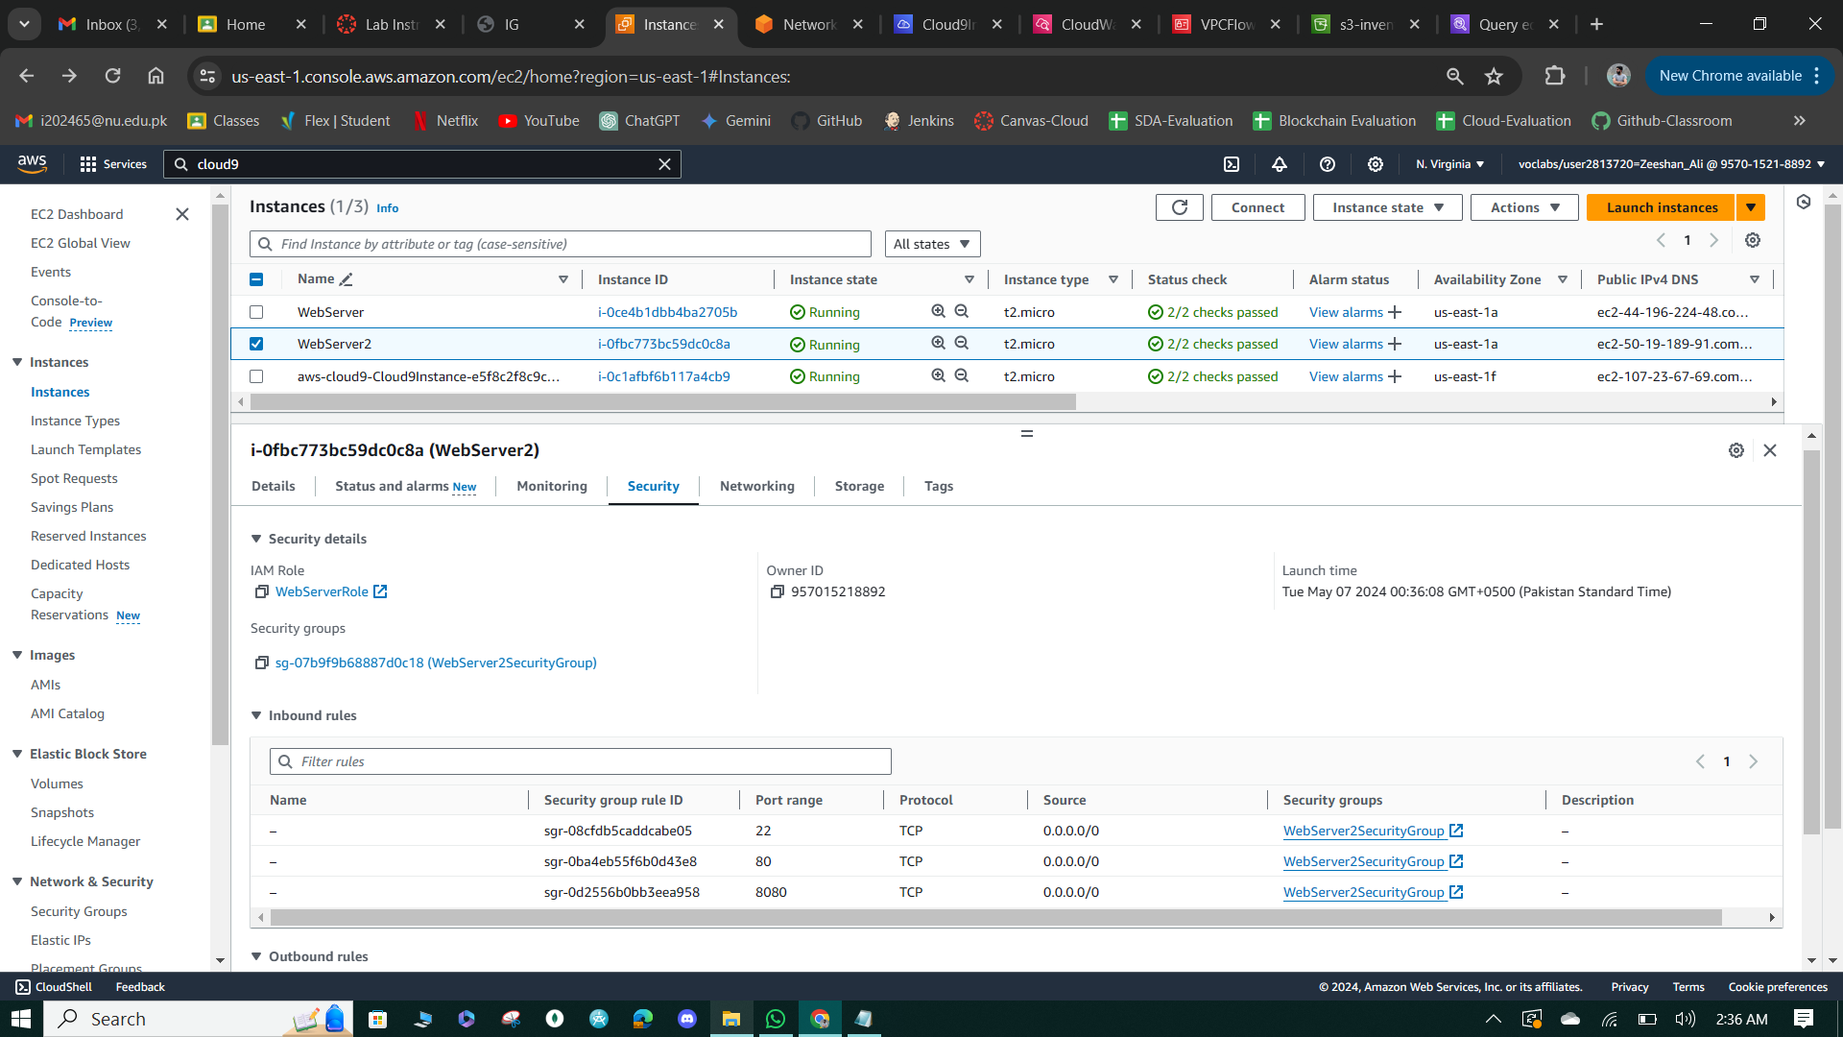

**Figure 52: Webserver Security**

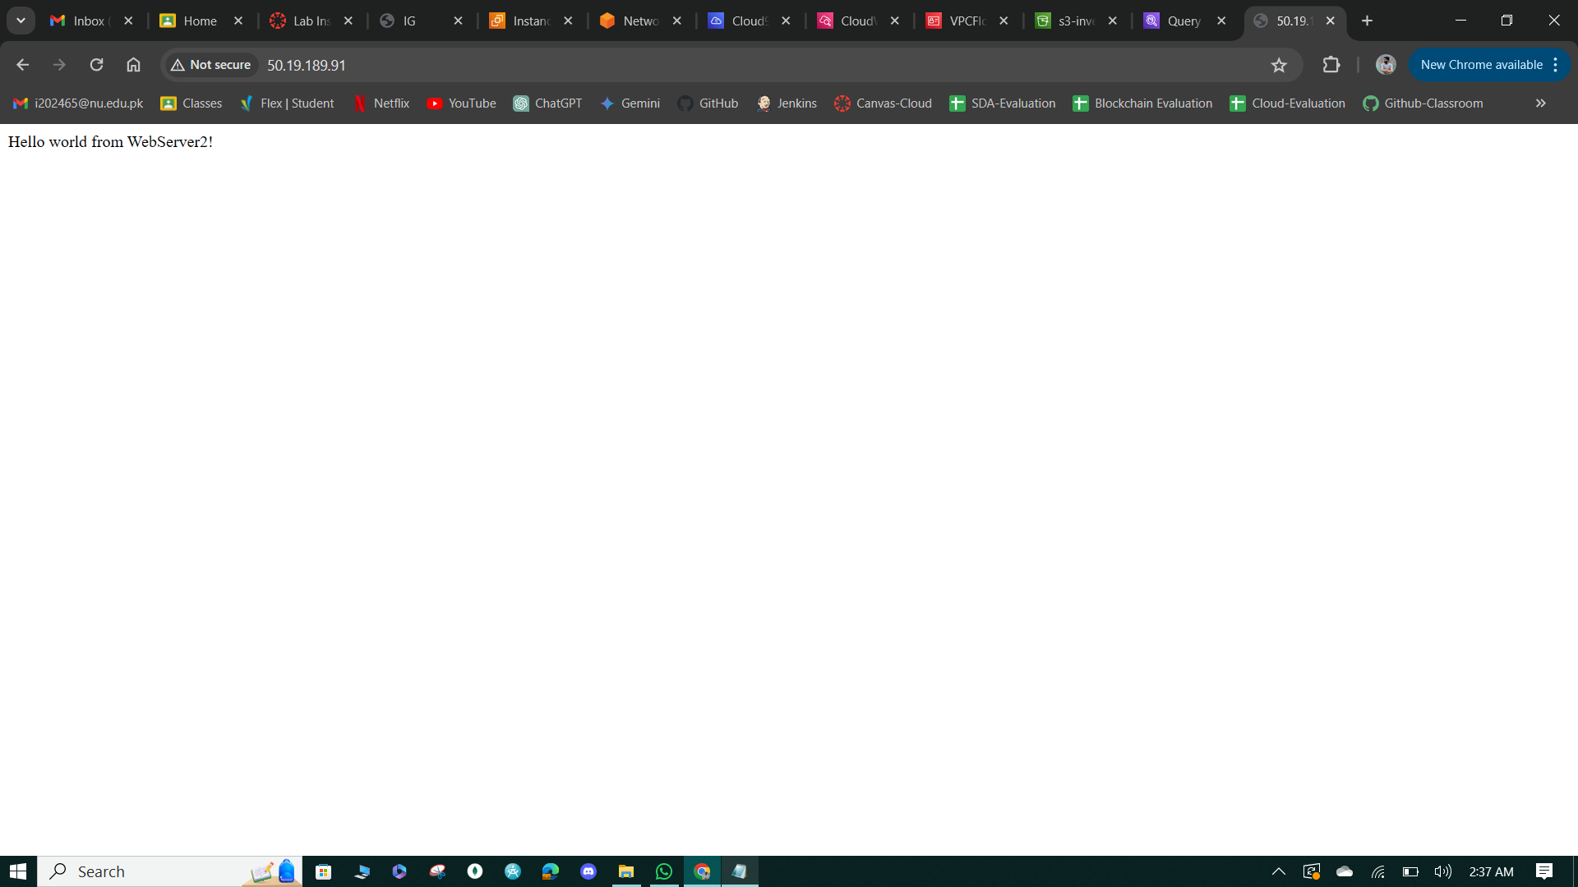

**Figure 53: Message from webserver.**

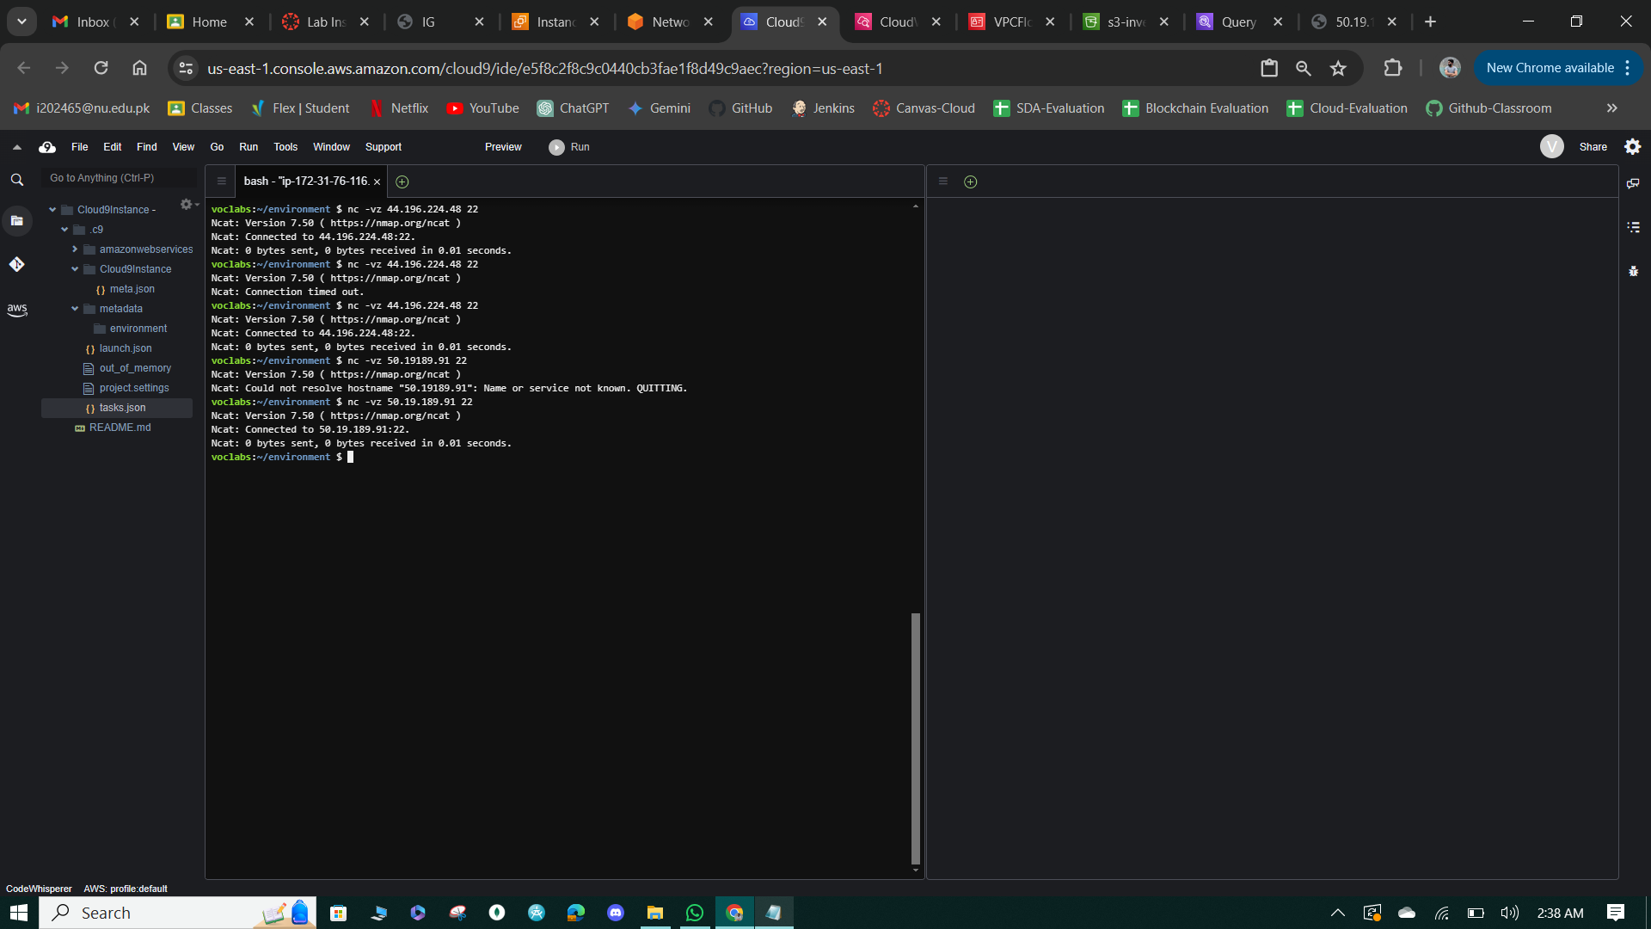

**Figure 54: Connection Status**

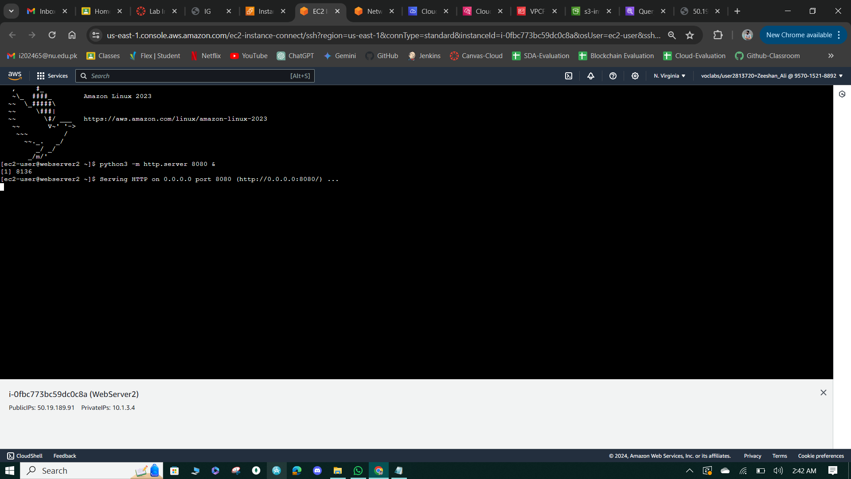

**Figure 55: Running the web server on port 8080.**

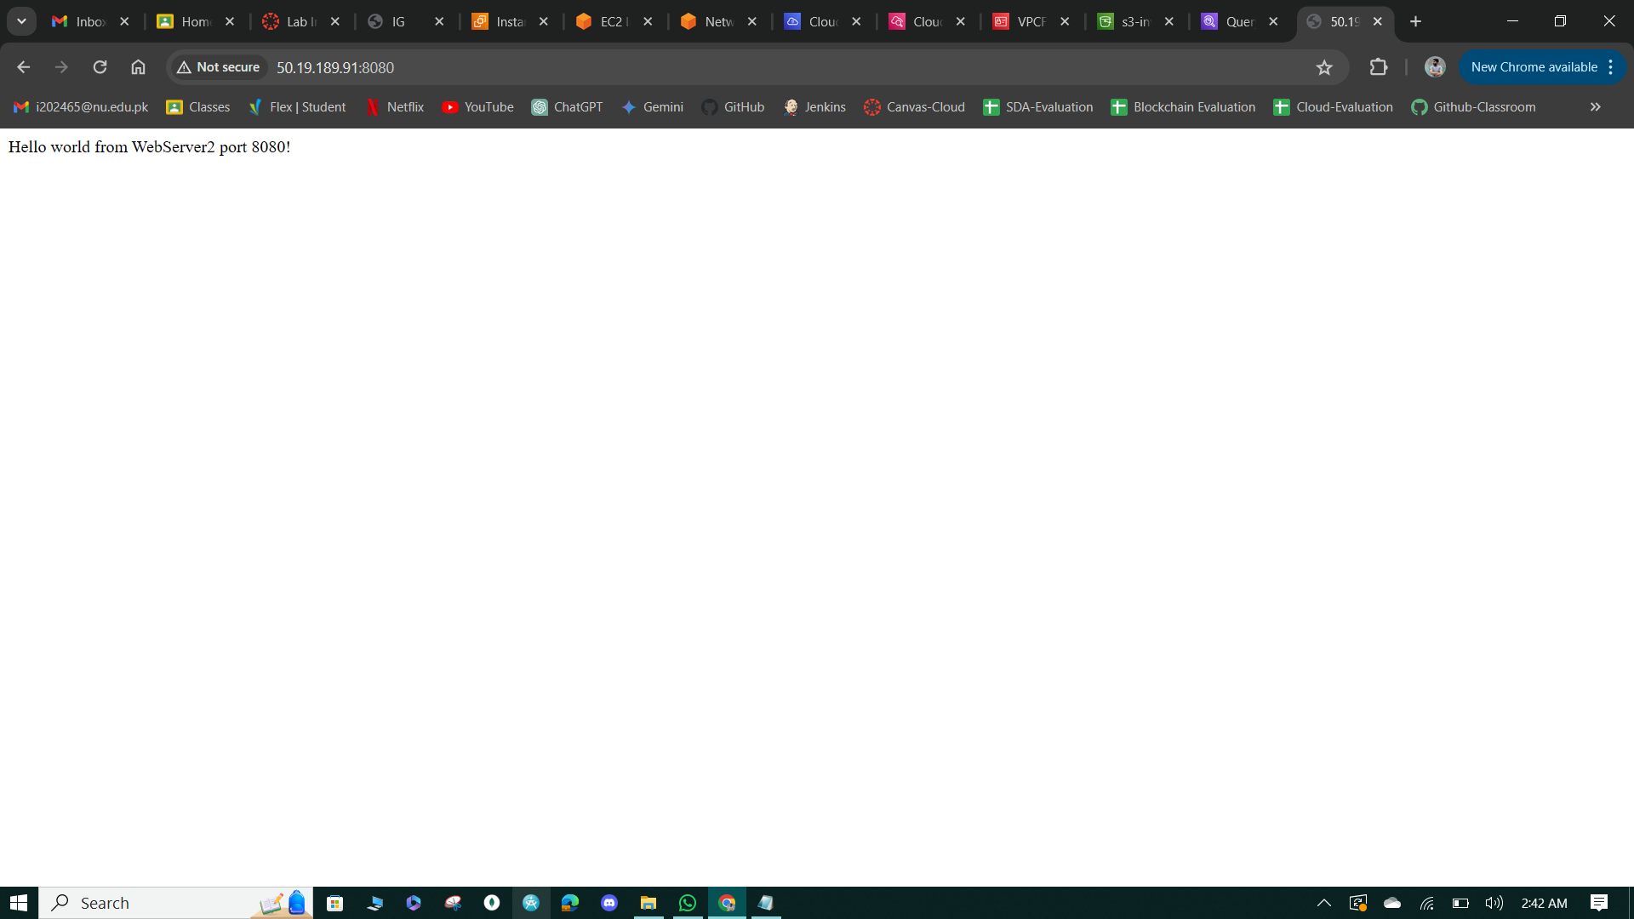

**Figure 56: Message Response from port 8080.**

**Task 7: Create a network firewall in a new VPC**

* Created a firewall named "NetworkFirewall" in the VPC console and associated it with the NetworkFirewallVPC, deploying it in the us-east-1a availability zone for the FirewallSubnet with an IP address type of IPv4.
* Named the new firewall policy "FirewallPolicy" and ensured that the Firewall status reached the "ready" state before proceeding, which typically takes approximately 3 minutes.

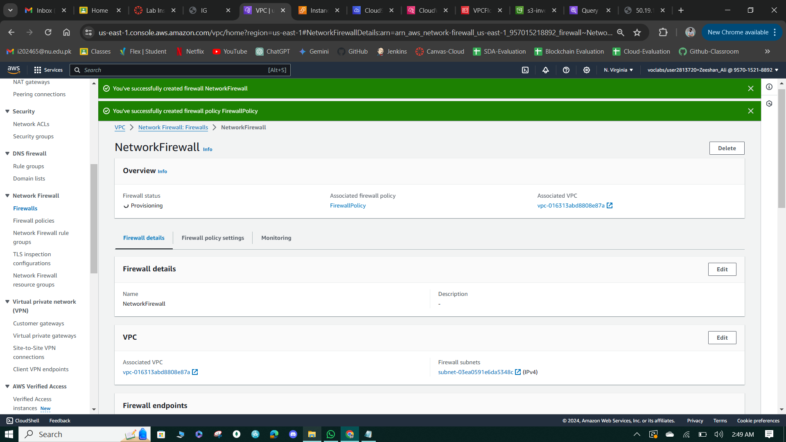

**Figure 57: Network Firewall Creation.**

**Task 8: Create route tables**

* Created a route table named "IGW-Ingress-Route-Table" in the NetworkFirewallVPC, adding a route that directs traffic destined for the CIDR block of the WebServer2 instance subnet to the Gateway Load Balancer Endpoint.
* Established an edge association to the IGW-Ingress-Route-Table, associating the NetworkFirewallIG internet gateway with the route table to handle ingress traffic from the internet.

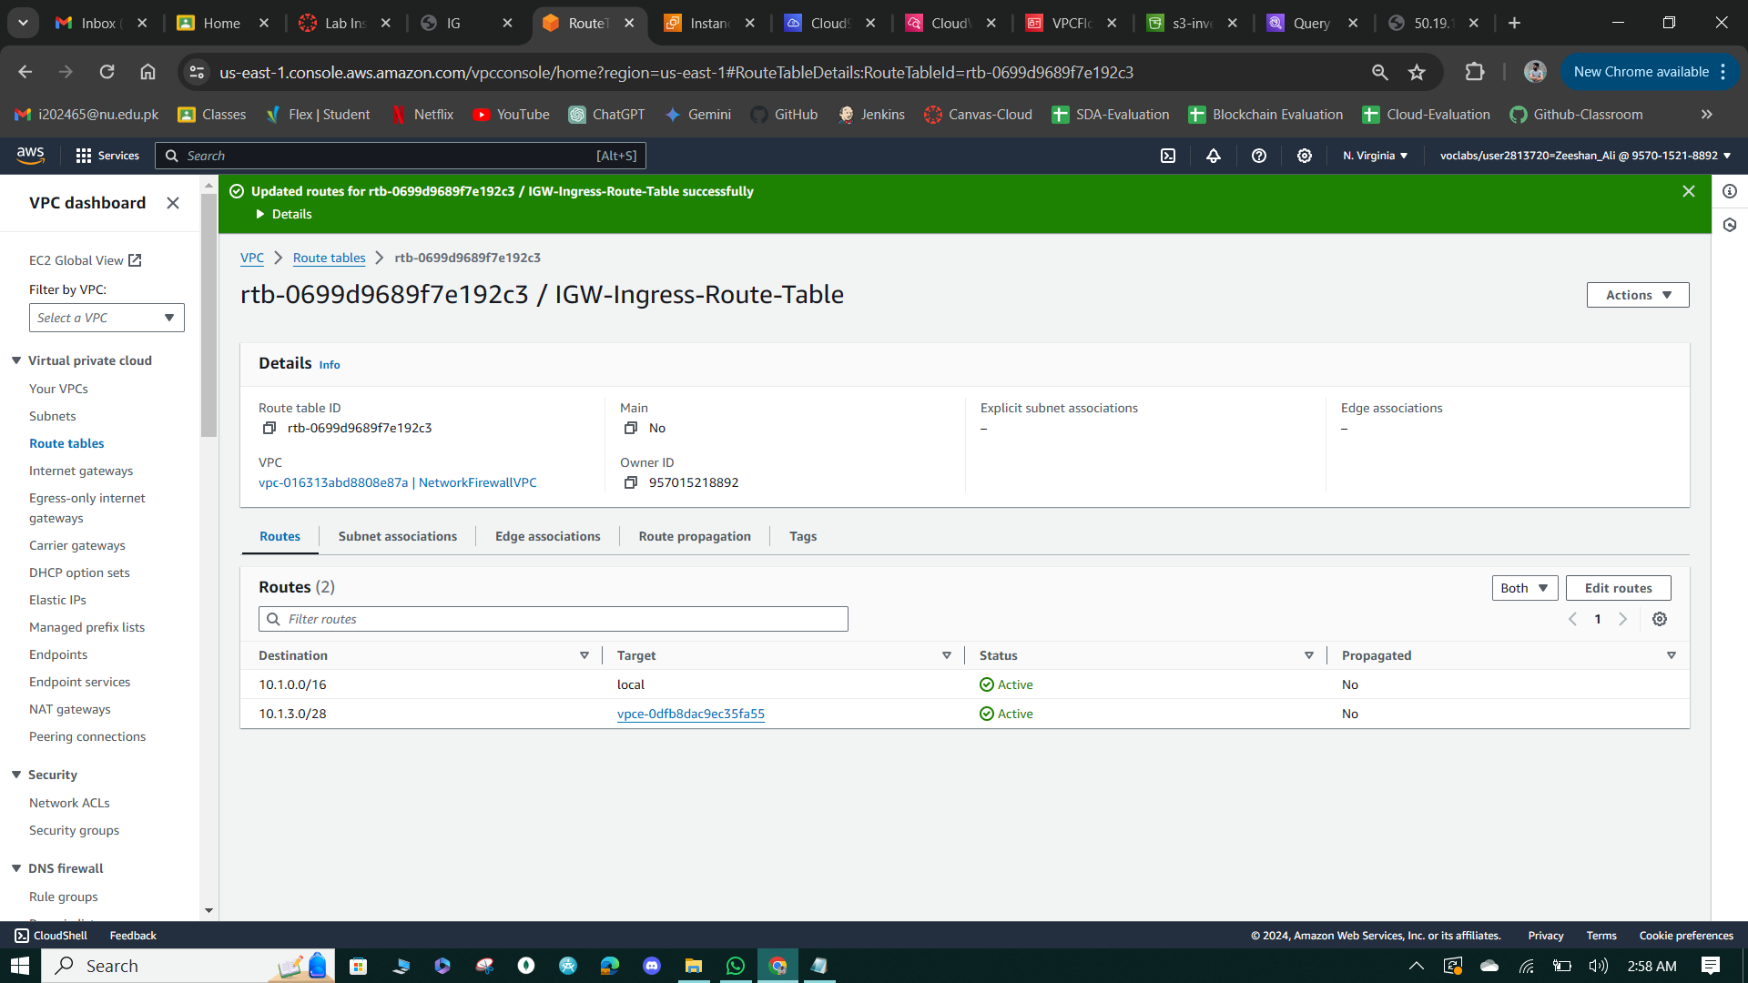

**Figure 58: Route Table Creation & Add Internet Gateway.**

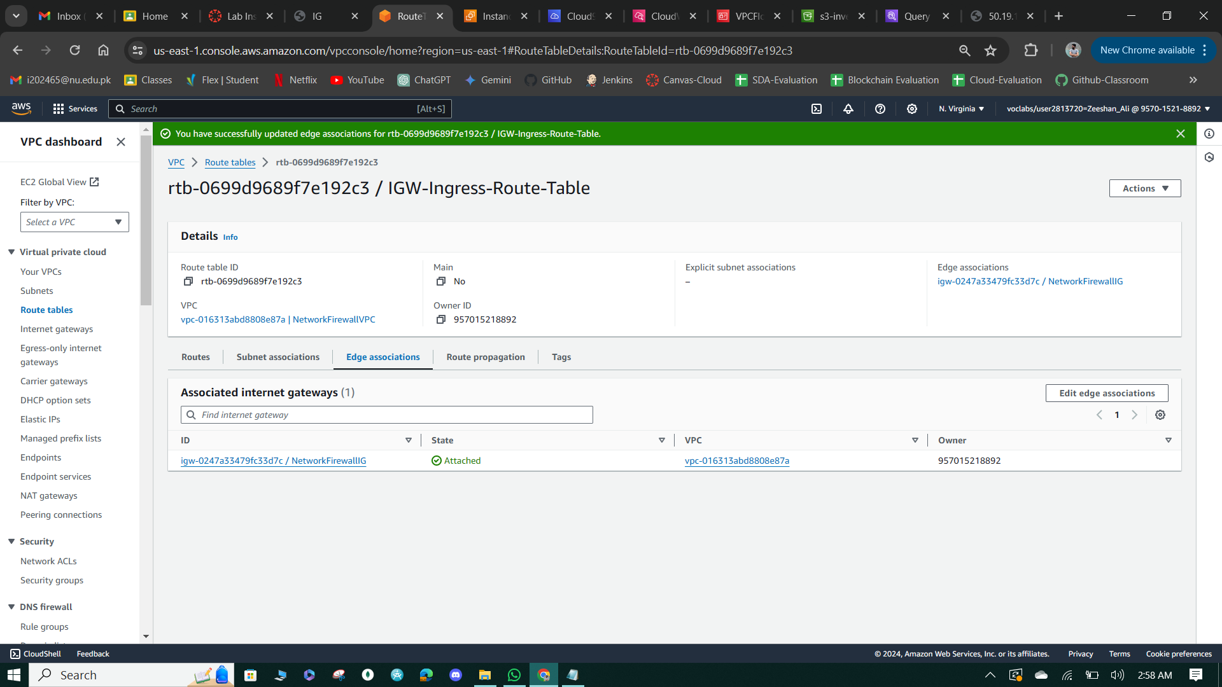

**Figure 59: Add an edge Associations.**

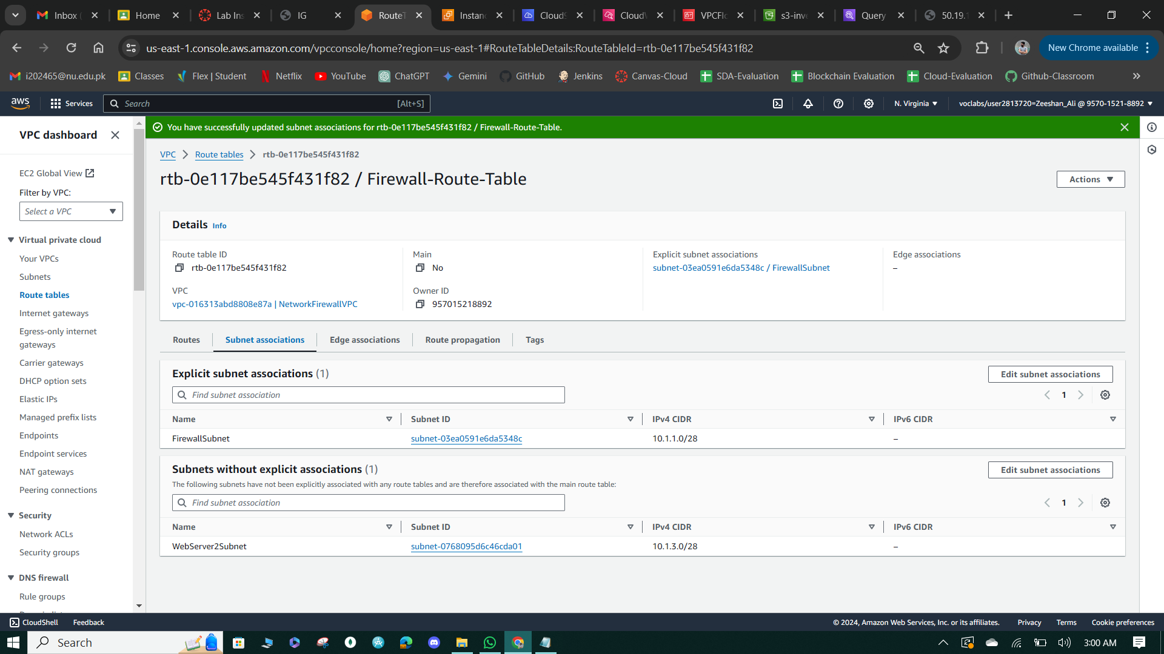

**Figure 60: Firewall table & edge associations.**

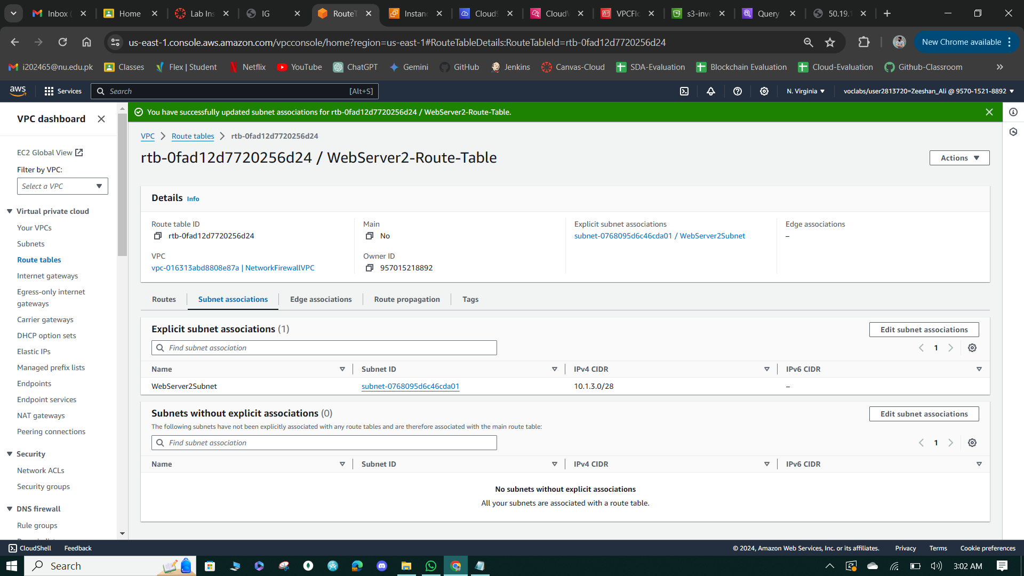

**Figure 61: Webserver table & Associations.**

**Task 9: Configure logging for the network firewall**

* Created a CloudWatch log group named "NetworkFirewallVPCLogs" with a retention setting of 6 months to store network firewall logs for the NetworkFirewallVPC.
* Configured both Alert and Flow type logging in the settings of the NetworkFirewall, specifying the log destination to be the "NetworkFirewallVPCLogs" CloudWatch log group for both types of logging.
* Tested the logging configuration by attempting to load the WebServer2 instance's website on port 80, resulting in a timeout due to the network firewall policy not yet allowing HTTP traffic on port 80. Reviewed the log events in the CloudWatch console, filtering by the public IP address to find log entries related to the test, which typically appear within 3-6 minutes.

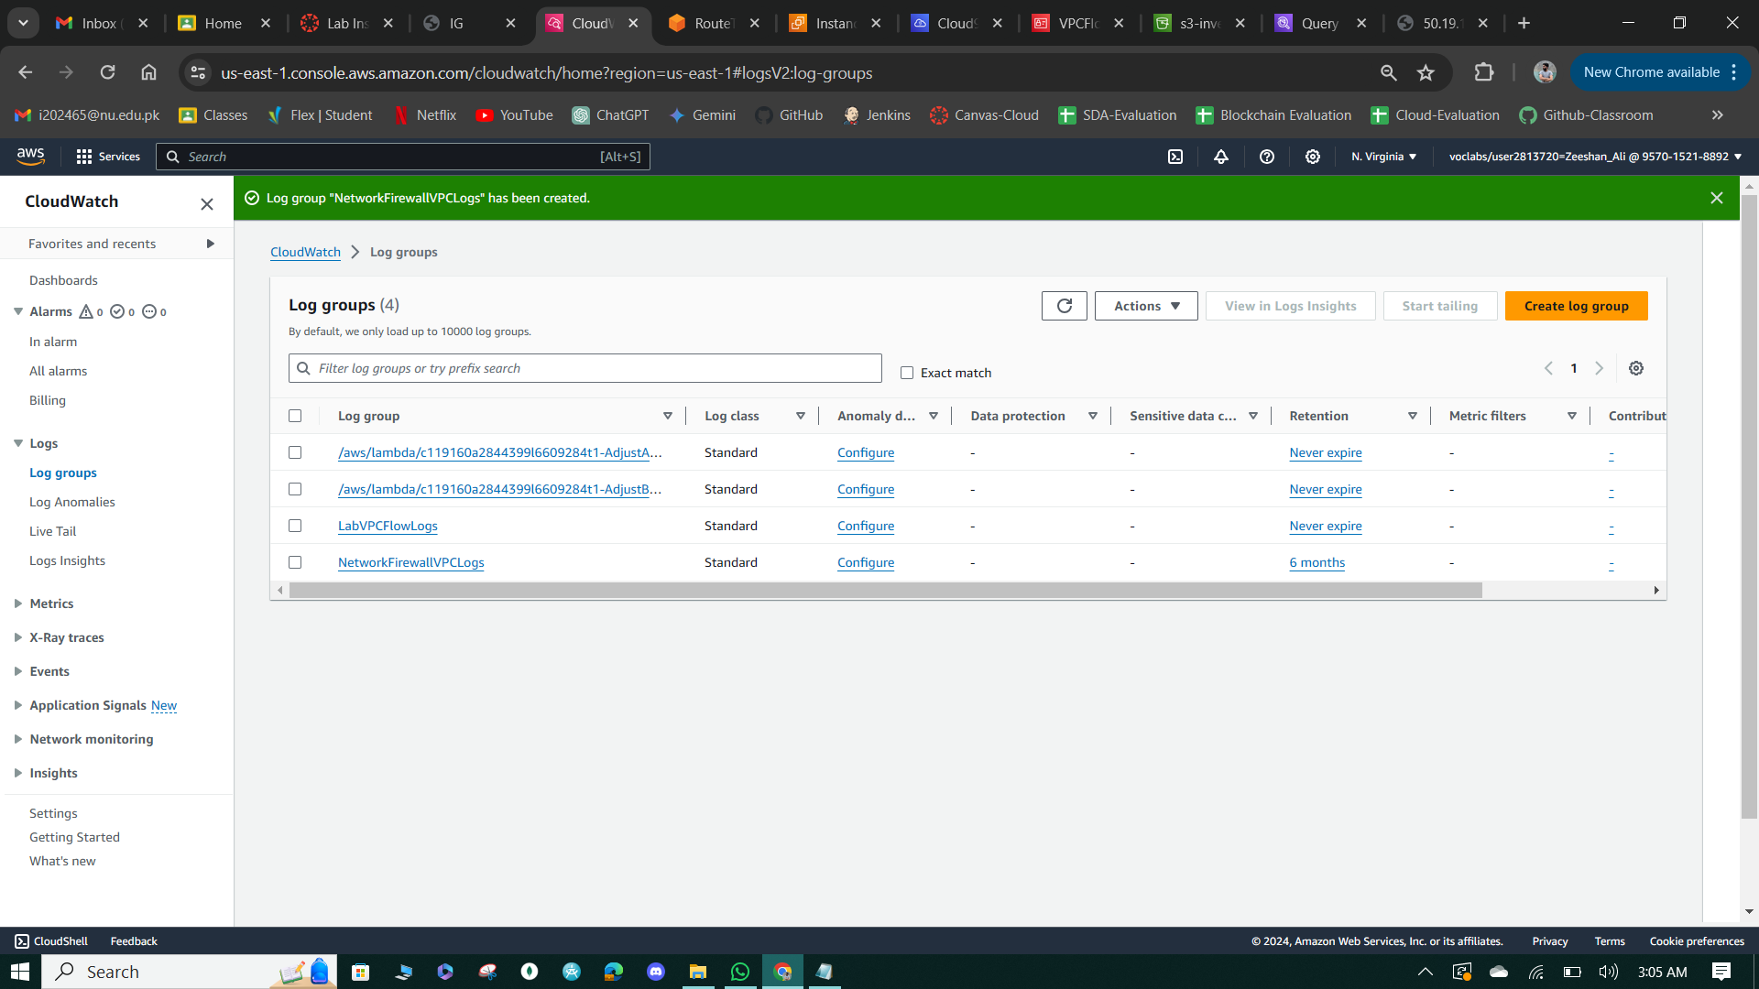

**Figure 62: Network Firewall Logs Creation.**

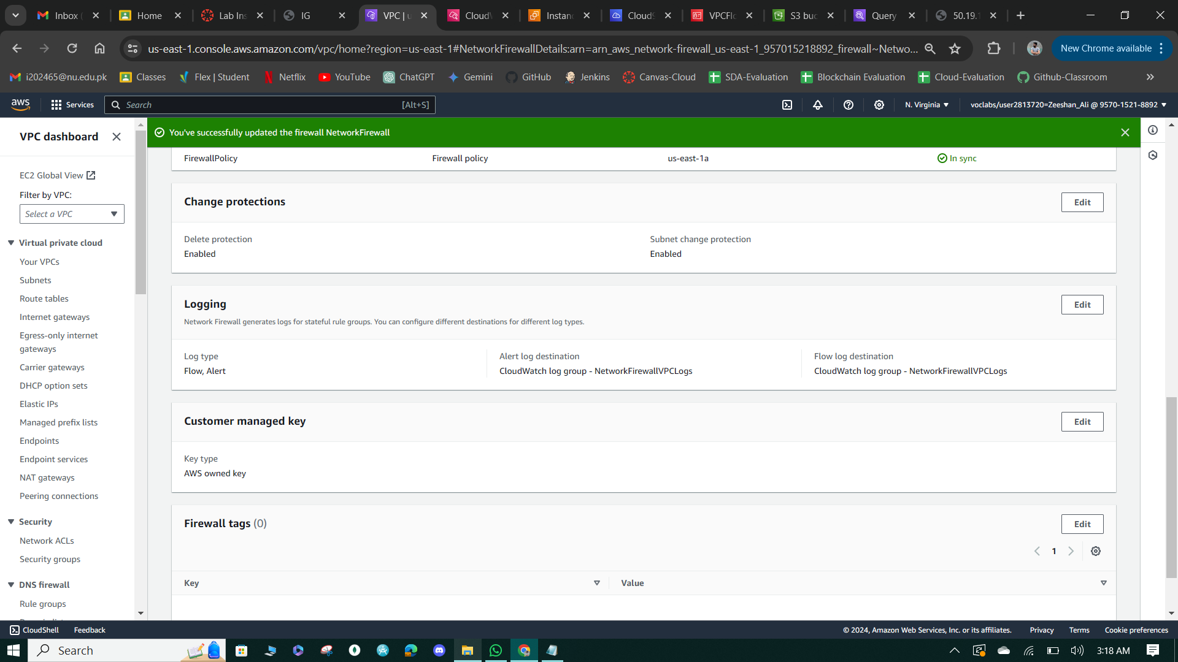

**Figure 63: Alert & Flow Firewall Details**

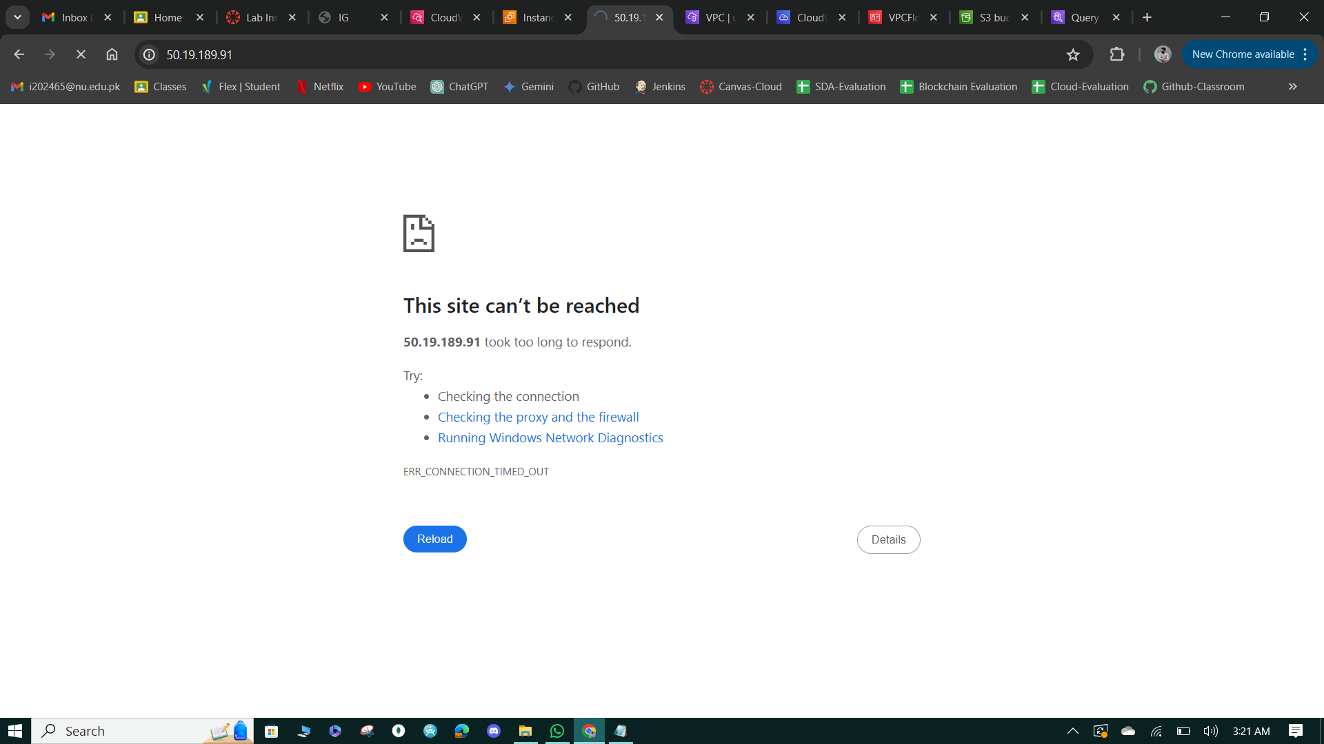

**Figure 64: Denied Access**

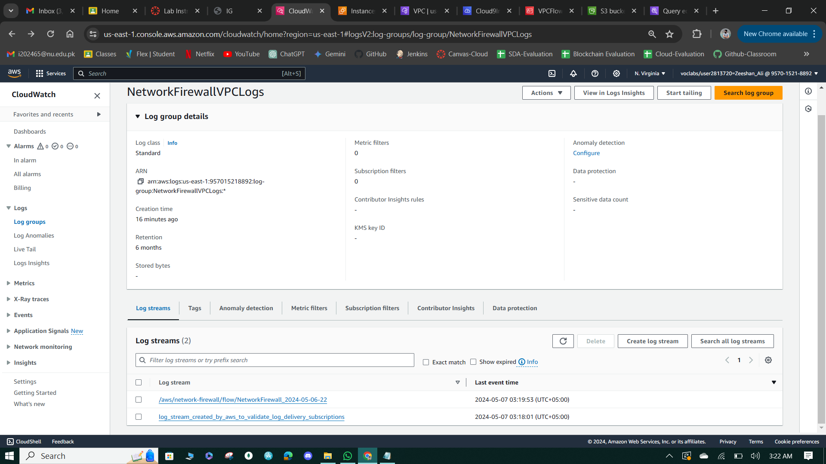

**Figure 65: Network Firewall VPC logs.**

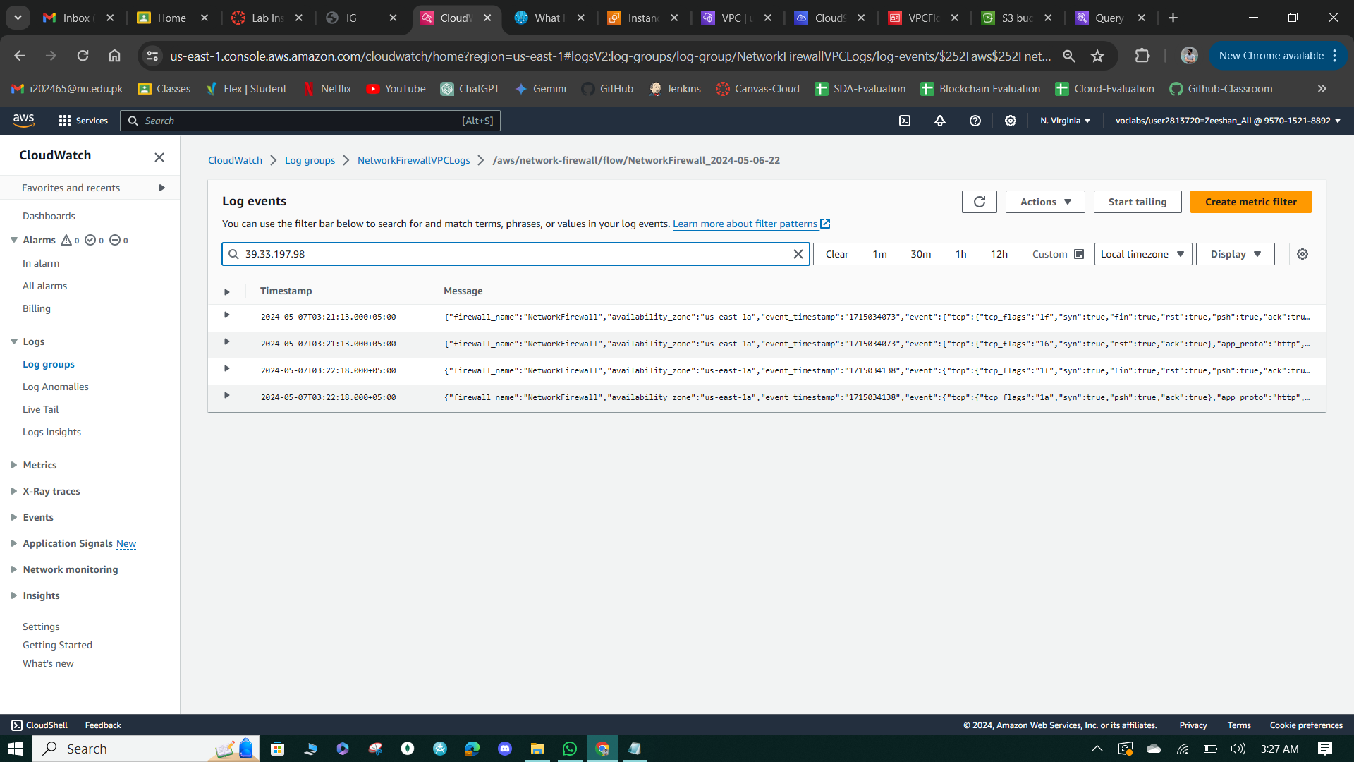

**Figure 66: search the system IP logs.**

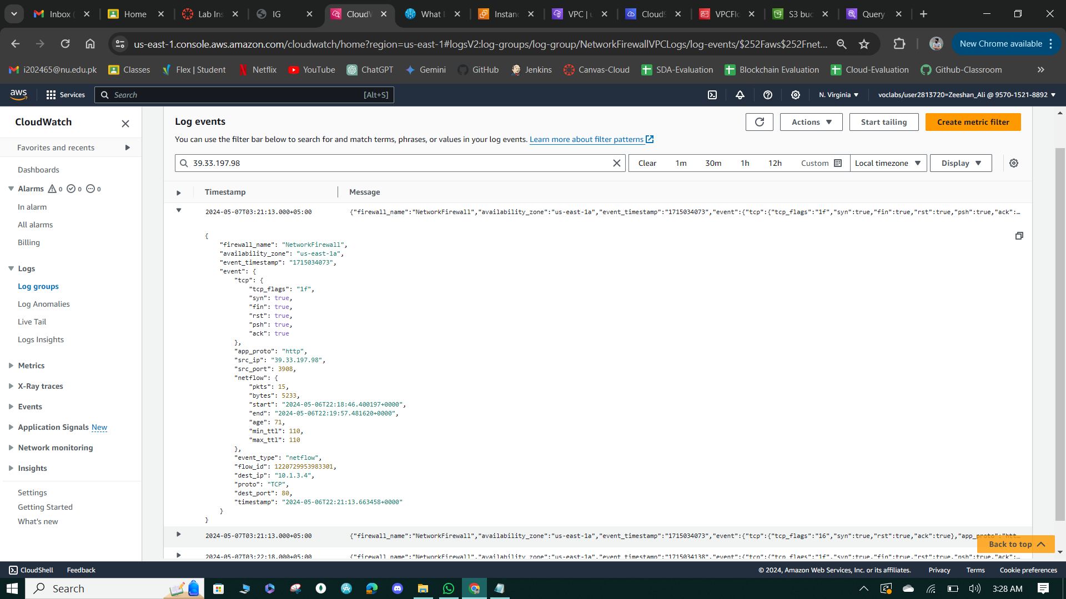

**Figure 67: Message Details**

**Task 10: Configure network firewall policy and test access**

* Created a stateful rule group named "NetworkFirewallVPCRuleGroup" with a capacity of 100 in the Network Firewall settings, configuring four rules to manage traffic to and from the internet and the NetworkFirewallVPC: dropping traffic on port 8080, allowing traffic on ports 80 and 22, and allowing ICMP traffic.
* Tested the firewall rules by attempting to load the WebServer2 website in a browser, testing SSH access using the netcat command from the Cloud9 terminal, and connecting to WebServer2 using EC2 InstanceConnect. Additionally, issued commands to ping www.amazon.com and check active listening ports on WebServer2 using netstat, verifying internet access and active services on specific ports.
* Verified the effect of the firewall rules by attempting to load http://<WebServer2-public-ip>:8080 in a browser, which failed due to the Deny rule authored in the network firewall policy. Reviewed network firewall log entries in CloudWatch to observe the results of the tests.

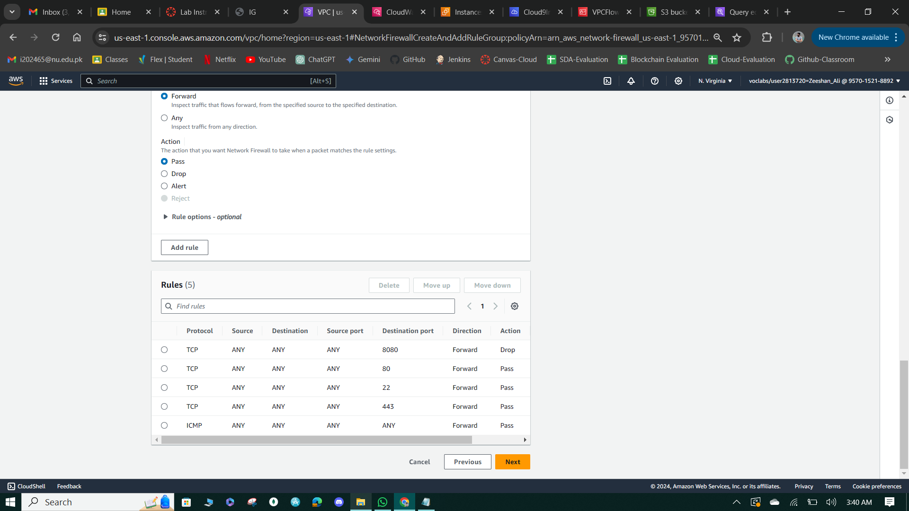

**Figure 68: Add Rules to the Group.**

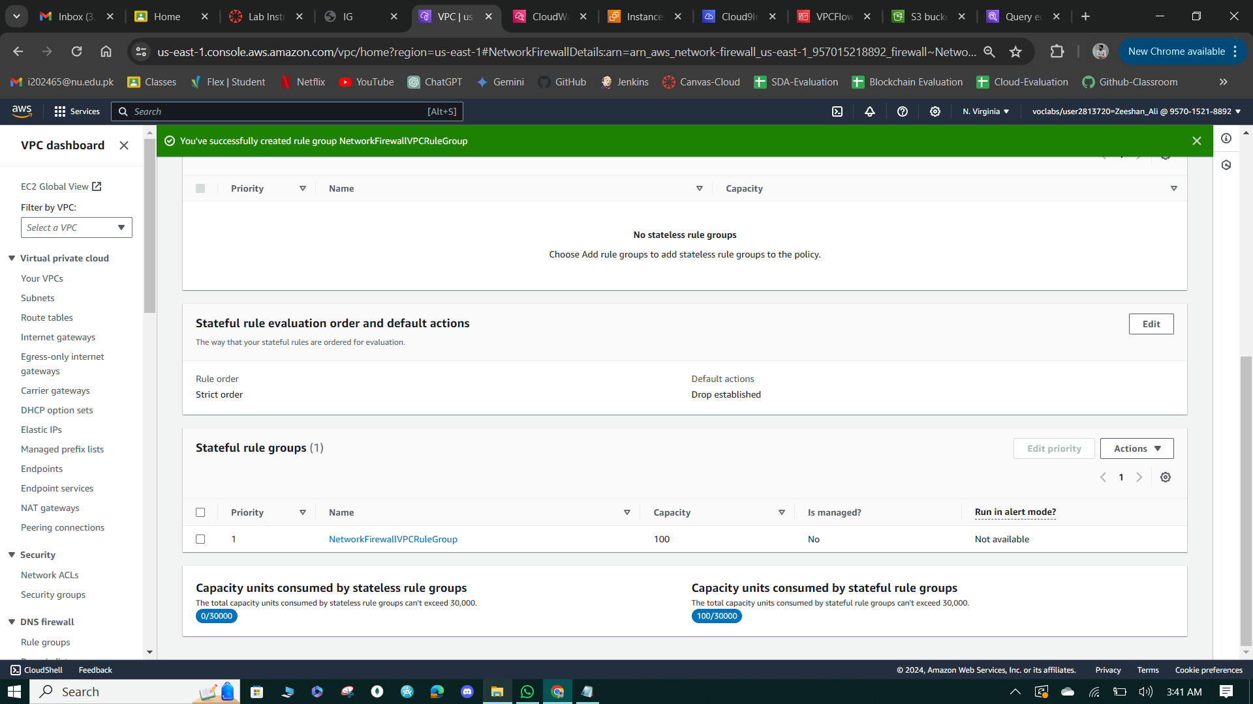

**Figure 69: Rule Policy Group Created.**

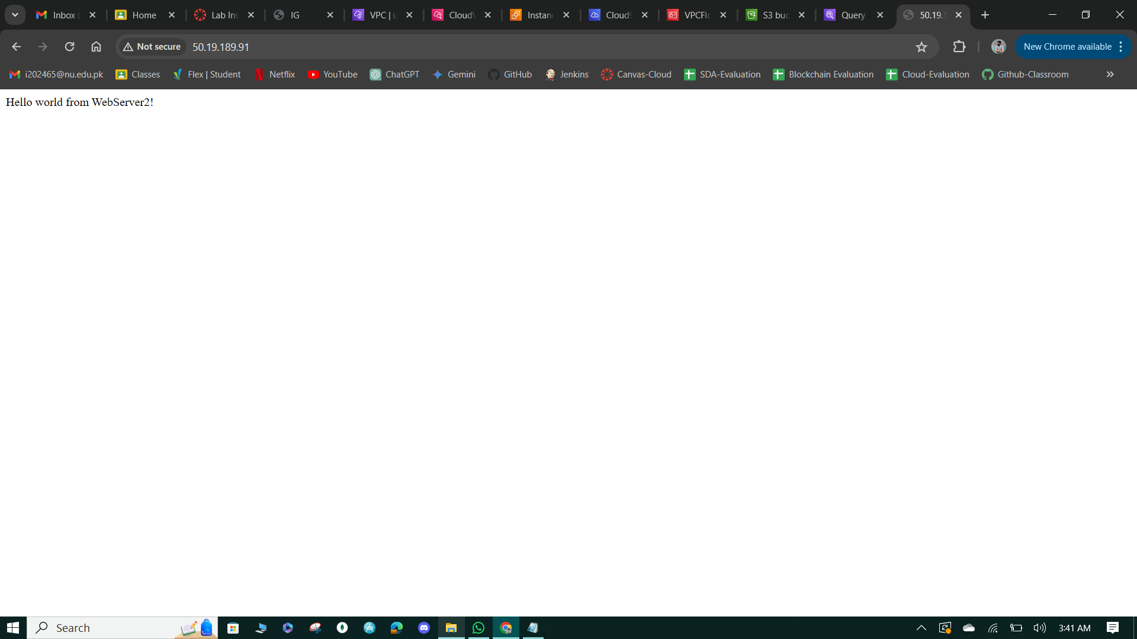

**Figure 70: Message from Webserver.**

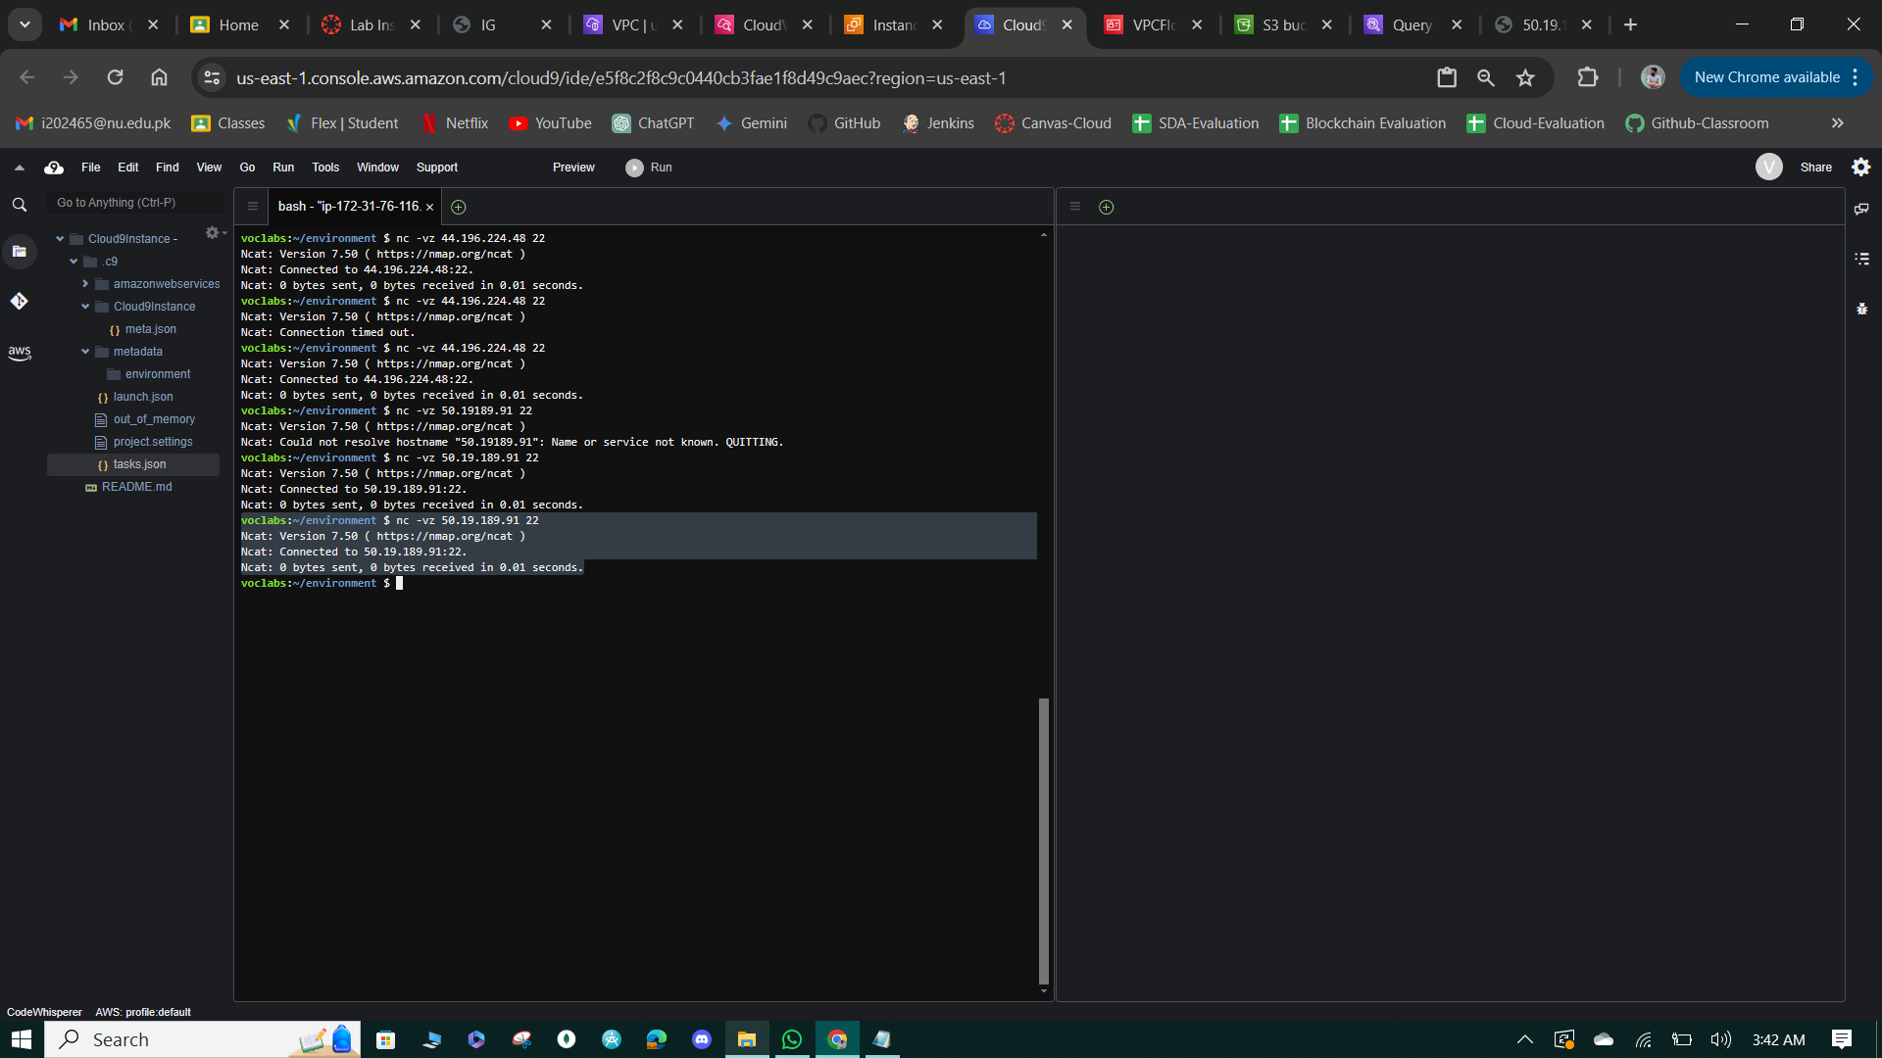

**Figure 71: Connected to the Network.**

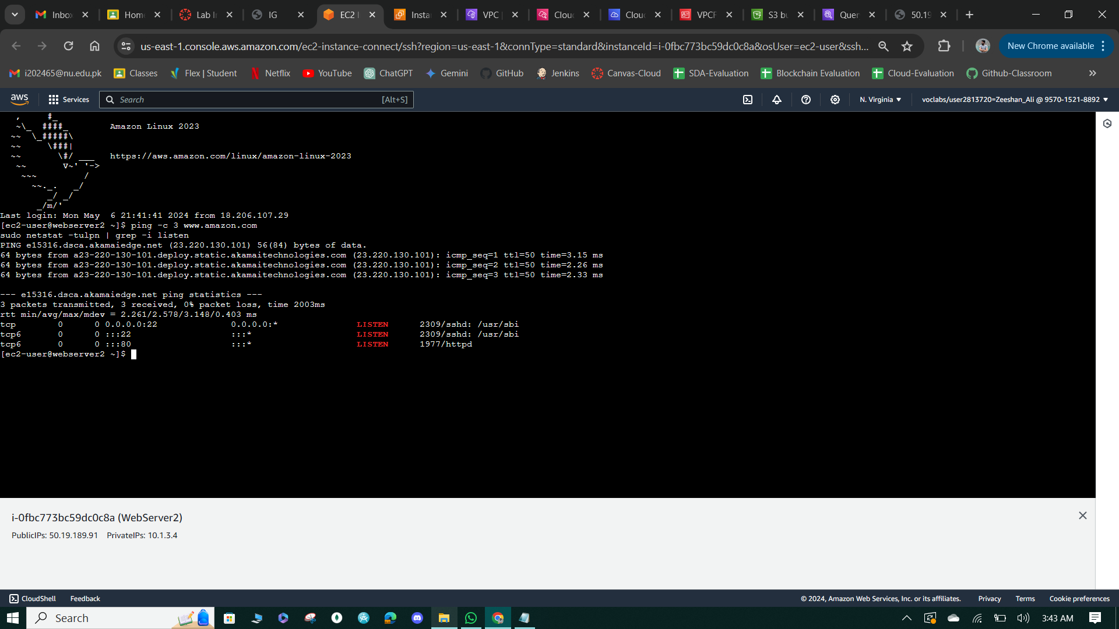

**Figure 72: ping status.**

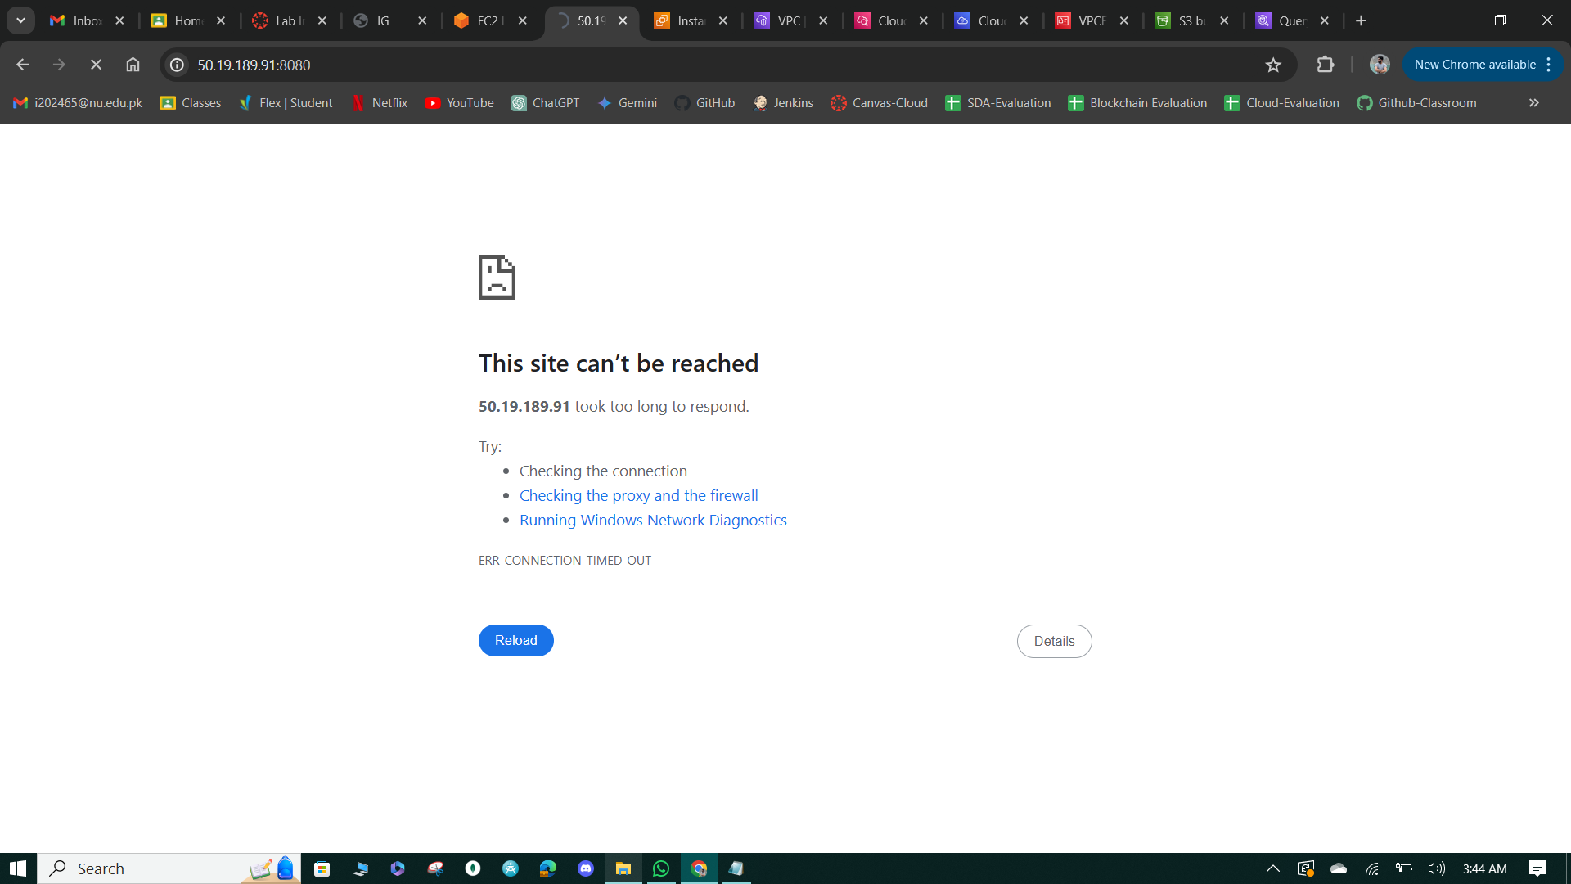

**Figure 73: Connection request time-out.**

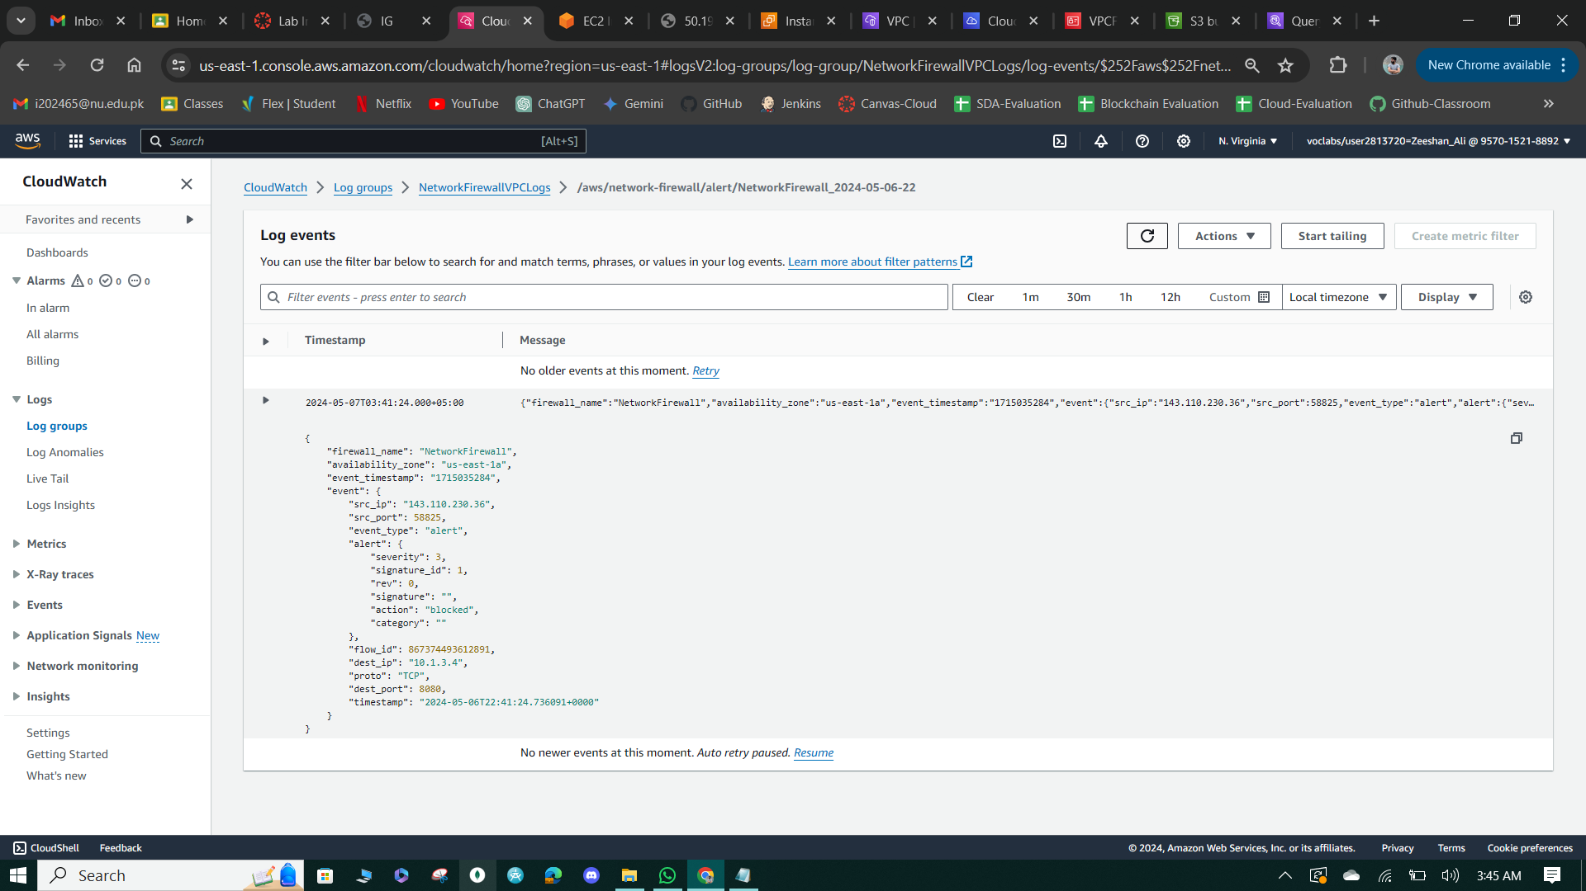

**Figure 74: Log stream to capture Message.**

**Diagramming Activity:**

The activity challenges students to explain how the network routing configuration works, in terms of traffic from the internet being routed to WebServer2 and traffic from WebServer2 being routed to the internet.

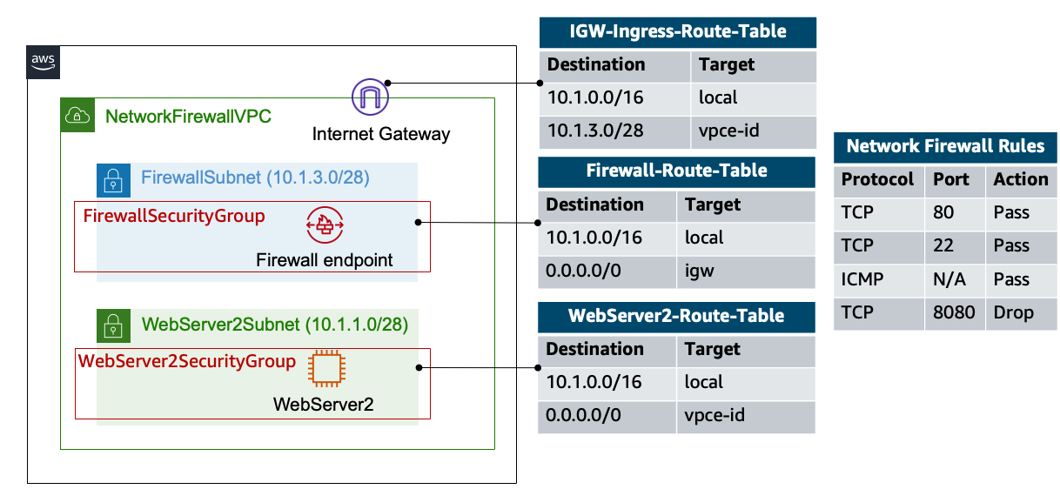

**Figure 75: Diagramming Activity.**

**Cost estimate to secure a VPC with a network firewall**

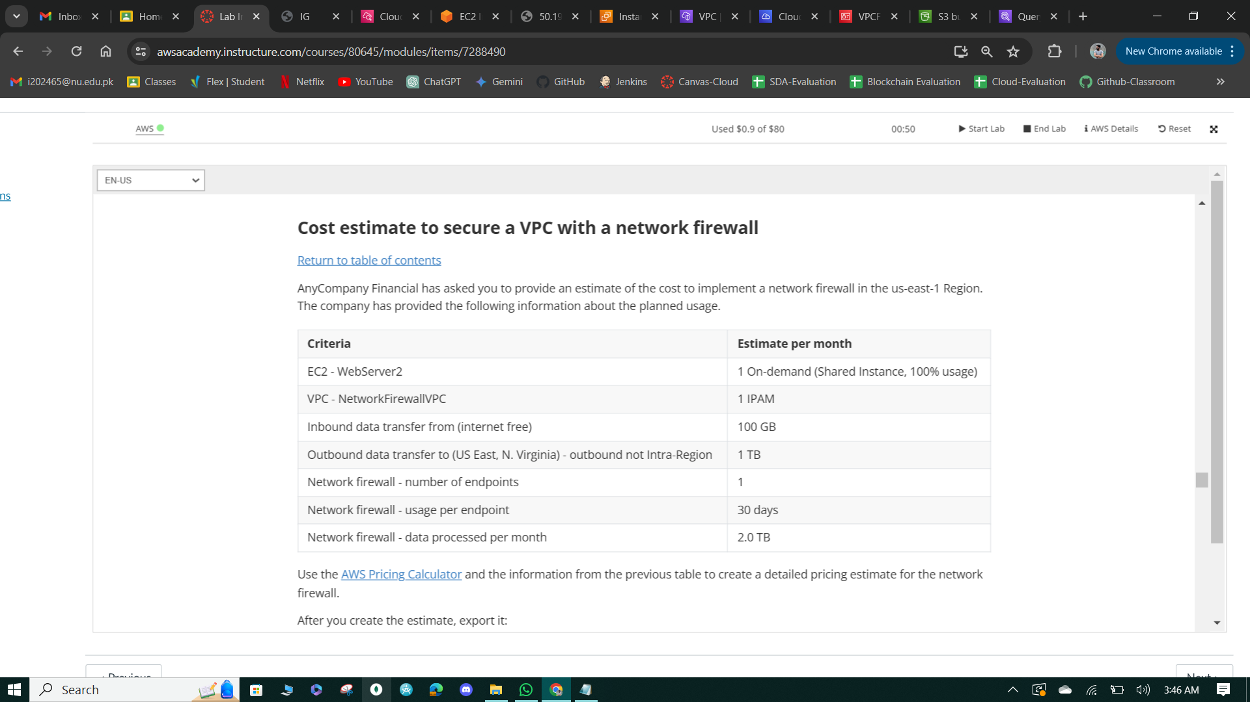

**Figure 76: Case Sceniro to build and configure VPC.**

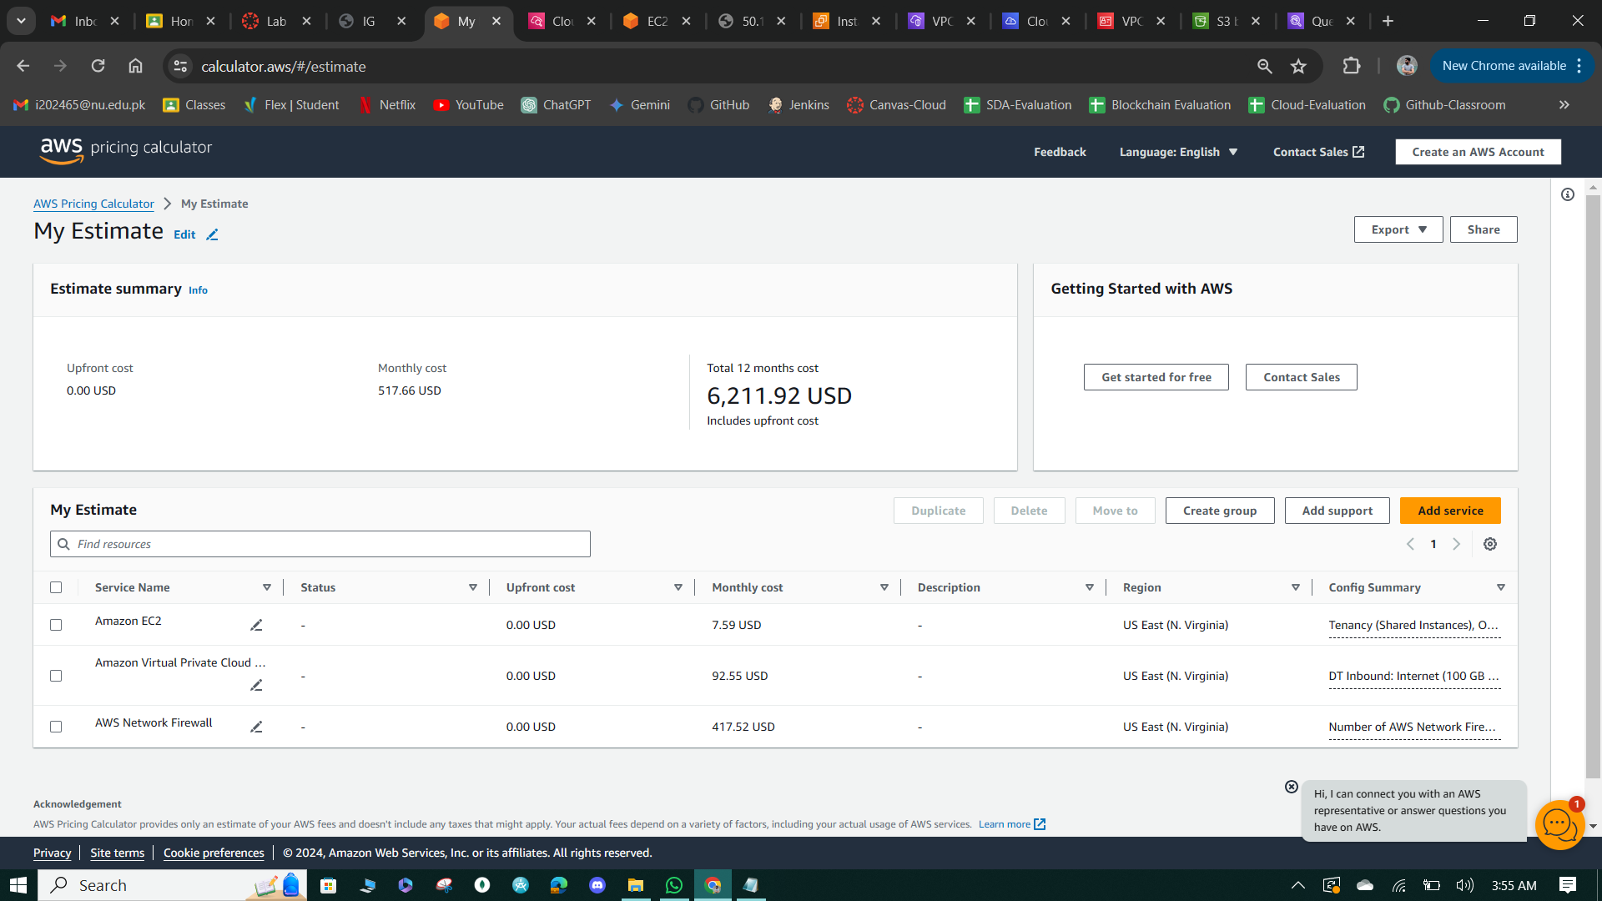

**Figure 77: Cost Estimation of the above Configuration.**

# Phase 3: Securing AWS Resources with KMS

* In this phase, AWS KMS (Key Management Service) is utilized to enhance security by encrypting sensitive data, managing encryption keys, and enforcing compliance requirements.
* It involves creating a customer-managed key and enabling key rotation to ensure cryptographic material freshness, crucial for regulatory compliance.
* For updating the KMS key policy and analyzing an IAM policy ensure that only authorized entities can access and perform cryptographic operations using the key. It demonstrates encrypting data in Amazon S3 buckets using AWS KMS, while it extends encryption to EC2 instance volumes, and it showcases envelope encryption for in-place data encryption.
* It illustrates encrypting Secrets Manager secrets with AWS KMS, adding an extra layer of security to sensitive information. These measures aim to fulfill regulatory requirements and safeguard AnyCompany Financial's data against unauthorized access.

**Task 1: Creating and managing a customer managed key**

* In this solution, a customer-managed key named "MyKMSKey" is created in AWS KMS. The key administrators and users are configured to include the "voclabs" IAM role.
* Additionally, key rotation is enabled to automatically rotate the key's cryptographic material every year for enhanced security.
* This ensures that cryptographic material remains fresh while maintaining access controls defined in the key policy.

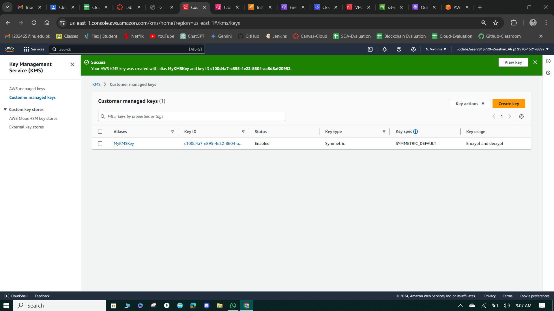

**Figure 78: MYKMSKEY!**

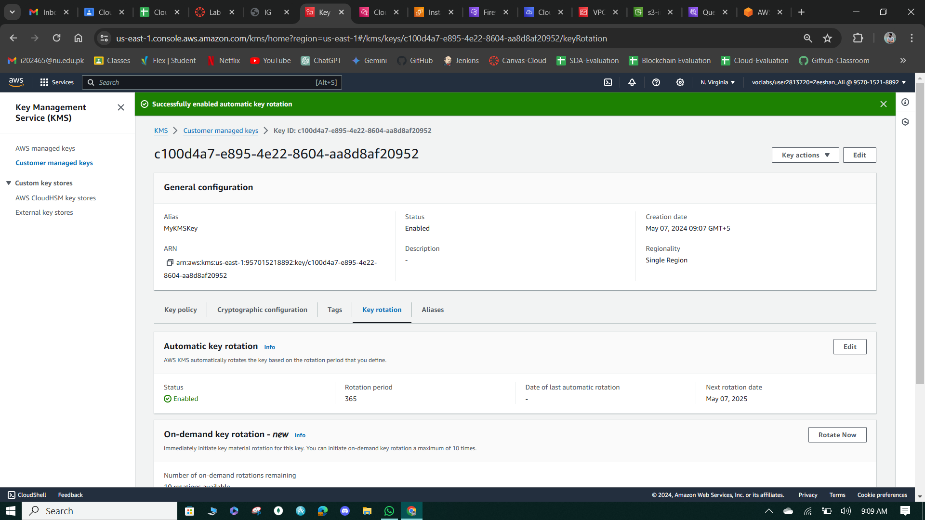

**Figure 79: Key Rotation**

**Task 2: Update the AWS KMS key policy and analyze an IAM policy**

* The Key policy for "MyKMSKey" is modified to allow specific IAM entities, including the "voclabs" IAM role and the "sofia" IAM user, to perform key management actions such as encryption, decryption, key re-encryption, and key generation.
* The modification ensures that only designated IAM entities listed in the "Principal" element have the necessary permissions to interact with the KMS key. This helps enforce the principle of least privilege by restricting access to cryptographic operations to only authorized users and roles.

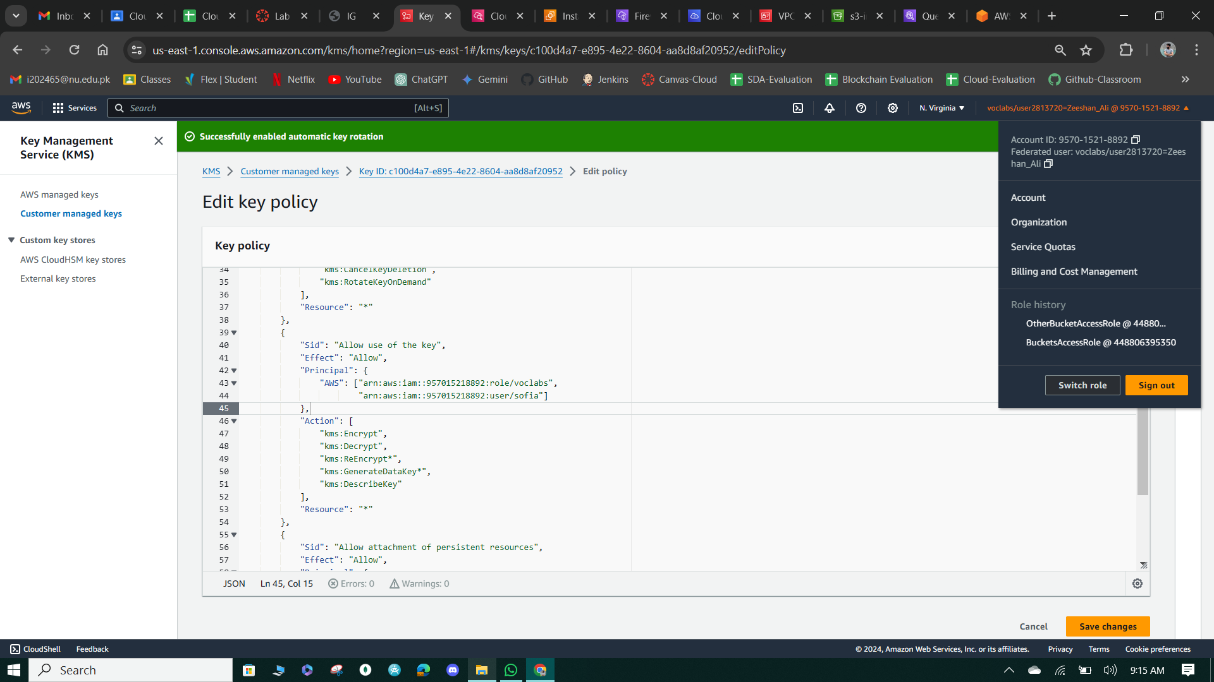

**Figure 80: Edit Policy.**

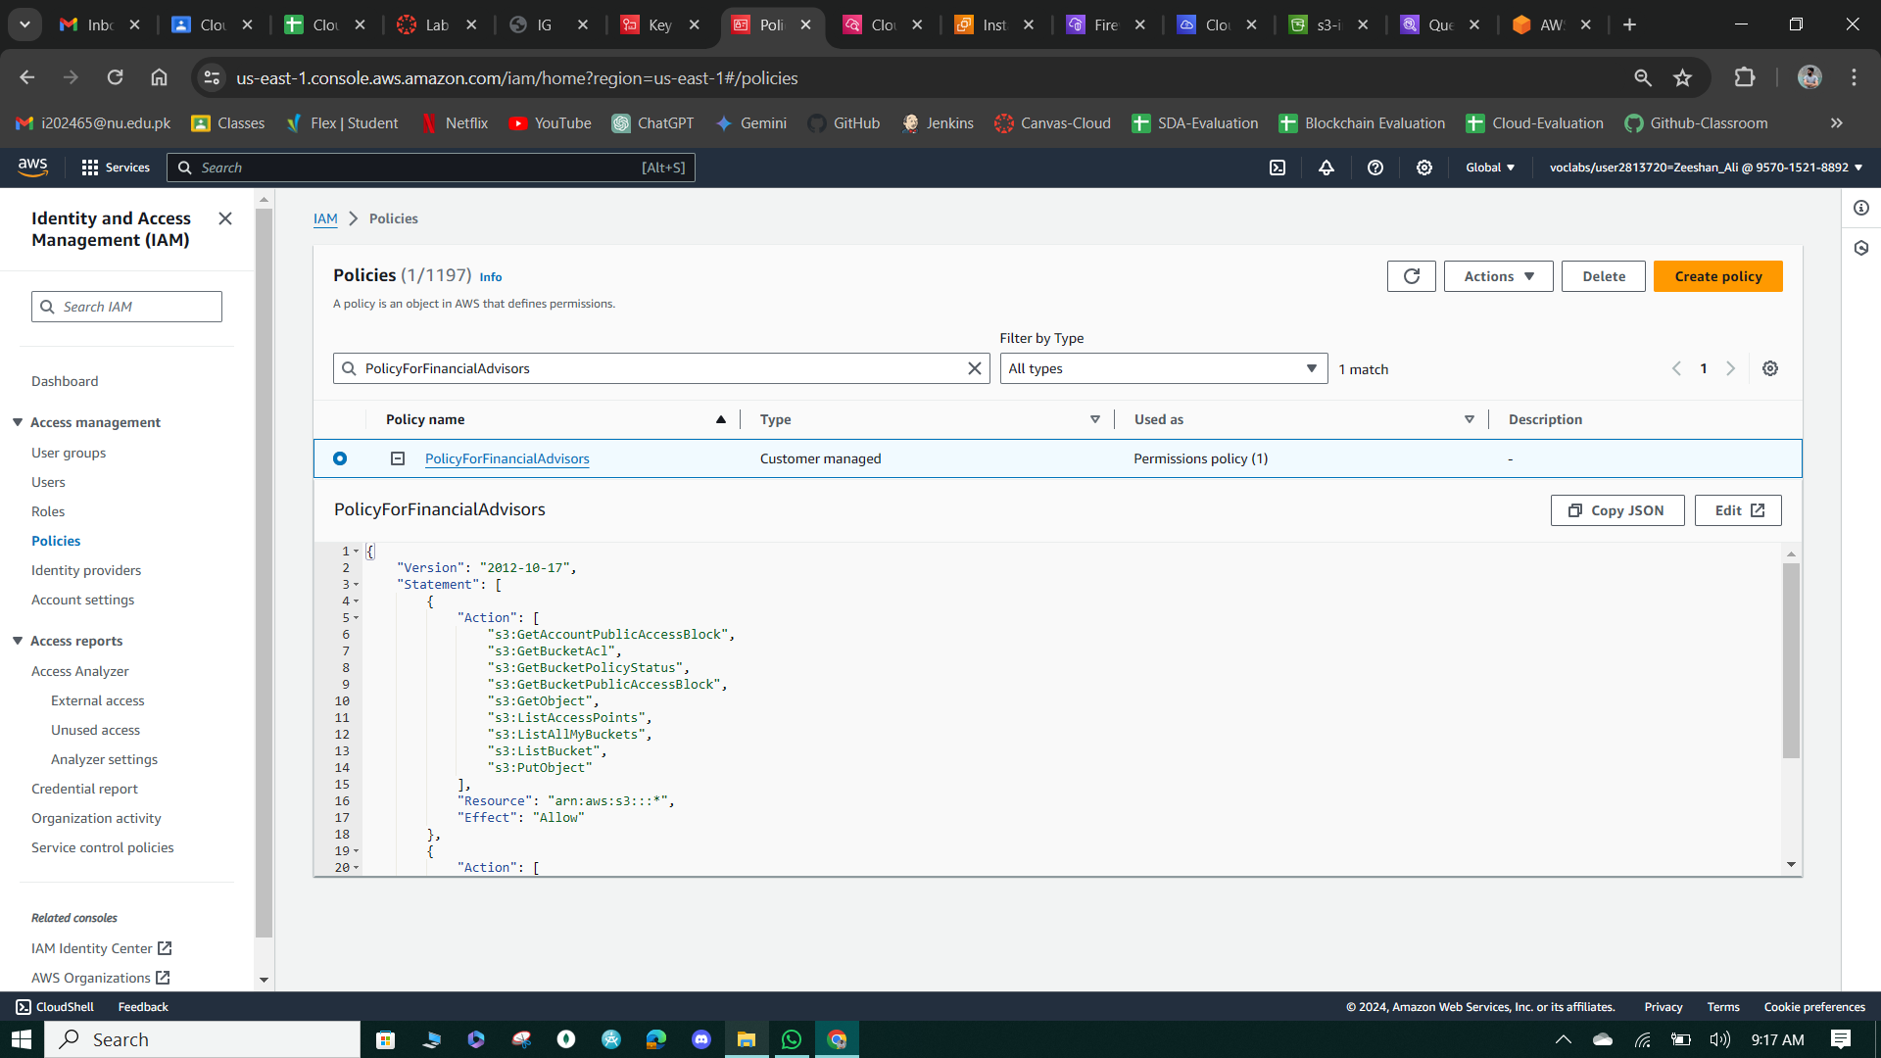

**Figure 81: Financial Advisor Policy**

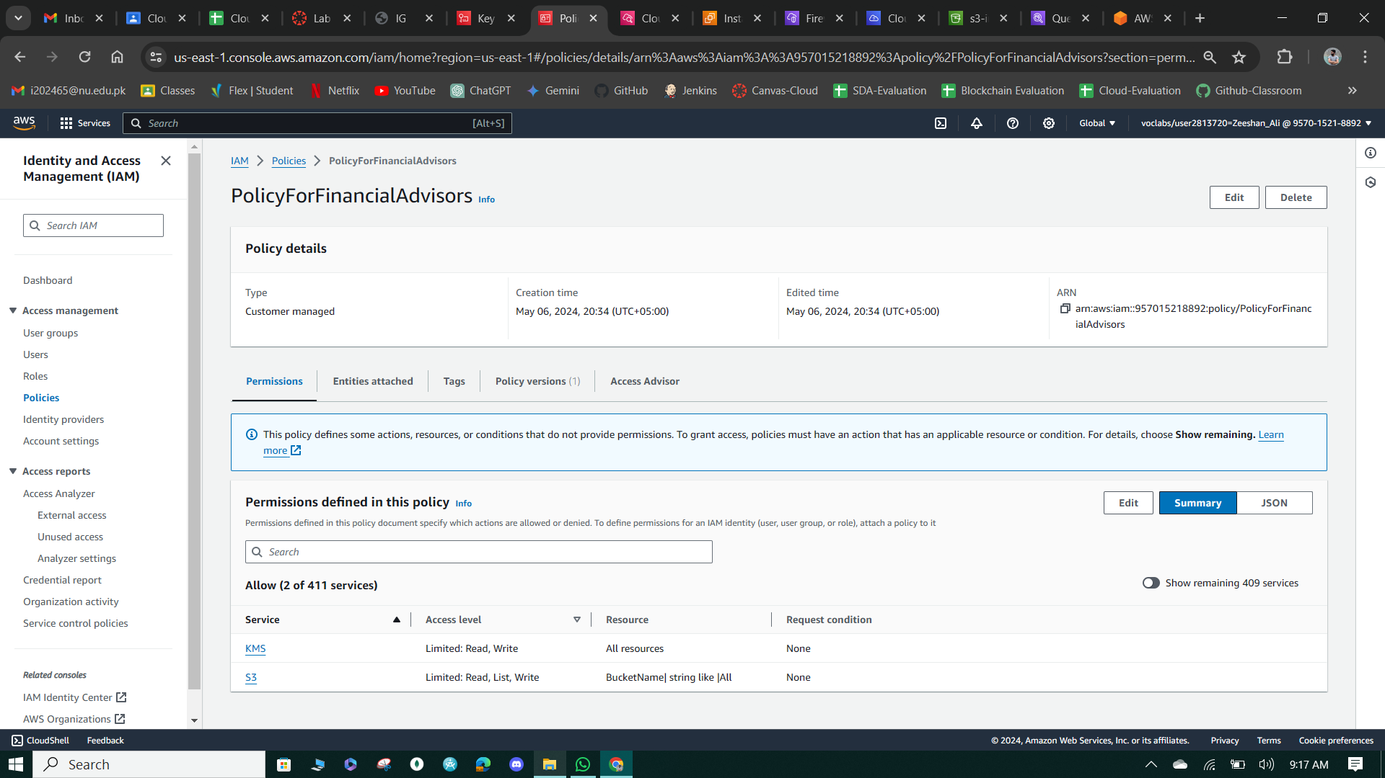

**Figure 82: Policy Permissions.**

**Task 3: Use AWS KMS to encrypt data in Amazon S3**

* The solution demonstrates the implementation of server-side encryption using AWS Key Management Service (SSE-KMS) for the data stored in the Amazon S3 bucket, ensuring that data is encrypted at rest.
* By encrypting the data with AWS KMS keys, access to the data is tightly controlled, and only authorized IAM users and roles with appropriate permissions can decrypt and access the data.
* The example scenario highlights the importance of encryption in protecting sensitive data, as it ensures that even if unauthorized users gain access to the S3 bucket, they cannot read the encrypted data without the necessary encryption keys.

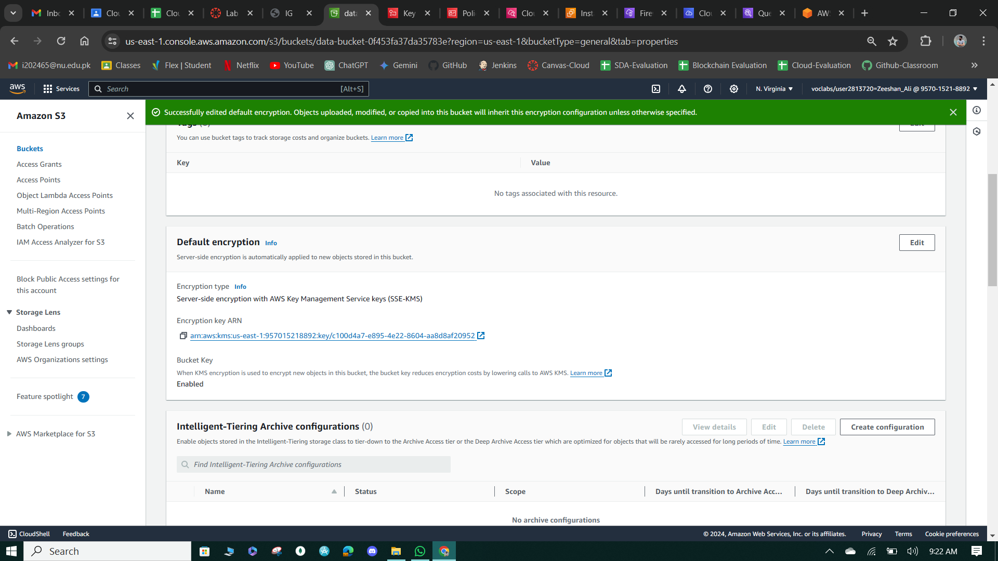

**Figure 83: Edit Default Encryption.**

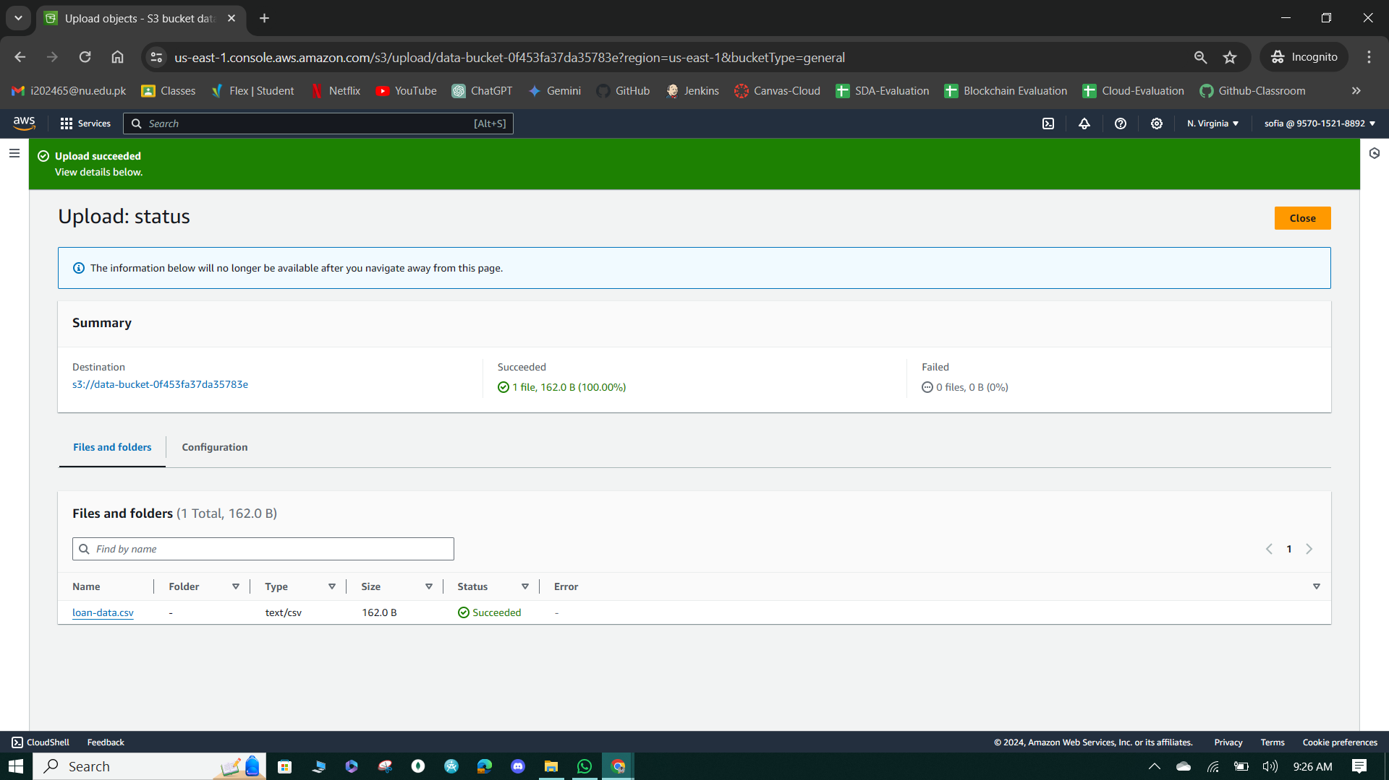

**Figure 84: Loan-data.csv uploaded.**

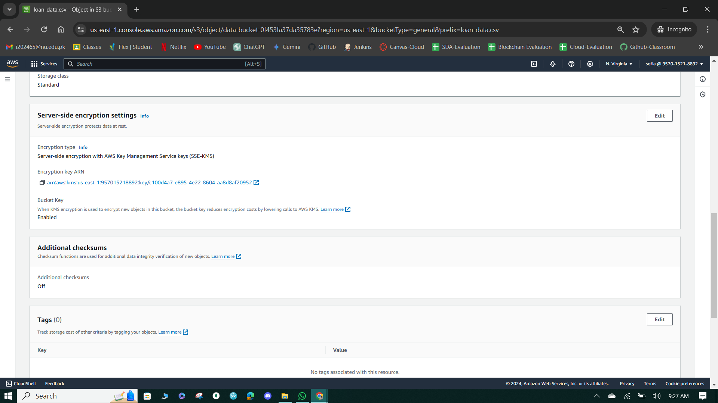

**Figure 85: Bucket Server-side encryption.**

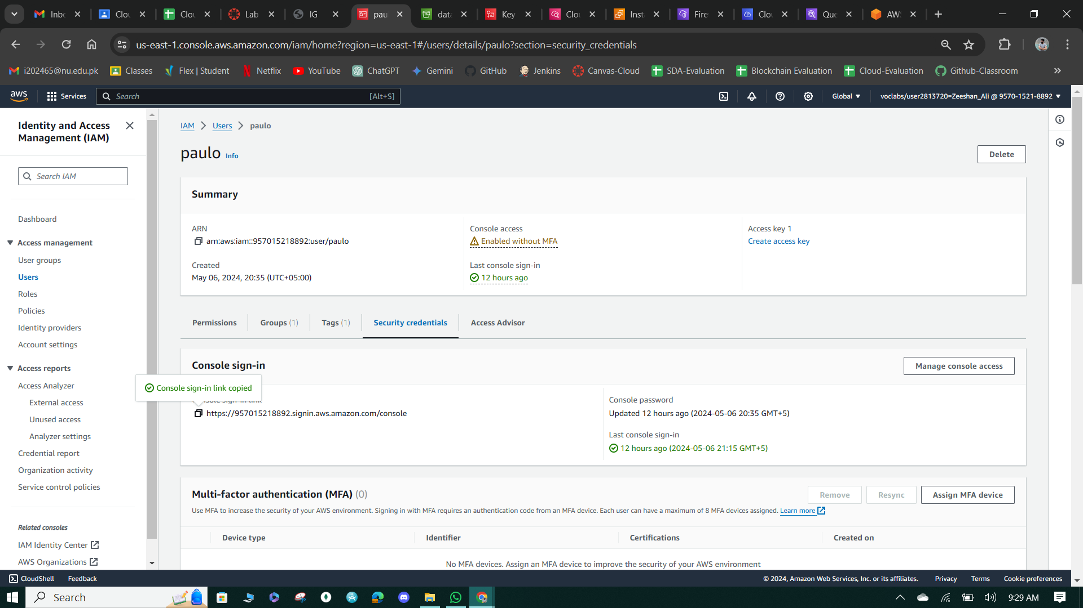

**Figure 86: Paulo IAM console-sign-in link.**

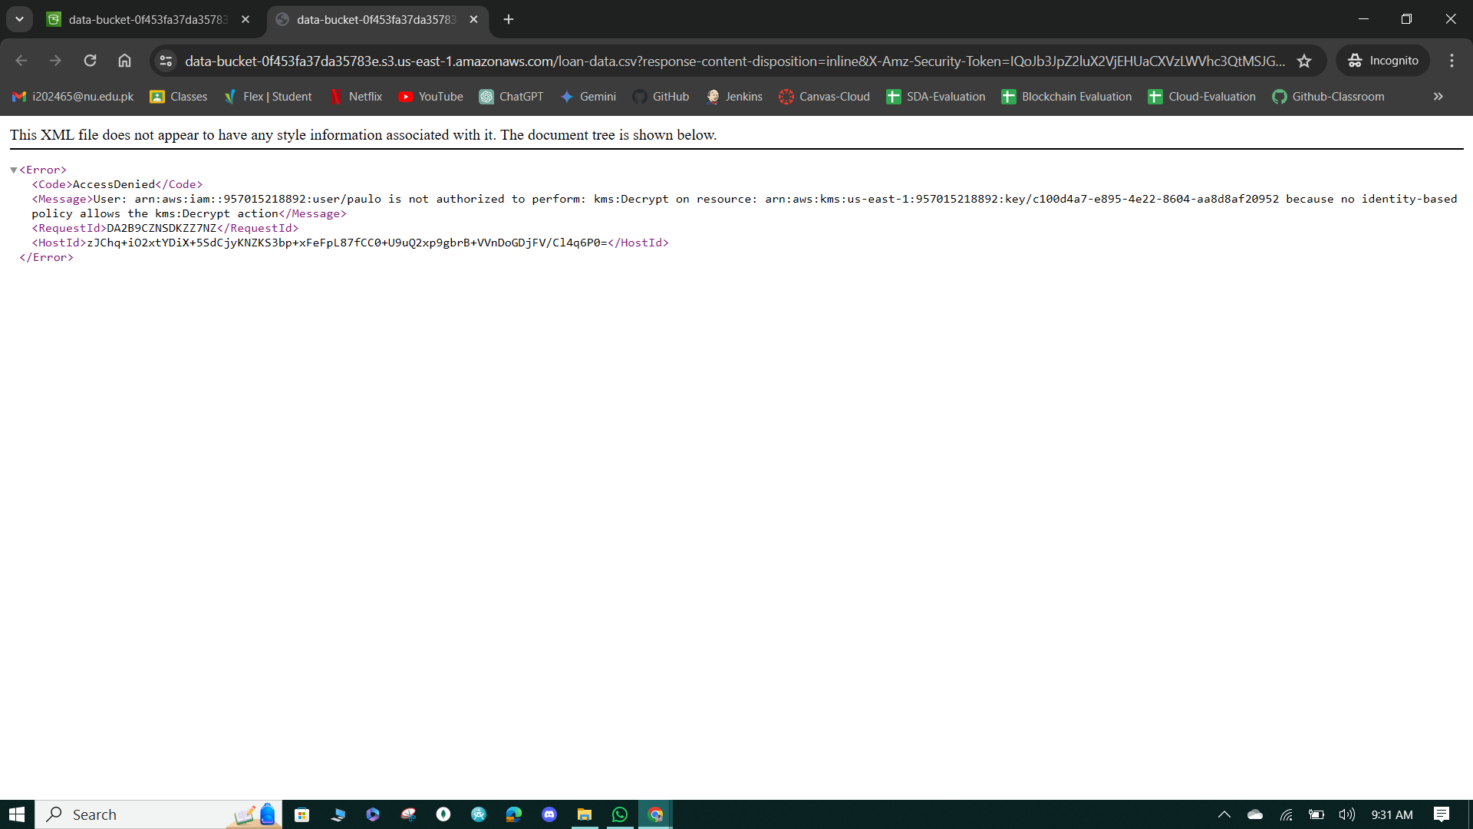

**Figure 87: Access Denied to Paulo.**

**Task 4: Use AWS KMS to encrypt the root volume of an EC2 instance**

* The solution demonstrates the creation of an encrypted EC2 instance named "EncryptedInstance" using Amazon Linux 2 AMI and a t2. micro instance type.
* By selecting the "Encrypted" option and specifying the "MyKMSKey" as the KMS key for encryption in the Configure storage section, the instance's root volume is encrypted using AWS Key Management Service (KMS), ensuring data security at rest.

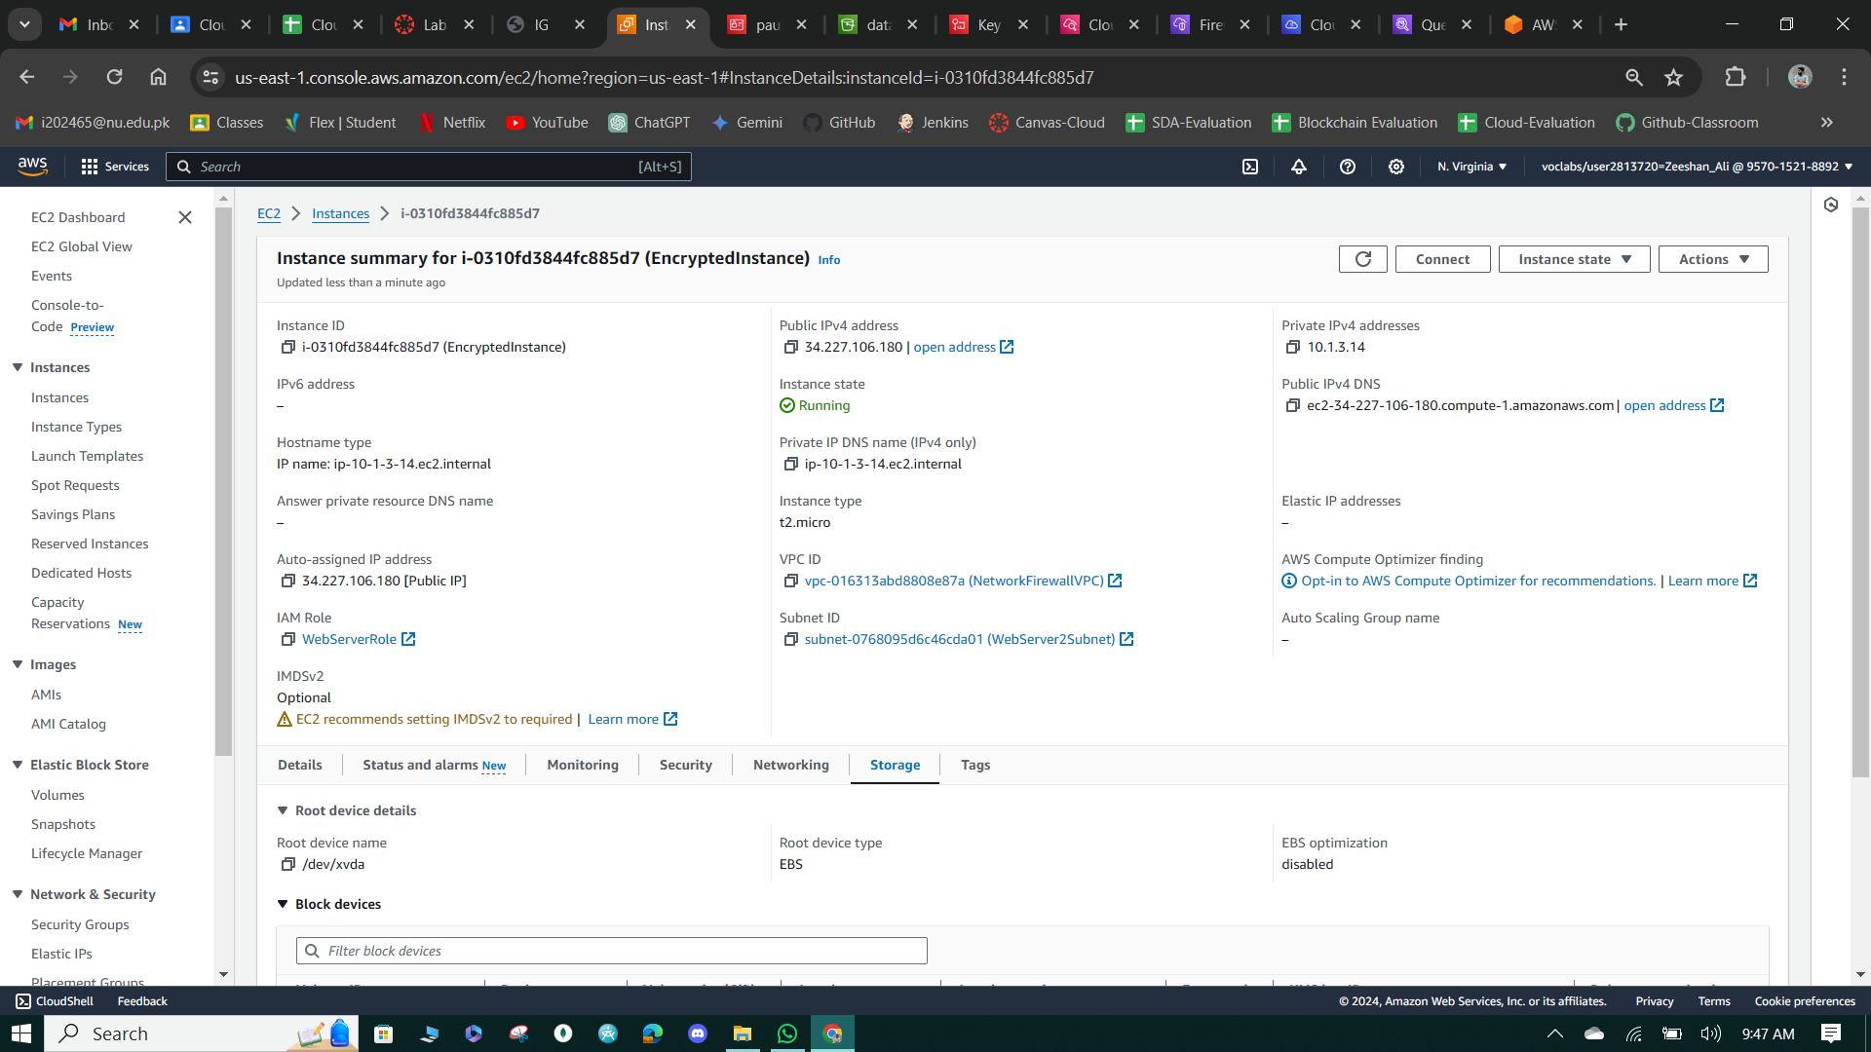

**Figure 88: Successfully Launched Encrypted Instance**

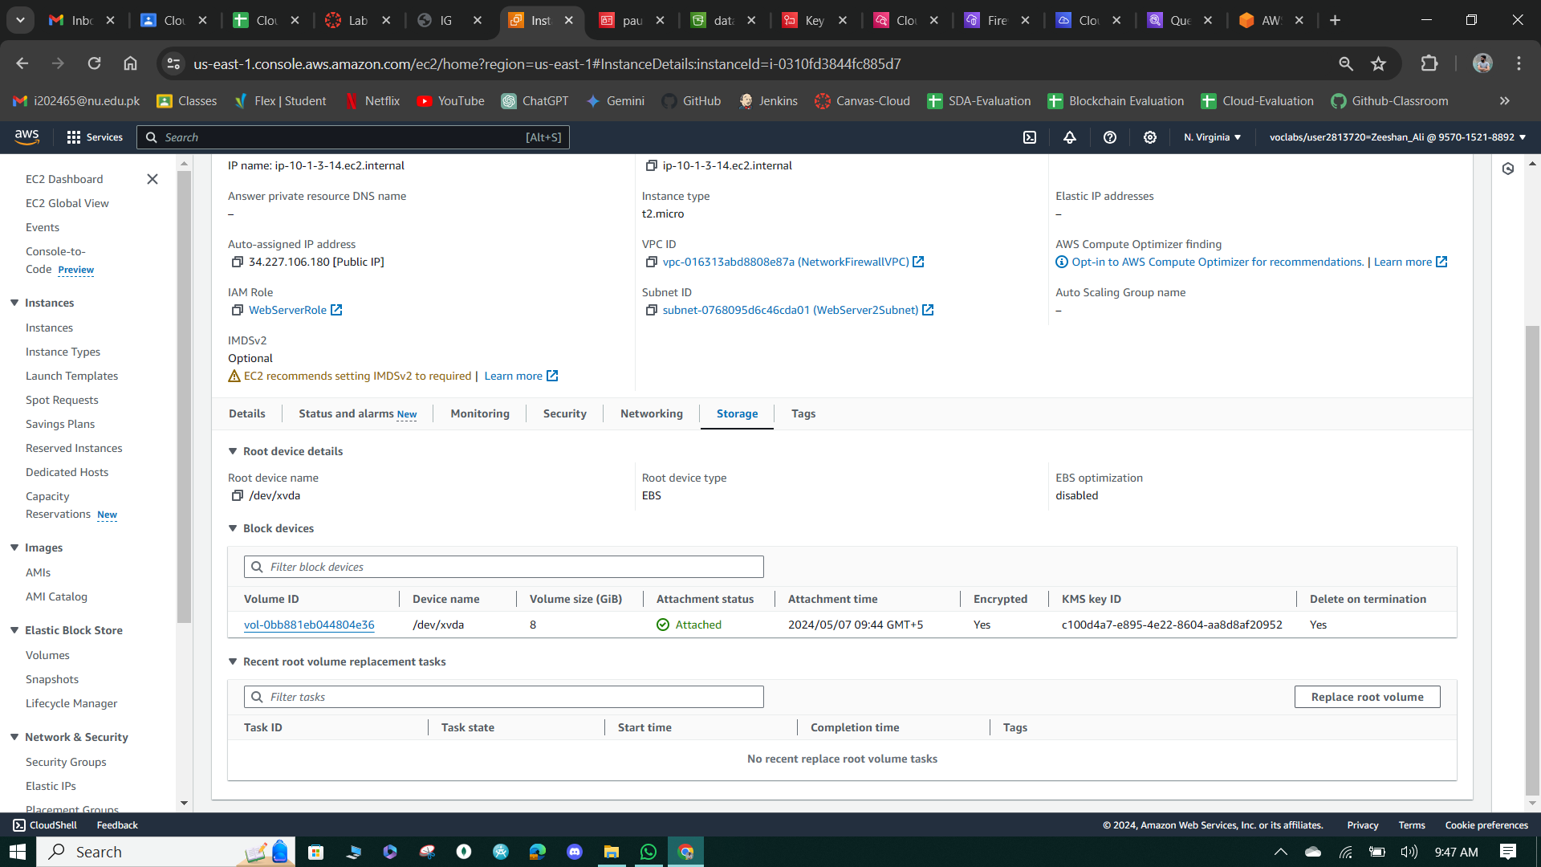

**Figure 89: Storage Configurations**

**Task 5: Use AWS KMS envelope encryption to encrypt data in place**

* In this task, AWS CLI is utilized within an EC2 instance to interact with AWS KMS, demonstrating the encryption and decryption of data using envelope encryption.
* The process involves generating a data key from the AWS KMS key, encrypting a file with this data key, and subsequently decrypting the file to ensure data retrievability.
* Envelope encryption enhances security by encrypting data keys with master keys, ensuring sensitive information remains protected, even if the master key is compromised.

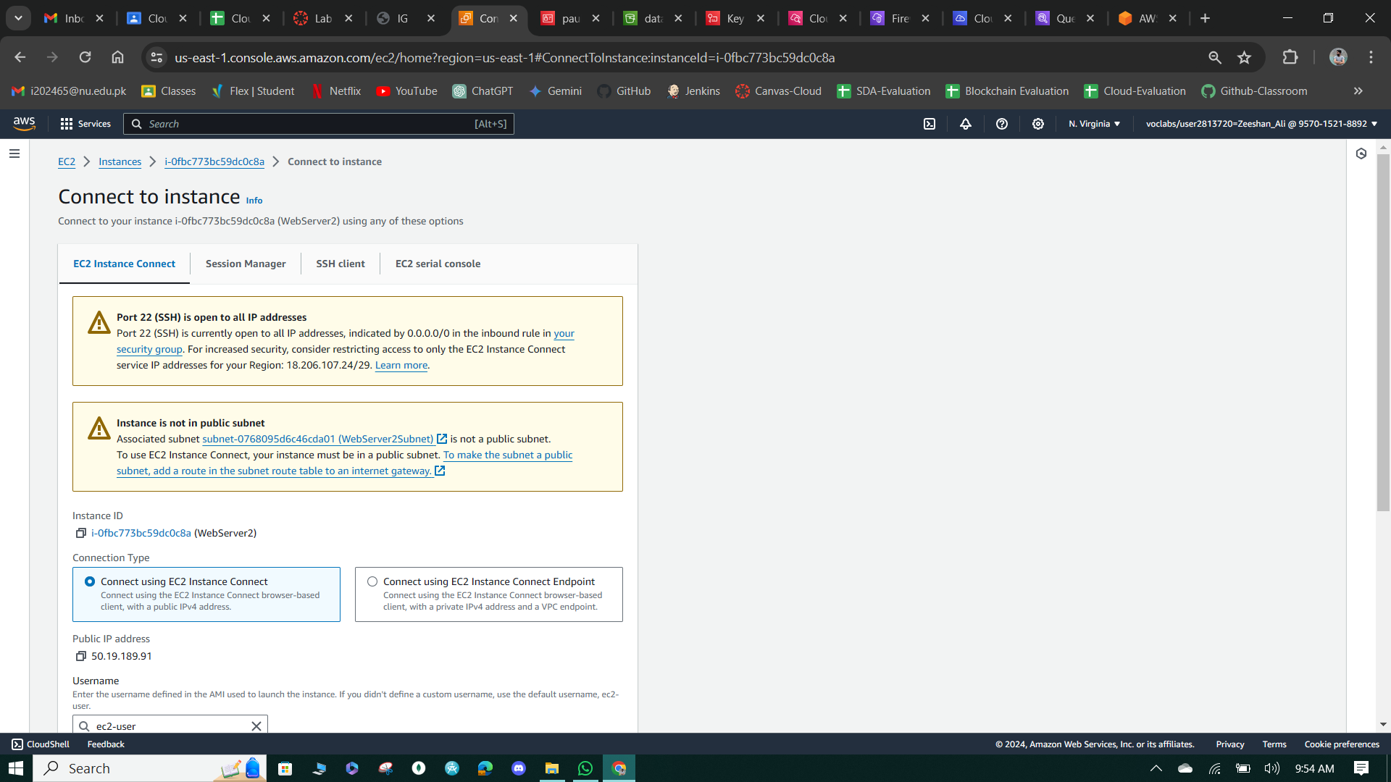

**Figure 90: EC2 Encrypted Instance Connect**

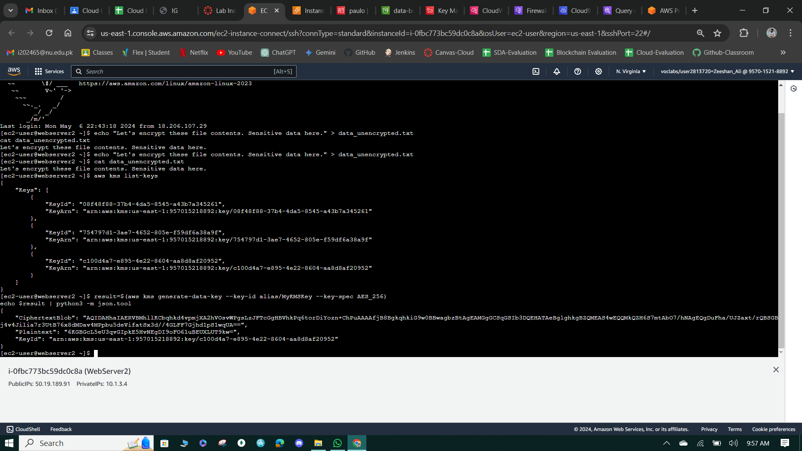

**Figure 91: List AWS KMS Keys**

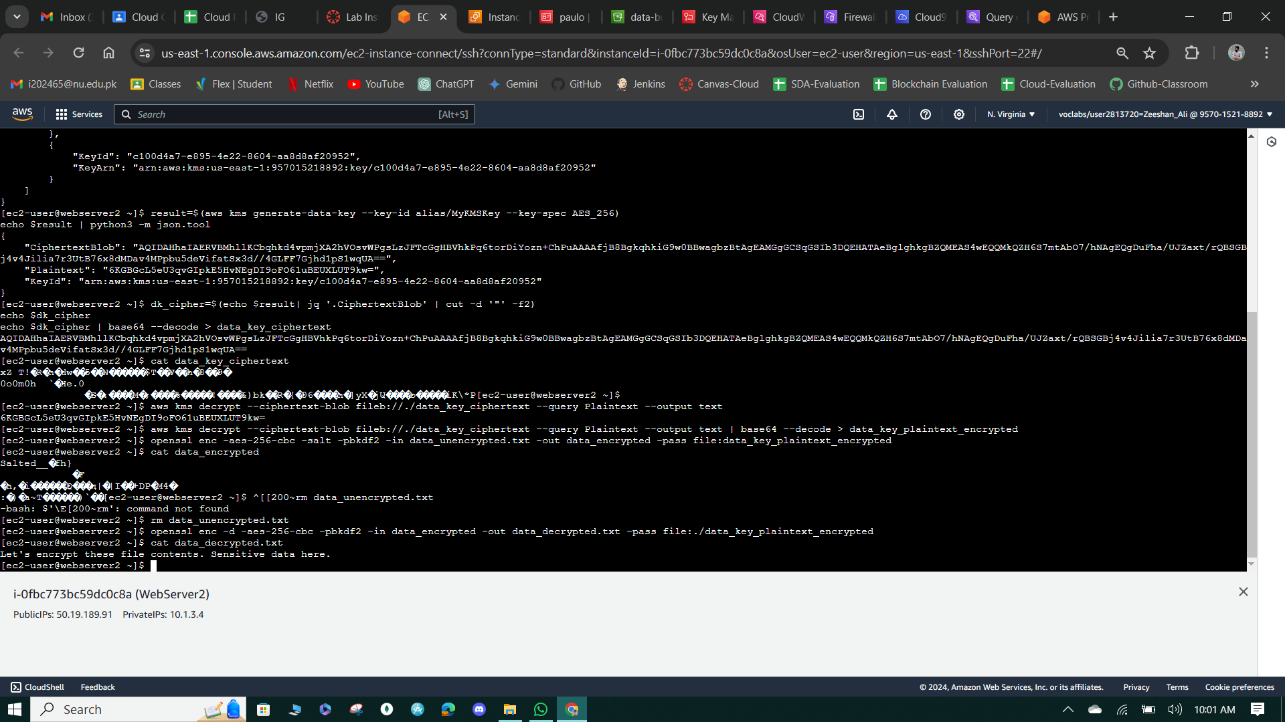

**Figure 92: View & Remove unencrypted data.**

**Task 6: Use AWS KMS to encrypt a Secrets Manager secret**

* This solution demonstrates how to store a secret using AWS Secrets Manager with encryption provided by the specified KMS key (MyKMSKey).
* It then shows how to retrieve the secret using AWS CLI commands within an EC2 instance, verifying its successful storage and retrieval.

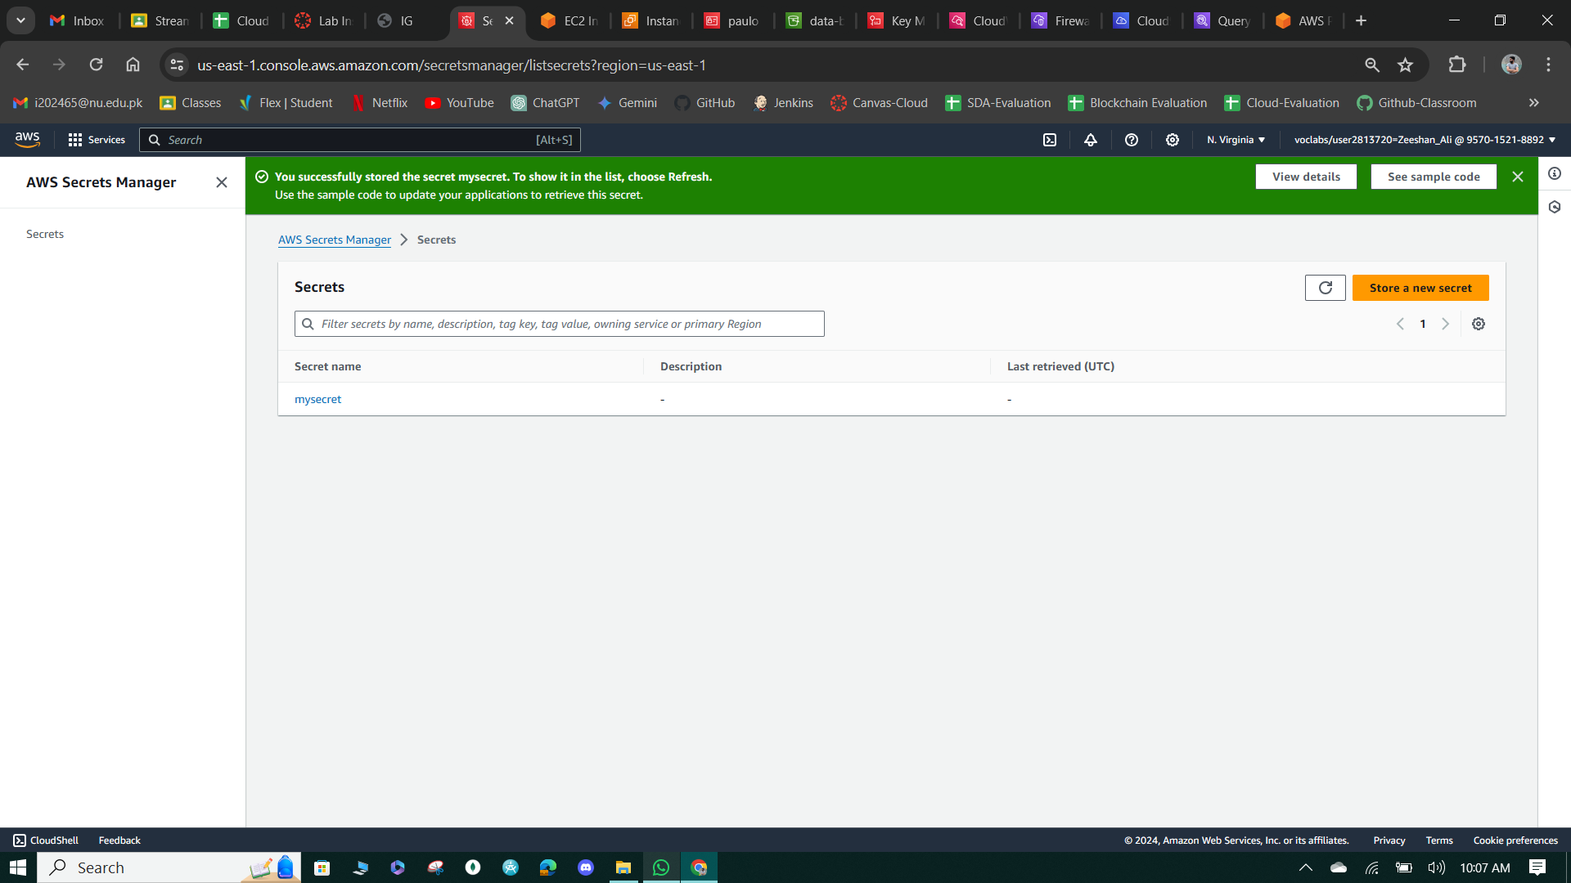

**Figure 93: Create Secrete Key**

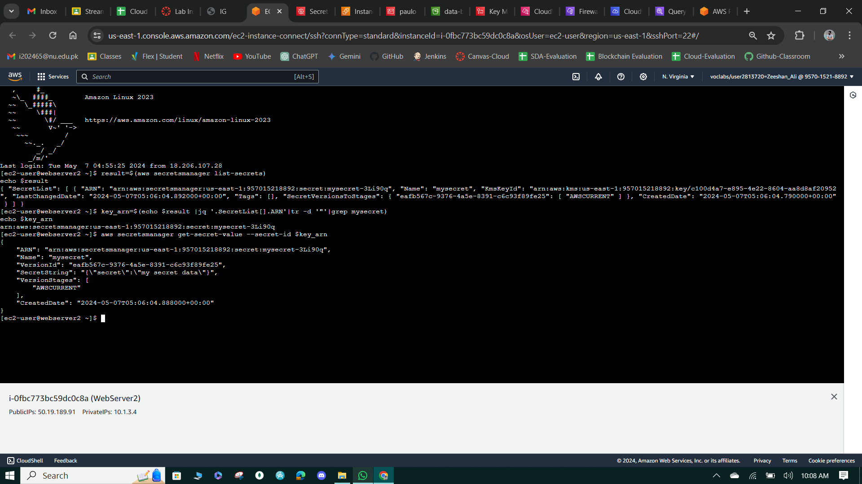

**Figure 94: Get Secret Key**

**Cost assessment for using AWS KMS**

**Question:** In this lab, does your use of AWS KMS result in additional cost in the account? If so, what usage would you be charged for?

**Answer:** Additional costs associated with this phase:

* **Each AWS KMS key:** You pay a monthly charge for each key that you create. For example, as of the time of this writing, in us-east-1, the cost was $1 per month per symmetric key.
* **Automatic key rotation:** If you enable automatic key rotation (which students did), each newly generated backing key incurs an additional cost. For example, as of the time of this writing, in us-east-1, the cost was $1 per month per backing key retained to decrypt older ciphertexts.
* **Key usage:** AWS KMS provides a free tier up to a certain number of requests per month. The number of requests included in the free tier depends on the AWS service with which the KMS is being used. For example, as of the time of this writing, in us-east-1, the first 20,000 requests that used the key were free tier. Usage beyond the free tier costs $0.03 per 10,000 requests. Such usage includes, for example:
  + KMS key used to encrypt files on S3.
  + KMS key used as a root key for encrypting EBS volumes.

# Phase 4: Monitoring and logging

* The use of CloudTrail, CloudWatch, and AWS Config security features does result in additional costs in the AWS account.
* CloudTrail charges based on the number of events recorded and data events. CloudWatch costs depend on log ingestion, storage, and metrics. AWS Config pricing is based on the number of configuration items recorded and active rules.
* Estimating the monthly cost requires considering factors such as the volume of API calls, log data size, and frequency of configuration changes.
* Usage patterns, such as the frequency and volume of API activity and log data, will influence the overall cost.
* Detailed cost estimation can be calculated based on specific usage patterns and the pricing details provided in AWS documentation for each service.

**Task 1: Use AWS CloudTrail to record S3 API calls**

* Create a CloudTrail trail named data-bucket-reads-writes in the CloudTrail console, specifying an existing S3 bucket for storing logs, and enable both Management and Data events, specifically for S3.
* Upload a file named customer-data.csv to the data-bucket in the S3 console, generating Put Object and Get Object events in the CloudTrail trail.
* Create an Athena table in the CloudTrail console using the cloudtrail-logs bucket as the storage location.
* Run queries in Athena to retrieve event details such as event time, principal ID, request parameters, event name, source IP address, and user agent for both Put Object and Get Object events related to the customer-data.csv file.

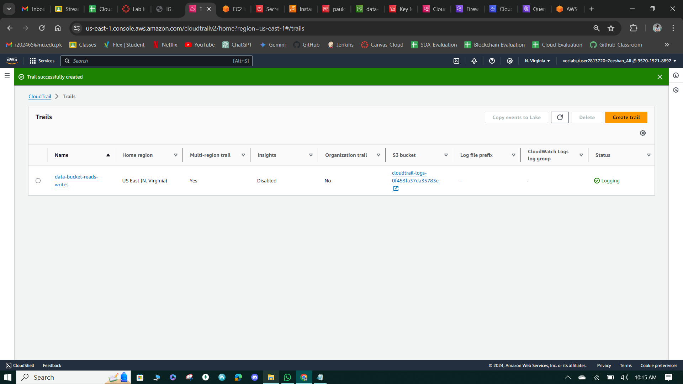

**Figure 95: Create Trail**

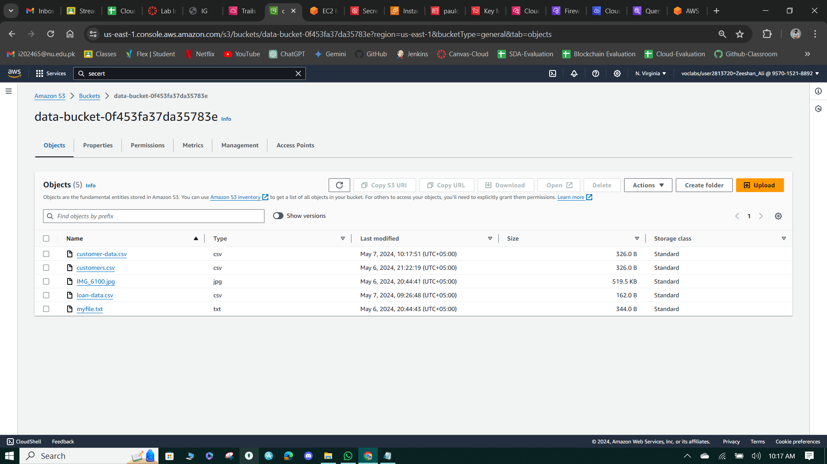

**Figure 96: Upload the Customers-data.csv file.**

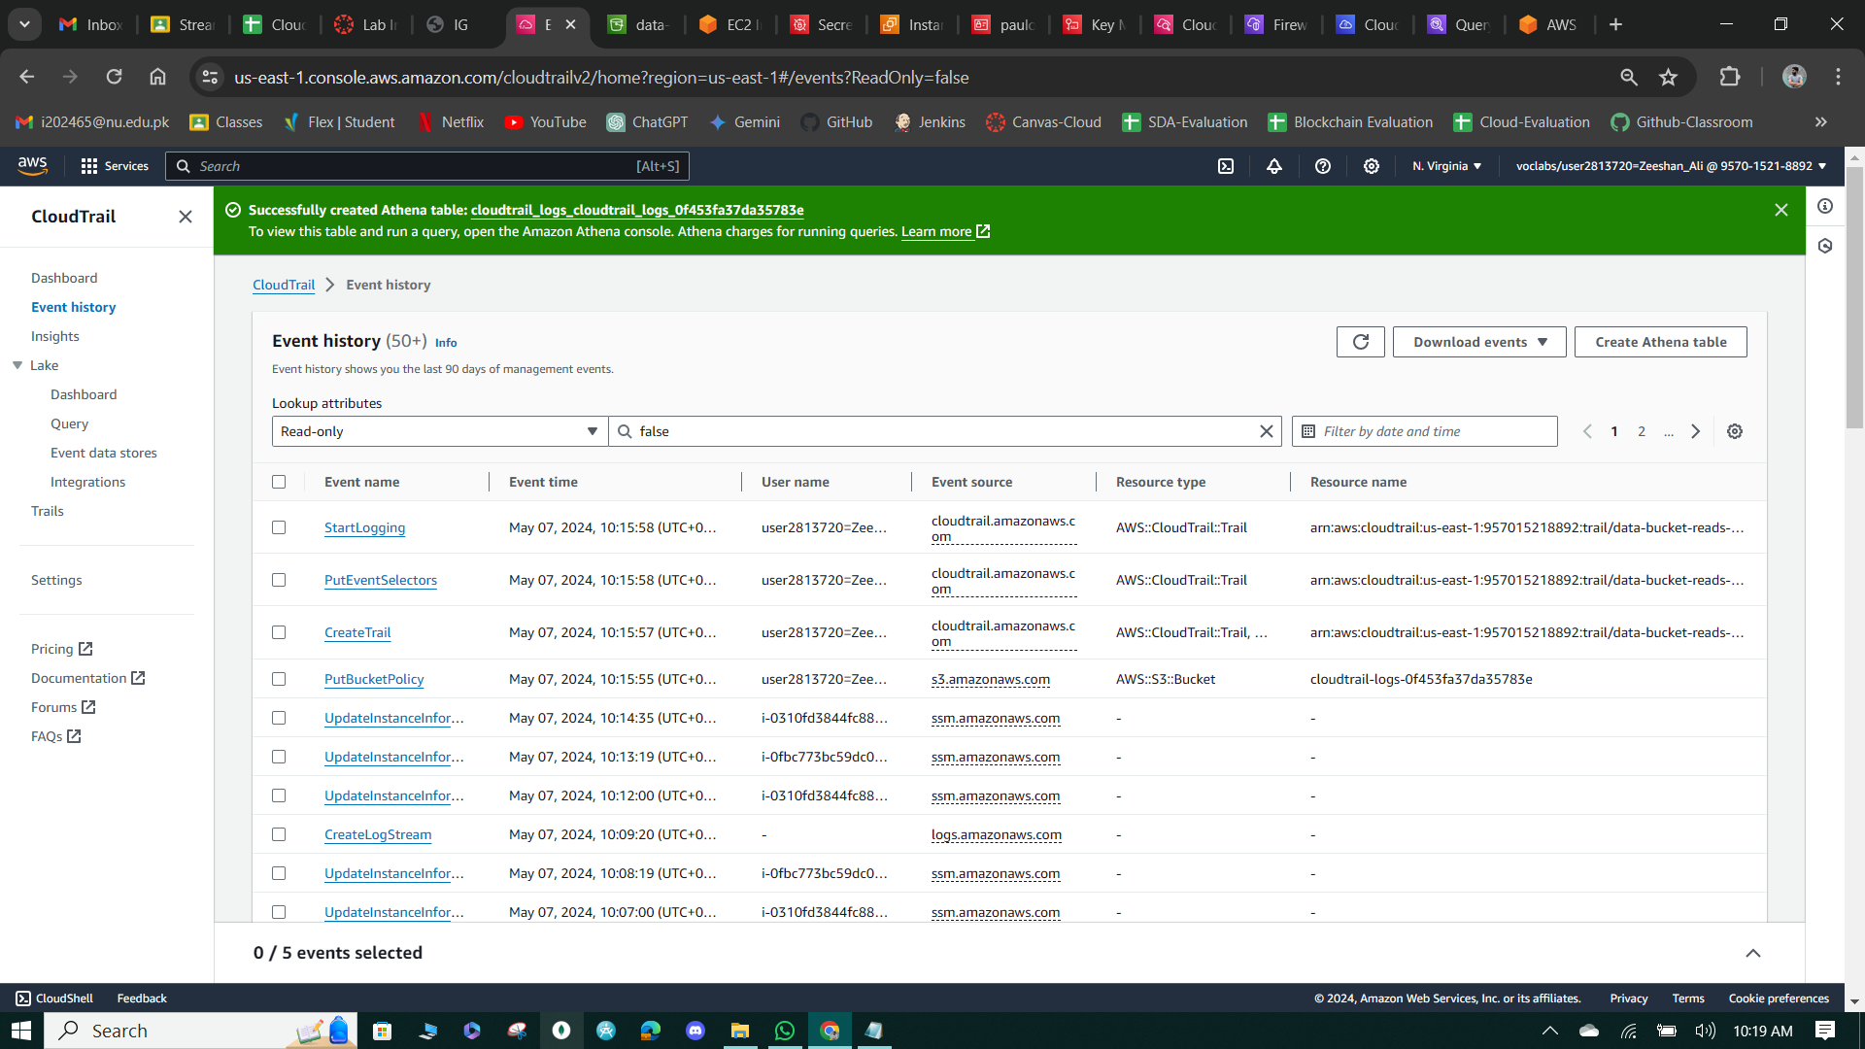

**Figure 97: Athena Table Creation.**

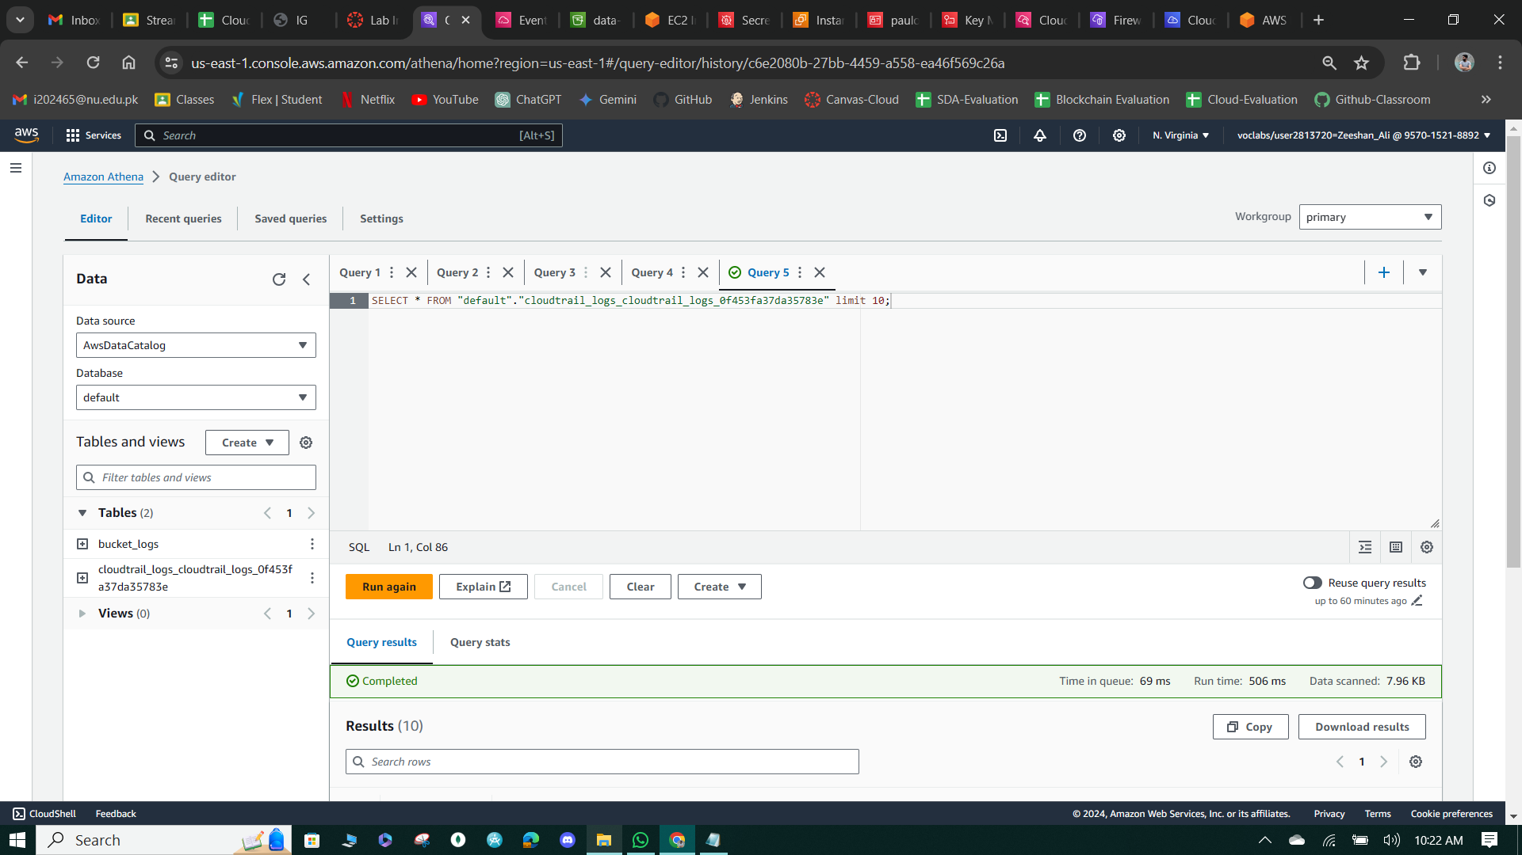

**Figure 98: Query to View top 10 results.**

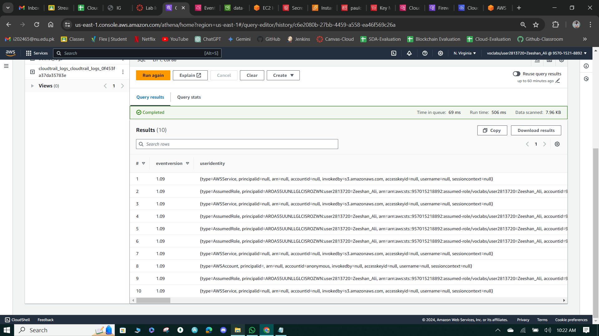

**Figure 99: Query Result.**

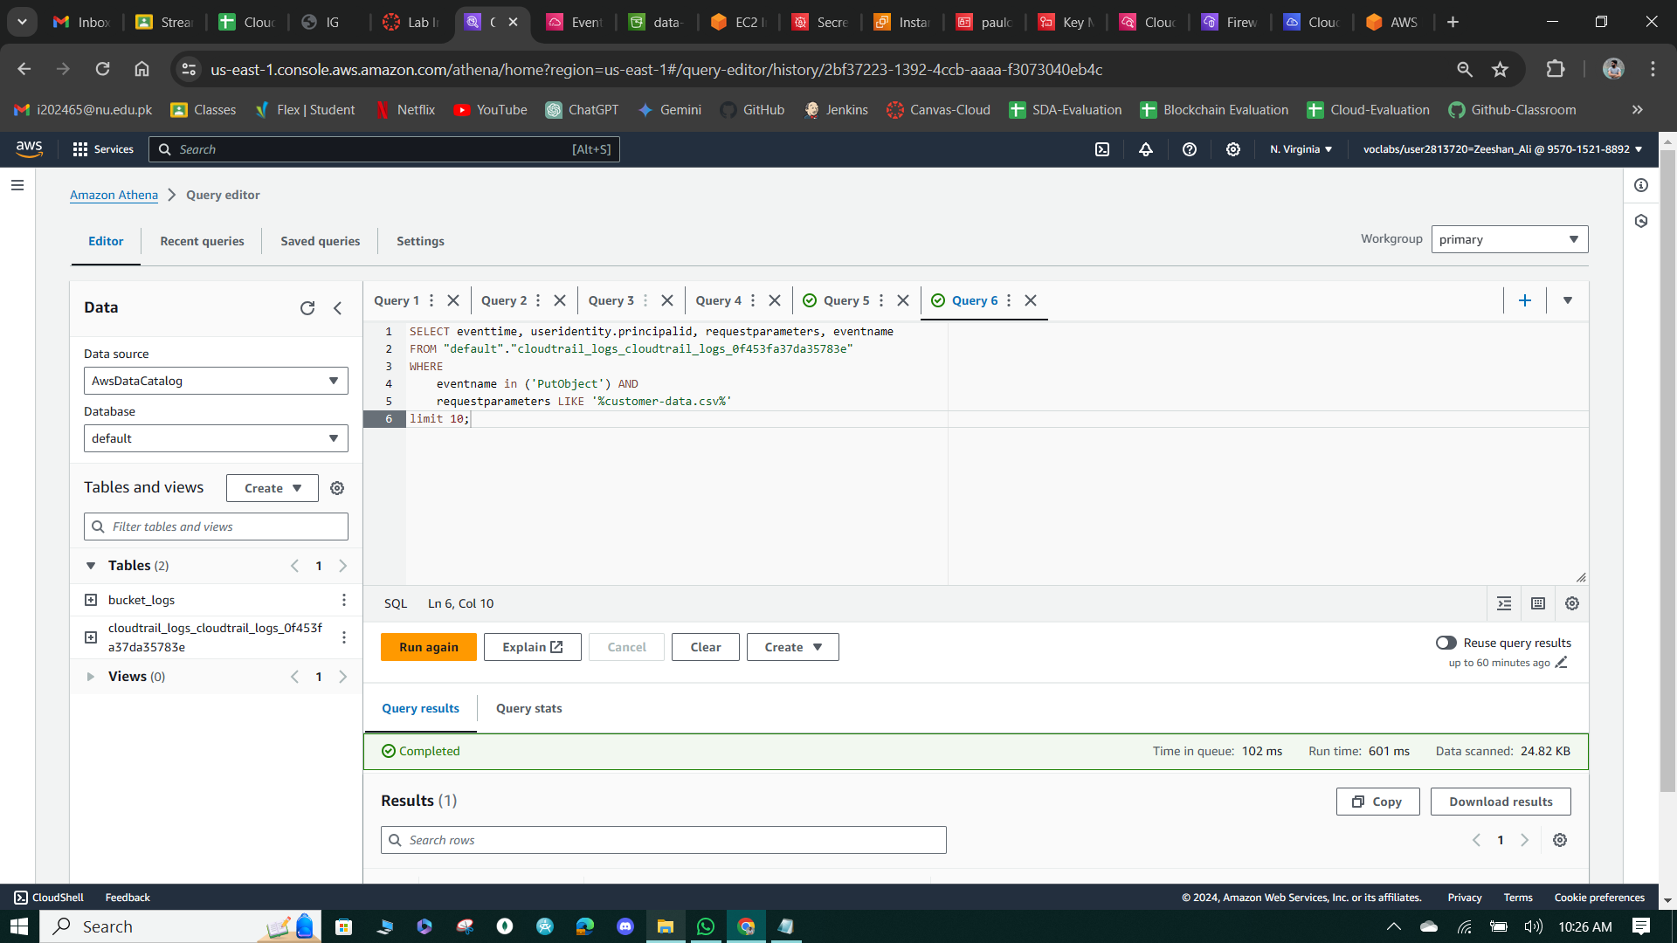

**Figure 100: Query to View PutObject Results.**

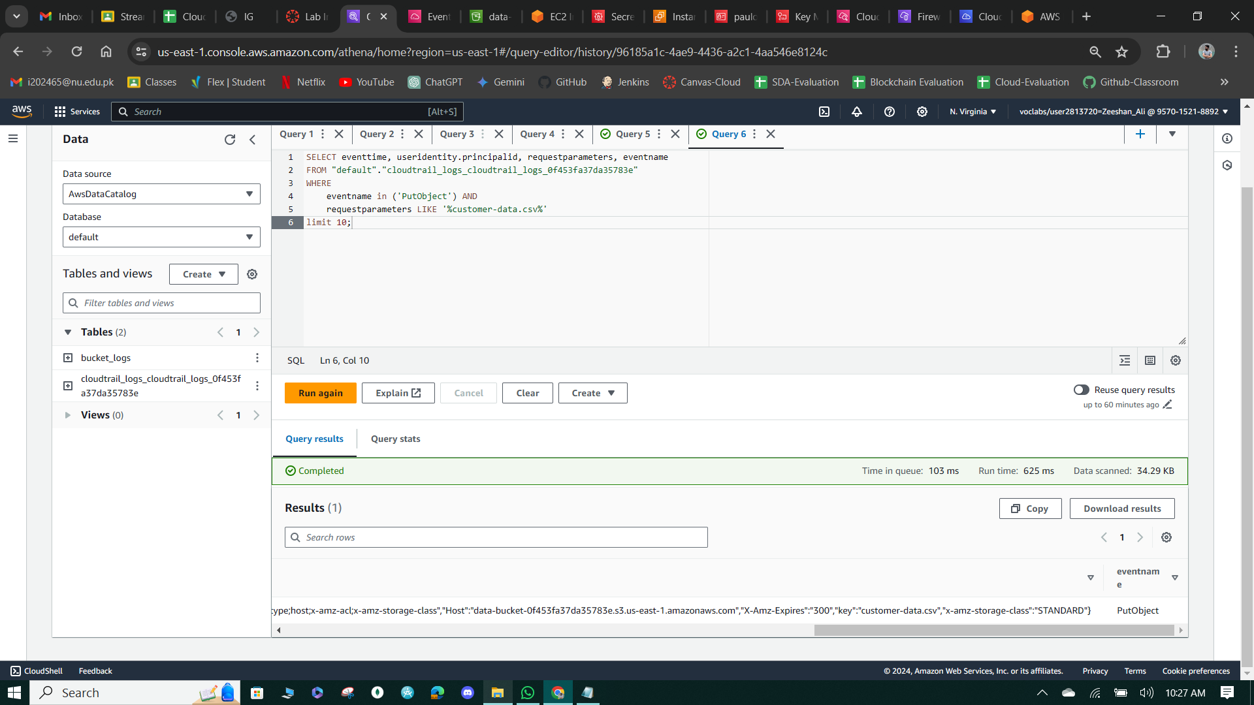

**Figure 101: Query Results**

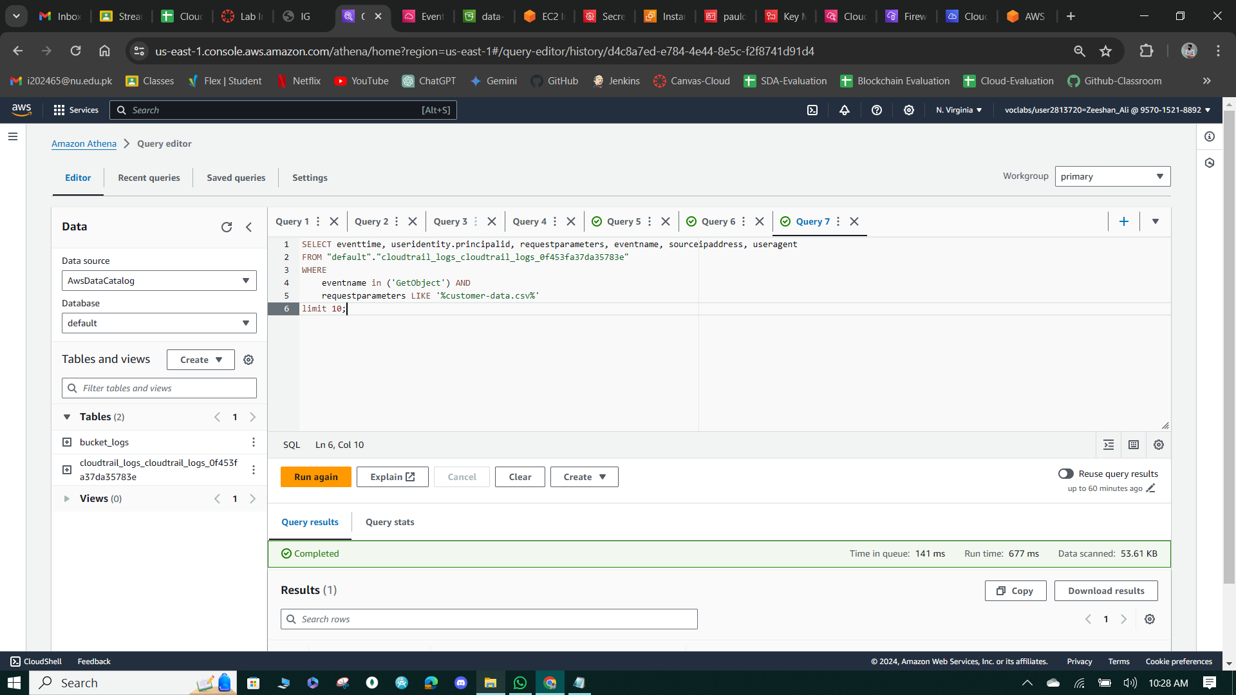

**Figure 102: Query to View GetObject Results**

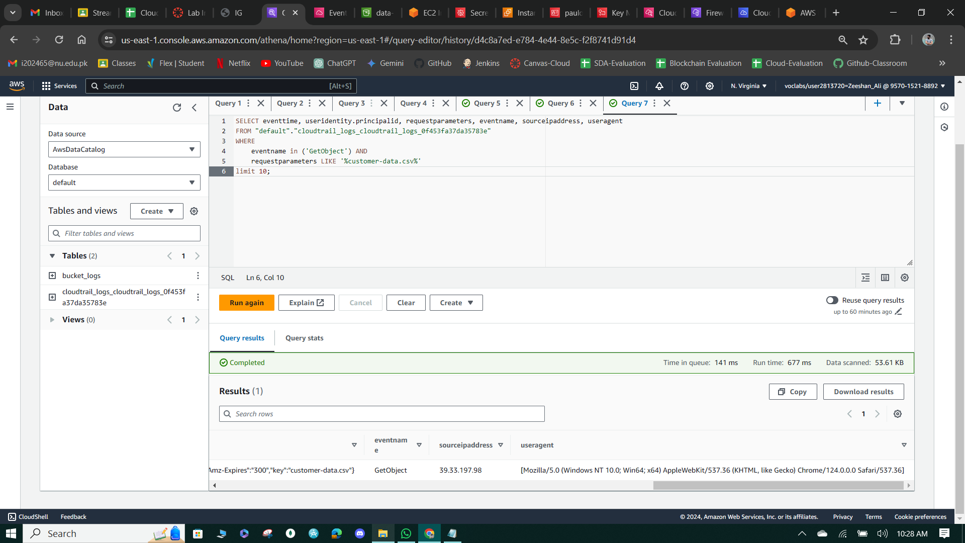

**Figure 103: Query Results.**

**Task 2: Use CloudWatch Logs to monitor secure logs**

* Set up a CloudWatch log group named "EncryptedInstanceSecureLogs" with indefinite retention.
* Install CloudWatch agent and collect on an EC2 instance named "EncryptedInstance" to monitor SSH access. Upload a PEM file to AWS Cloud9, connect to the EC2 instance using SSH, and observe secure log events.
* Analyze CloudWatch logs to identify successful and failed SSH login attempts, providing insights into system access and potential security threats.

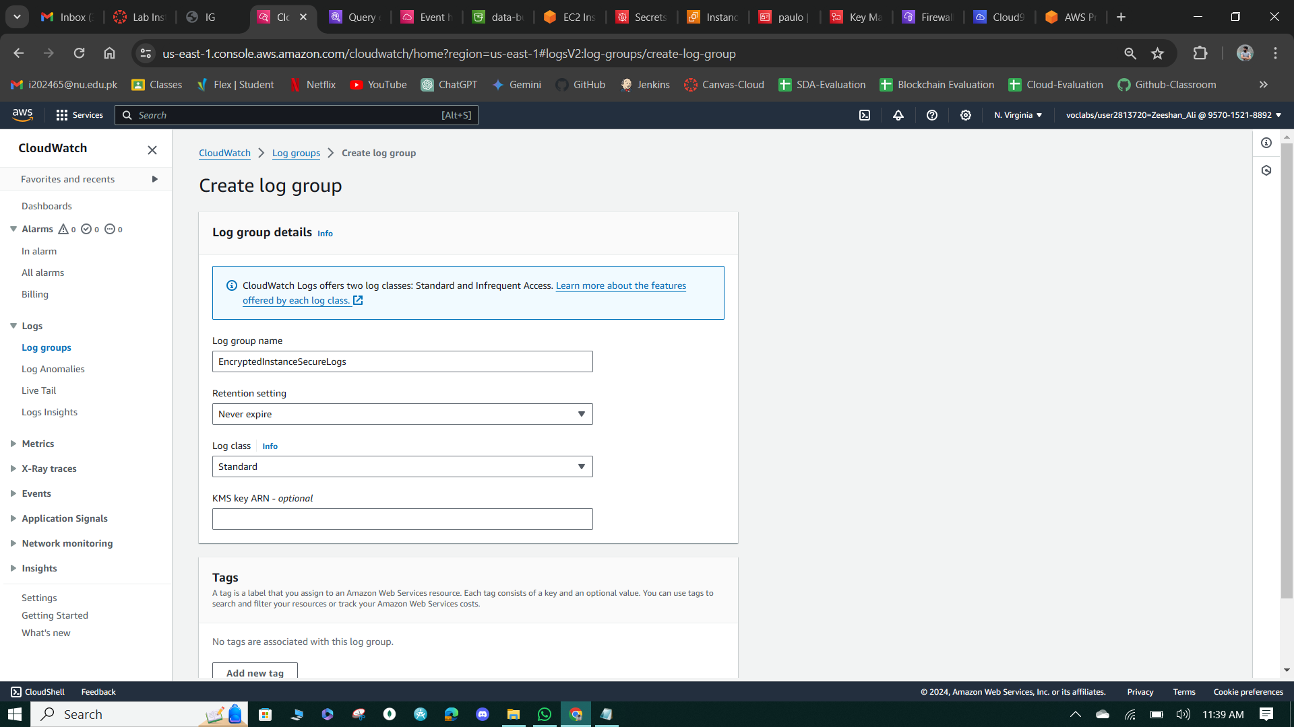

**Figure 104: Create logs.**

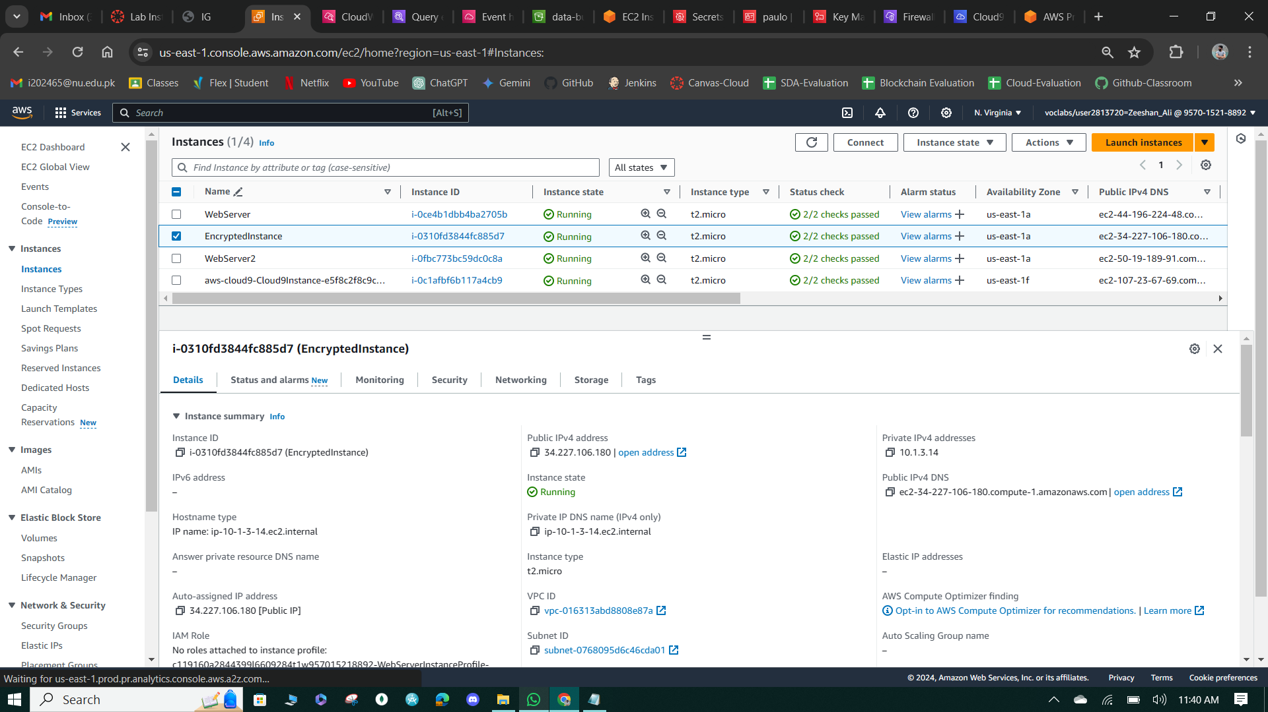

**Figure 105: EC2 Instance**

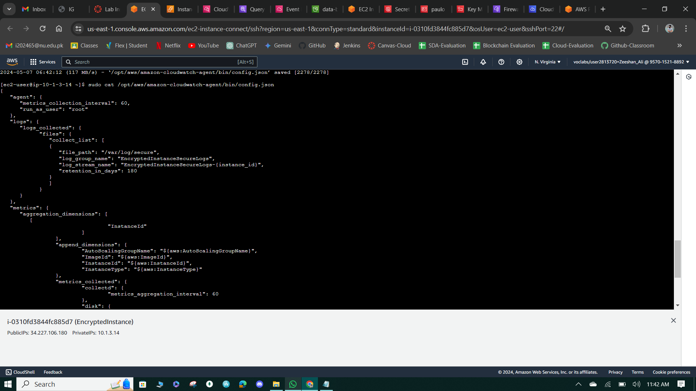

**Figure 106: AWS cloud Agent Config,json.**

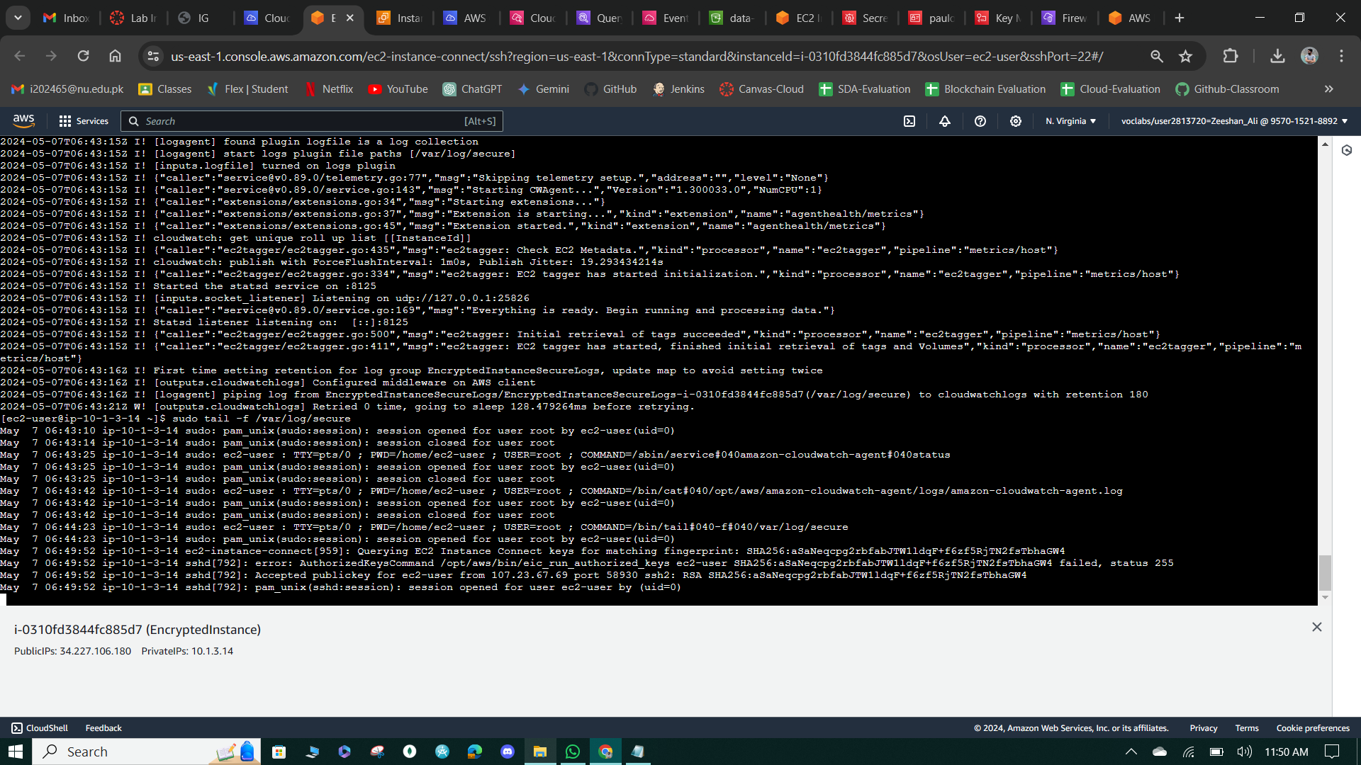

**Figure 107: Cloud Watch Agents Logs & view secure logs.**

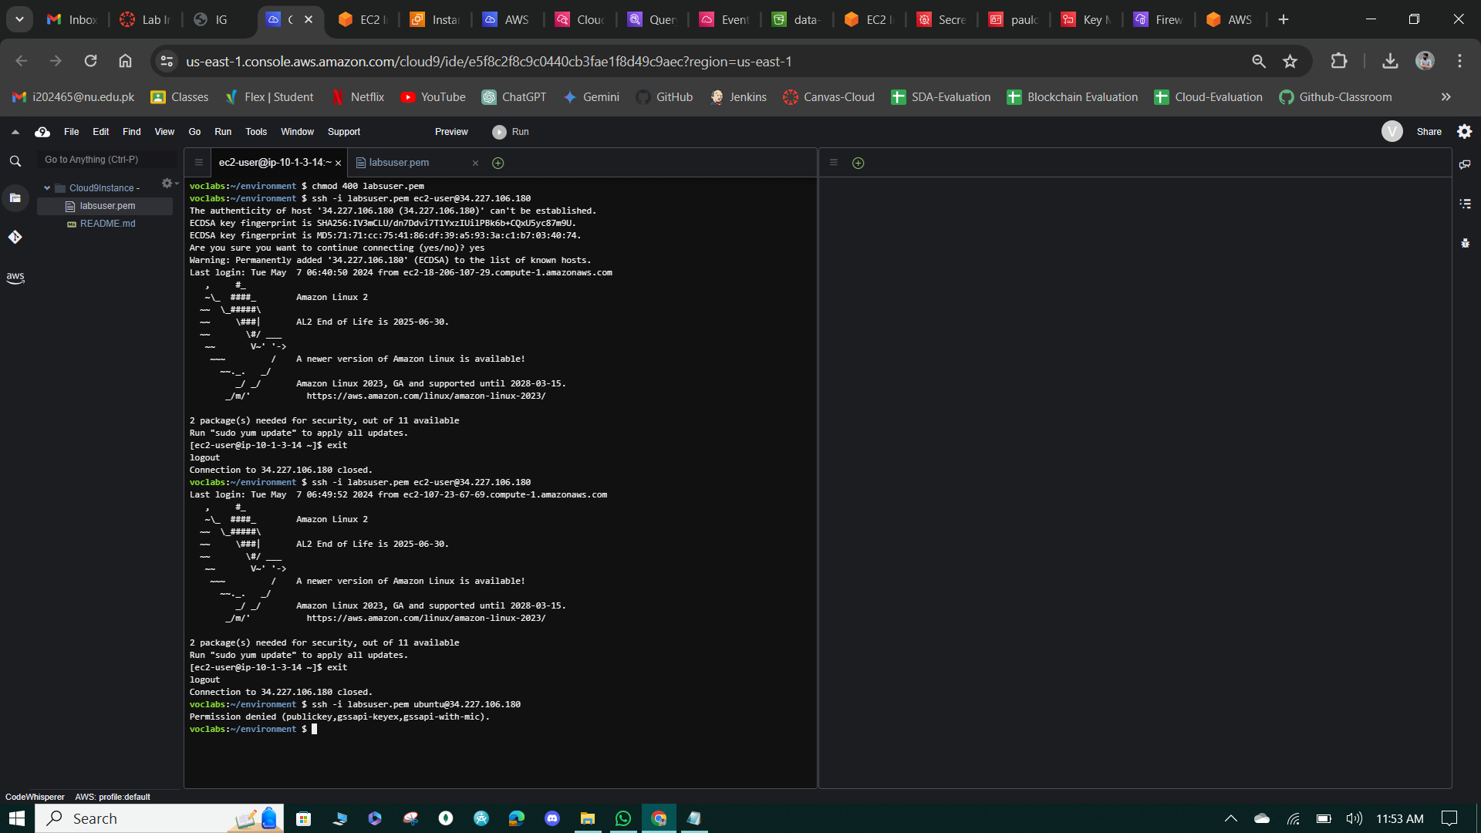

**Figure 108: Login with invalid User.**

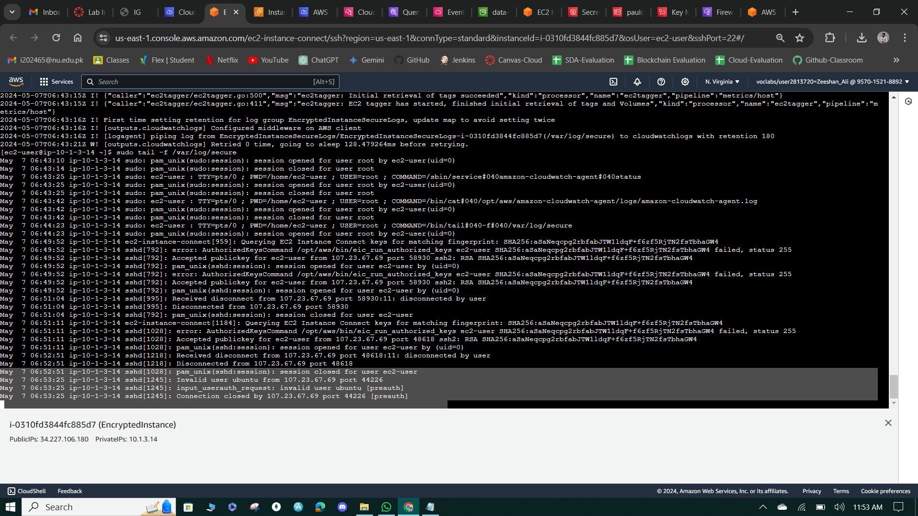

**Figure 109: Logs Result to Decline Invalid user.**

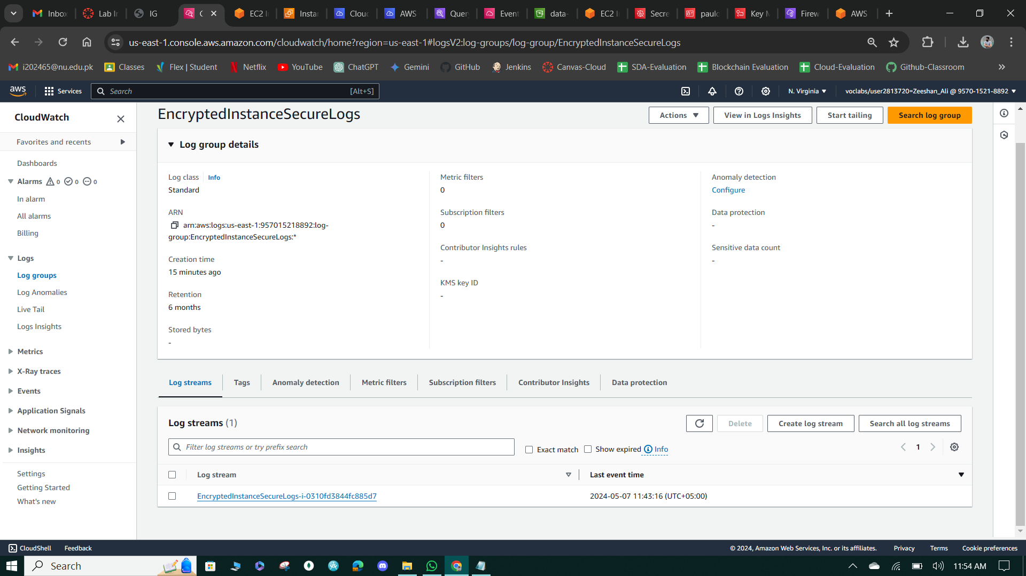

**Figure 110: Instance Secure logs.**

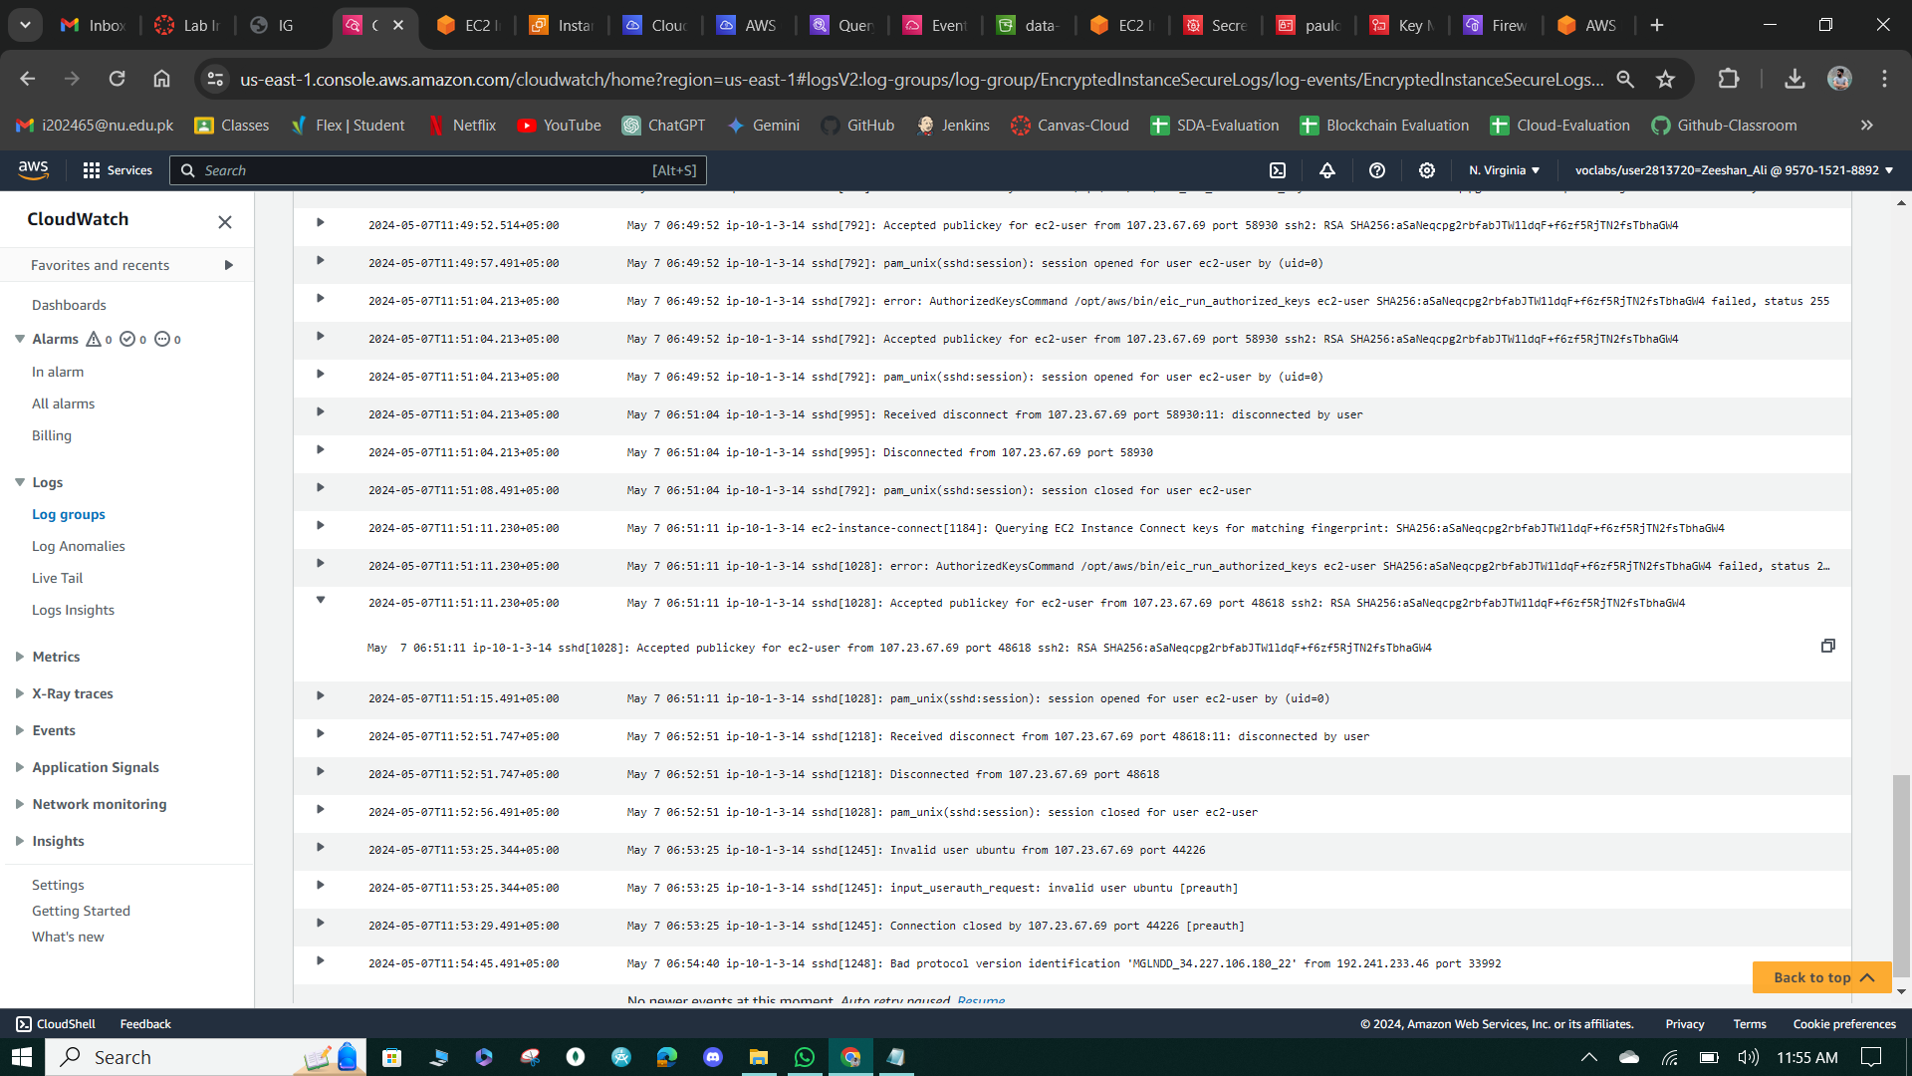

**Figure 111: EC2-user accepted public key.**

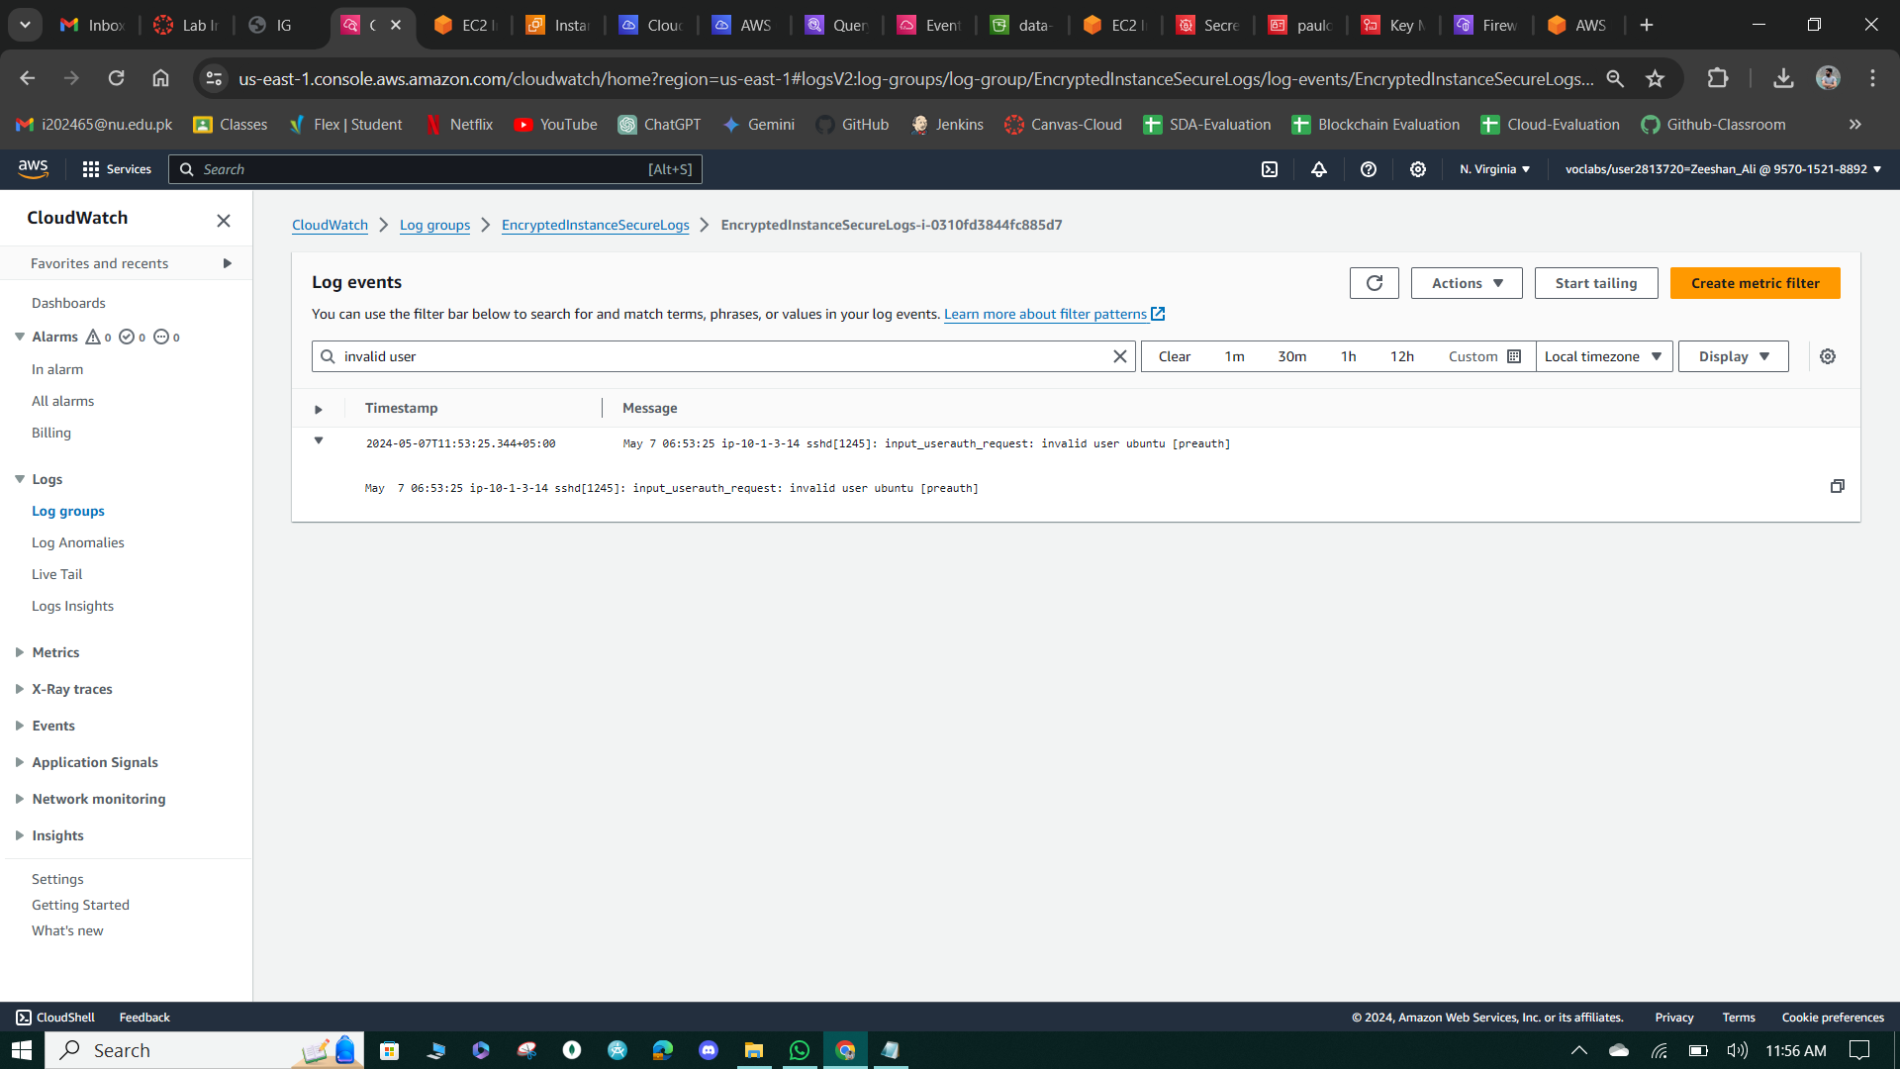

**Figure 112: Invalid Ubuntu user.**

**Task 3: Create a CloudWatch Alarm to send notifications in case of security incidents**

* Set up a CloudWatch metric filter to detect "Invalid user" log entries in the EncryptedInstanceSecureLogs log group. Create a metric filter named "Not valid users" with a corresponding metric named "NotValidUsers" to count occurrences.
* Configure a CloudWatch alarm to trigger if the count of "Invalid user" entries exceeds 5 within a 24-hour period. Specify an SNS topic for notification and provide details for email recipients, monitoring SSH access attempts and notifying the team accordingly.

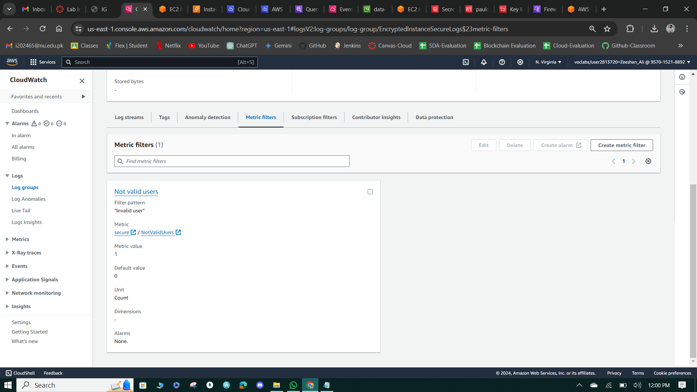

**Figure 113: Created Metric Filter of Invalid user.**

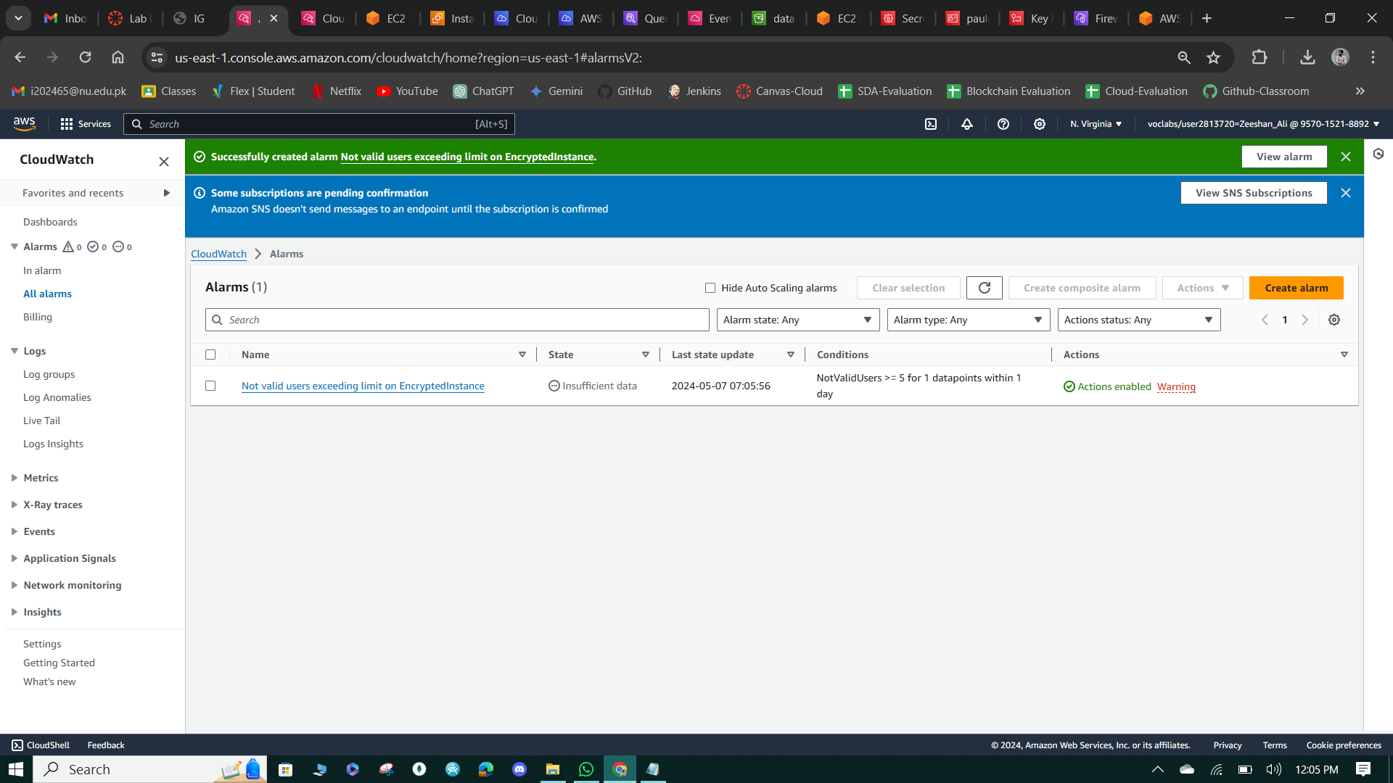

**Figure 114: Alaram Created.**

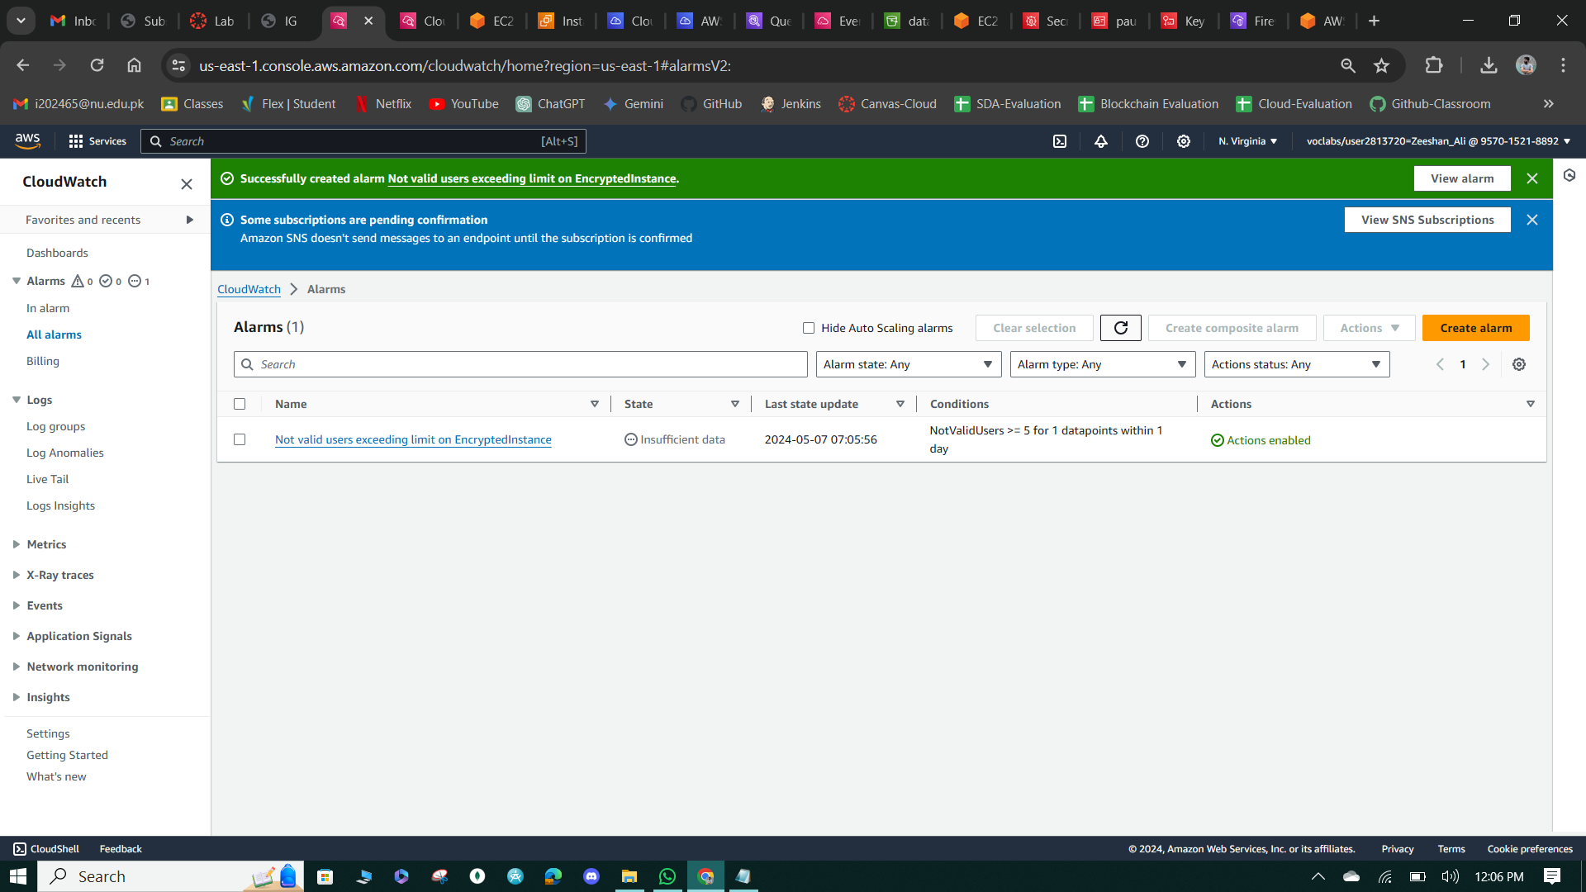

**Figure 115: Alaram Actions Enabled.**

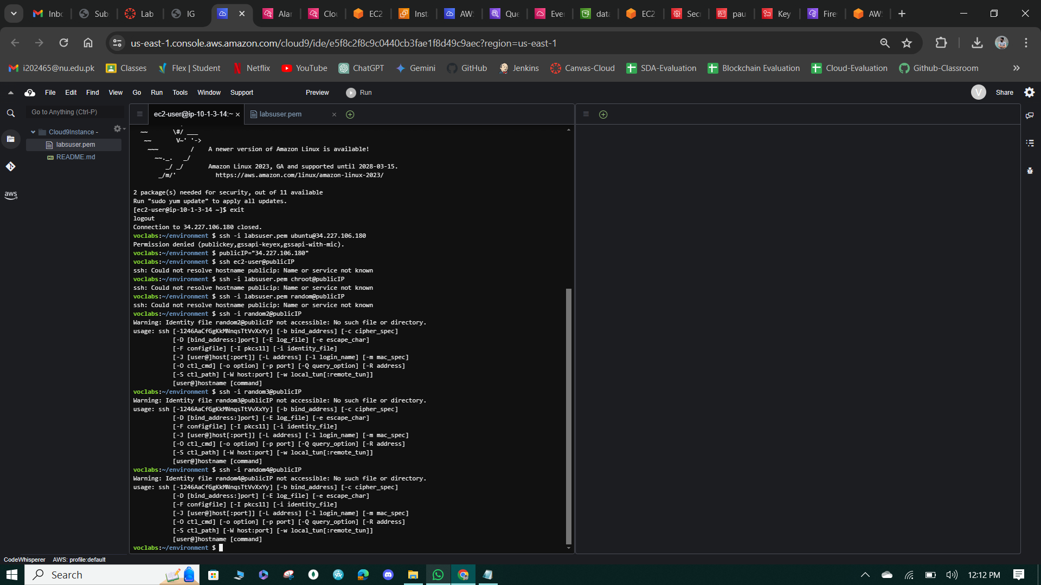

**Figure 116: Multiple users accessing it.**

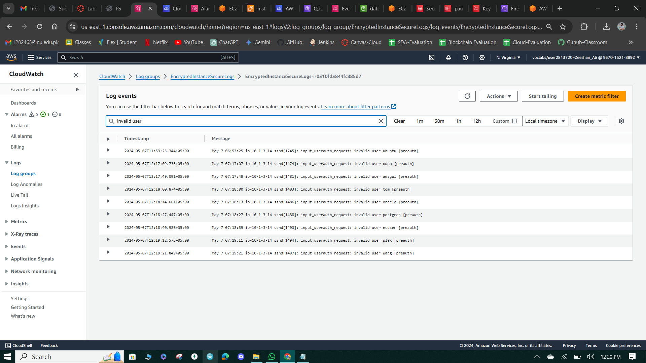

**Figure 117: Invalid Users logs.**

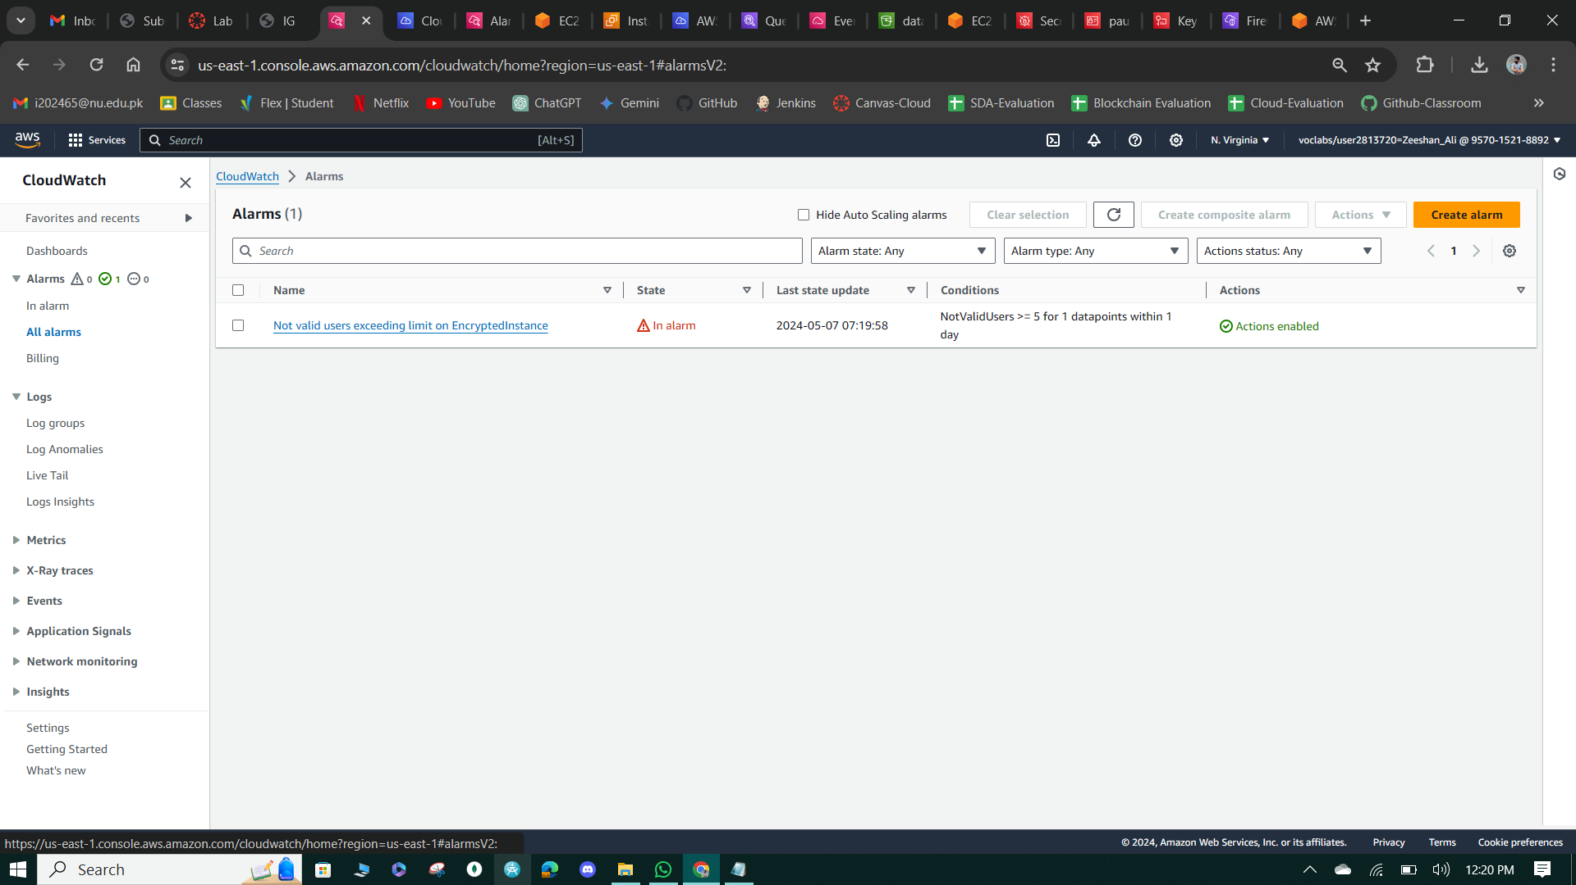

**Figure 118: STATE is in "In-Alaram.”**

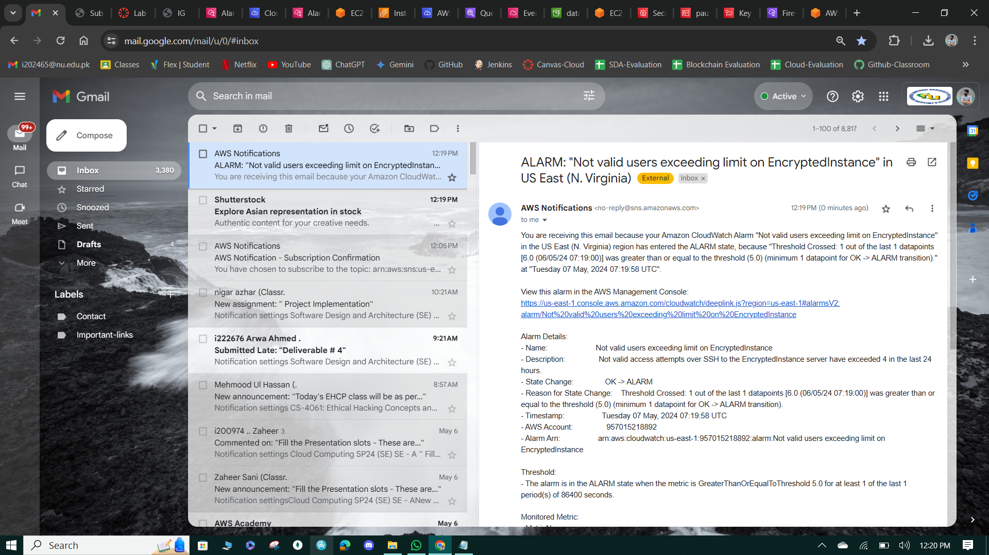

**Figure 119: Email Notification.**

**Task 4: Configure AWS Config to assess security settings and remediate the configuration of AWS resources**

Review IAM roles AWSConfigRole and SSMAutomationRole in the IAM console, granting permissions for AWS Config and Systems Manager. Create a new S3 bucket named "compliance-bucket-unique-ID" in the US East (N. Virginia) region with ACLs enabled. Set up AWS Config in the console, recording all current and future resource types, specifying the AWSConfigRole and aws-config bucket. Add the AWS managed rule "s3-bucket-logging-enabled" to ensure S3 bucket logging is enabled, verifying compliance for the created bucket "compliance-bucket".

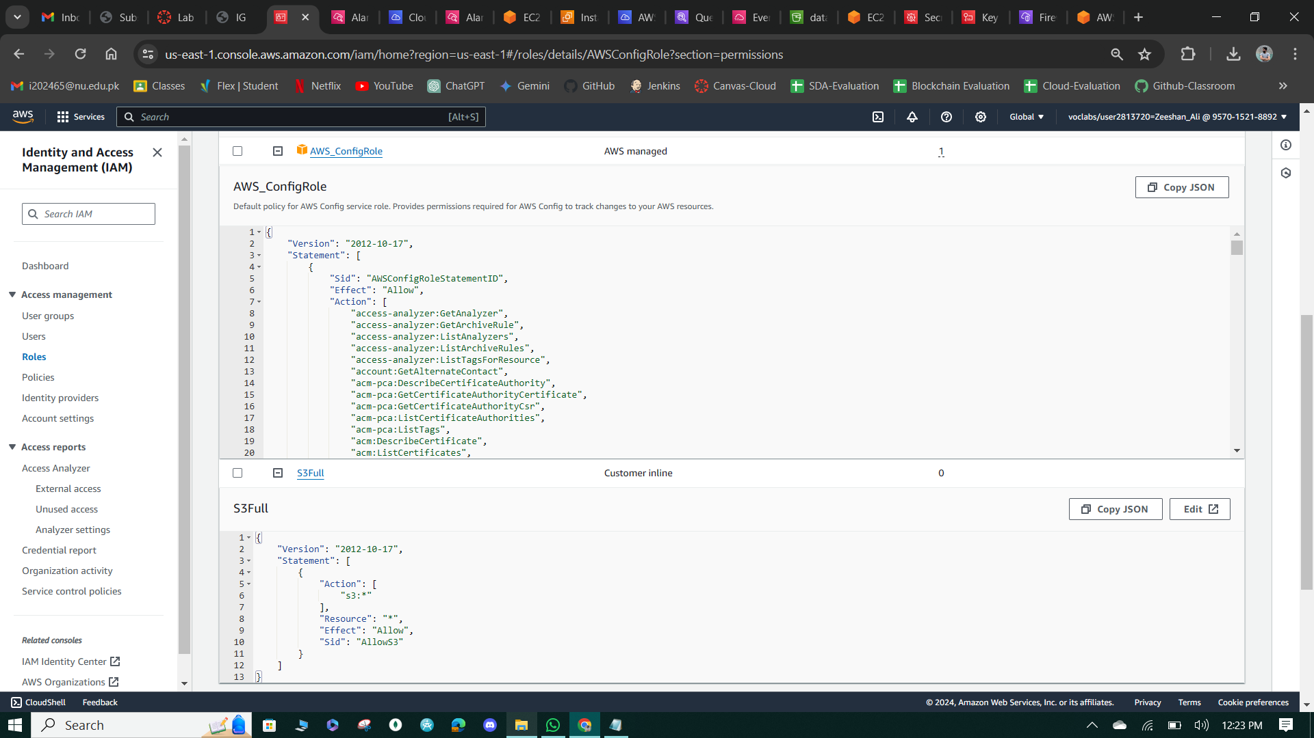

**Figure 120: AWS Config Role**

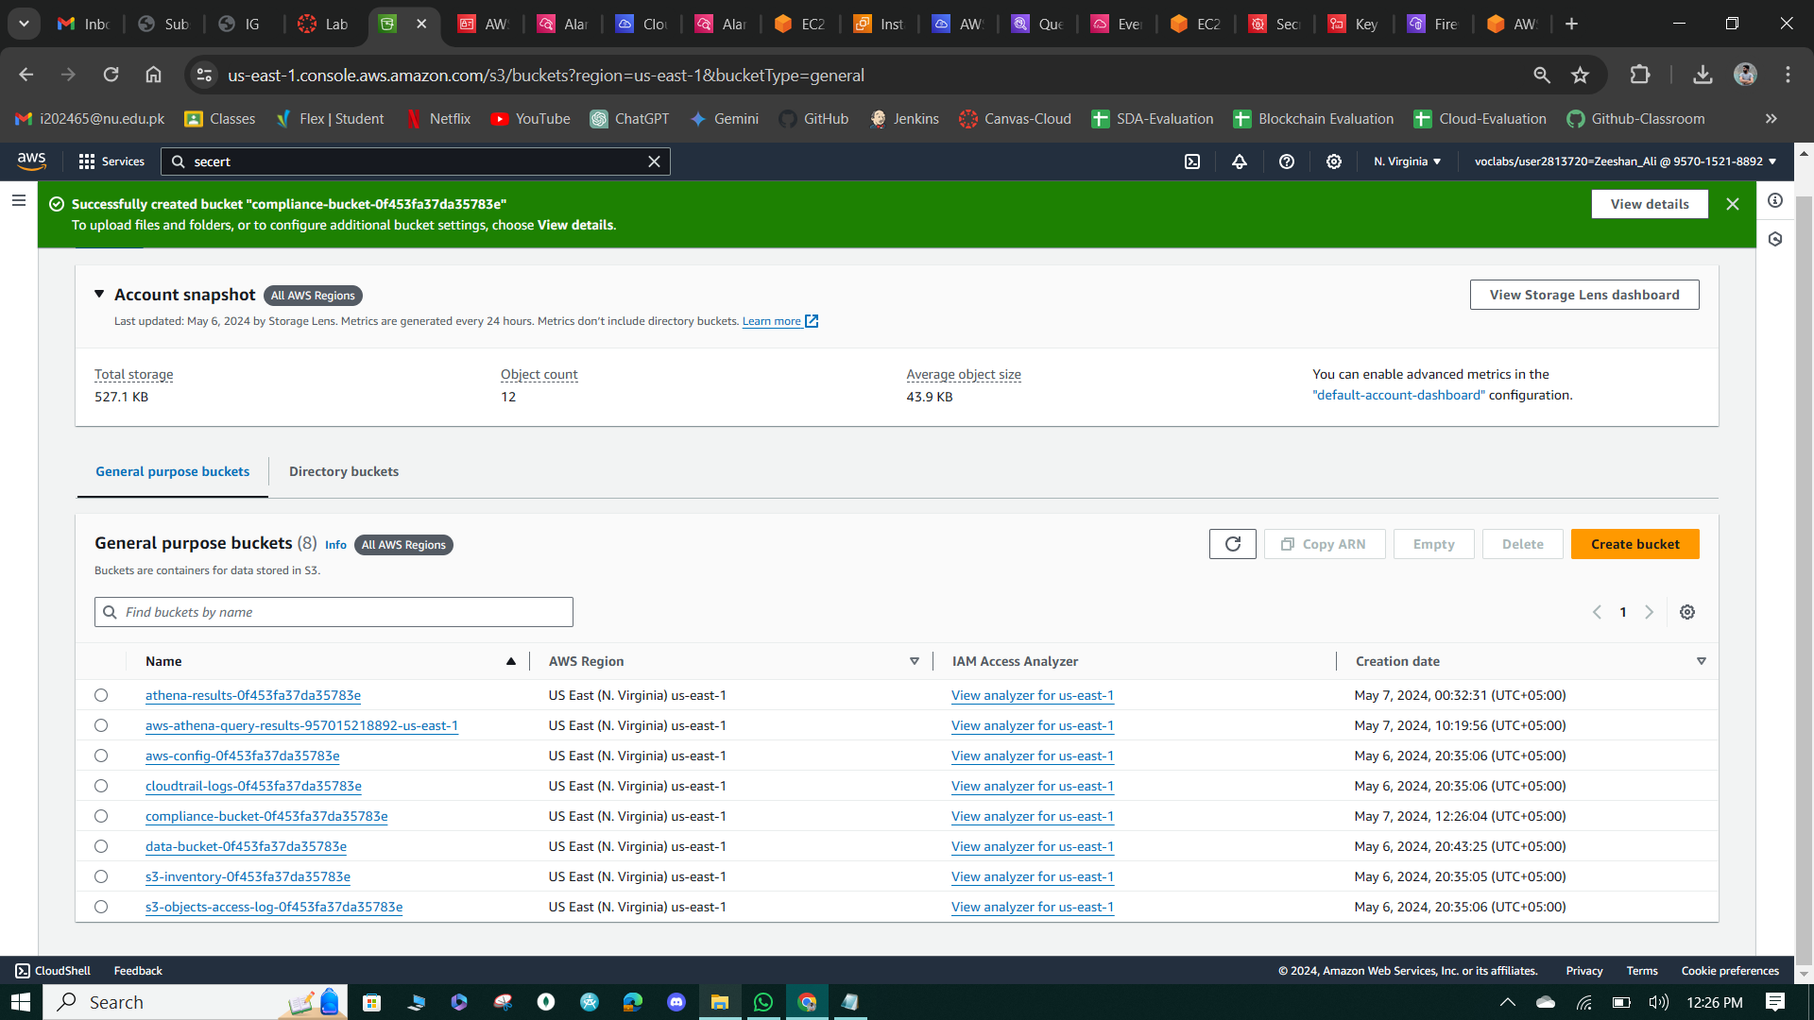

**Figure 121: Compliance Bucket.**

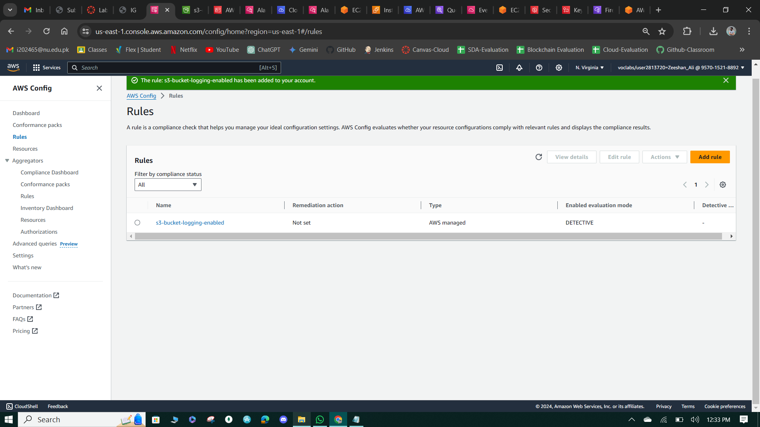

**Figure 122: AWS Config Rules**

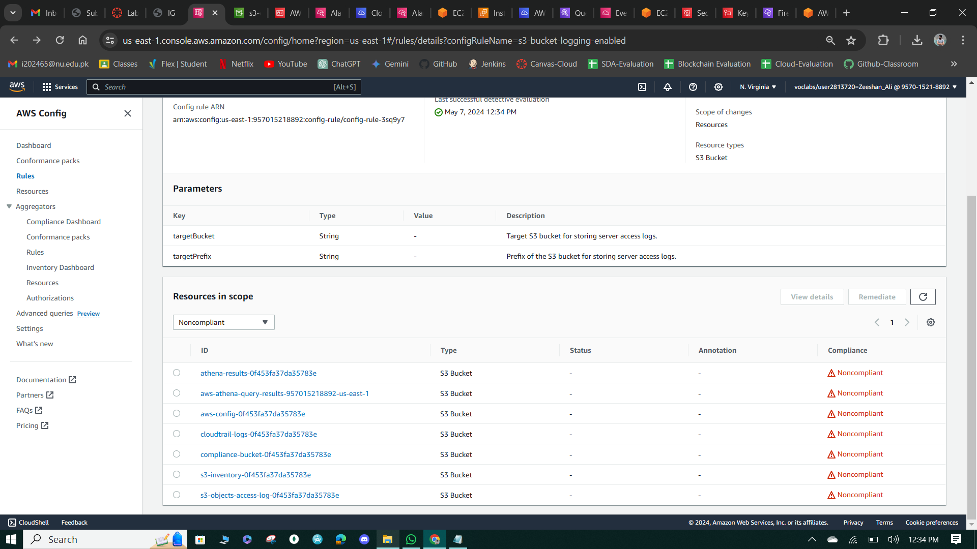

**Figure 123: SE Bucket Logging Enabled.**

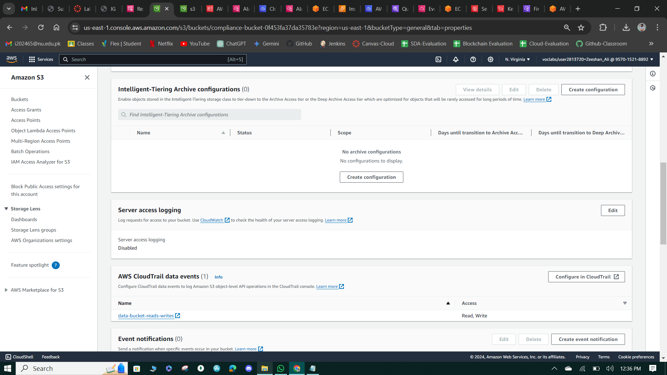

**Figure 124: Server Access Log Disabled.**

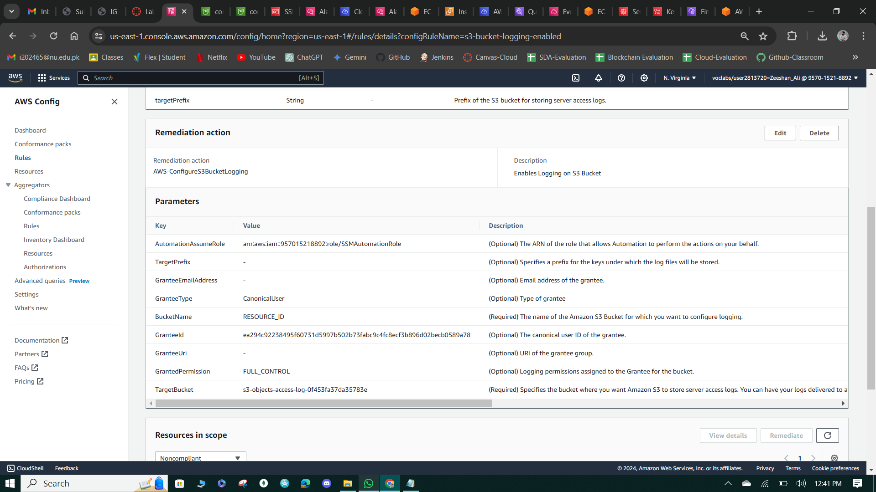

**Figure 125: Configure Remediation Actions.**

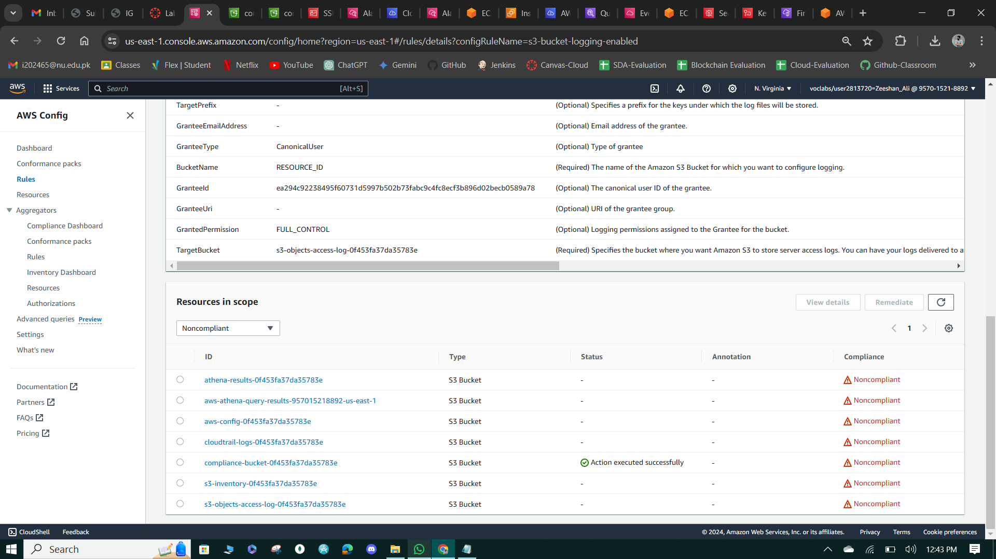

**Figure 126: Action Enabled Successfully.**

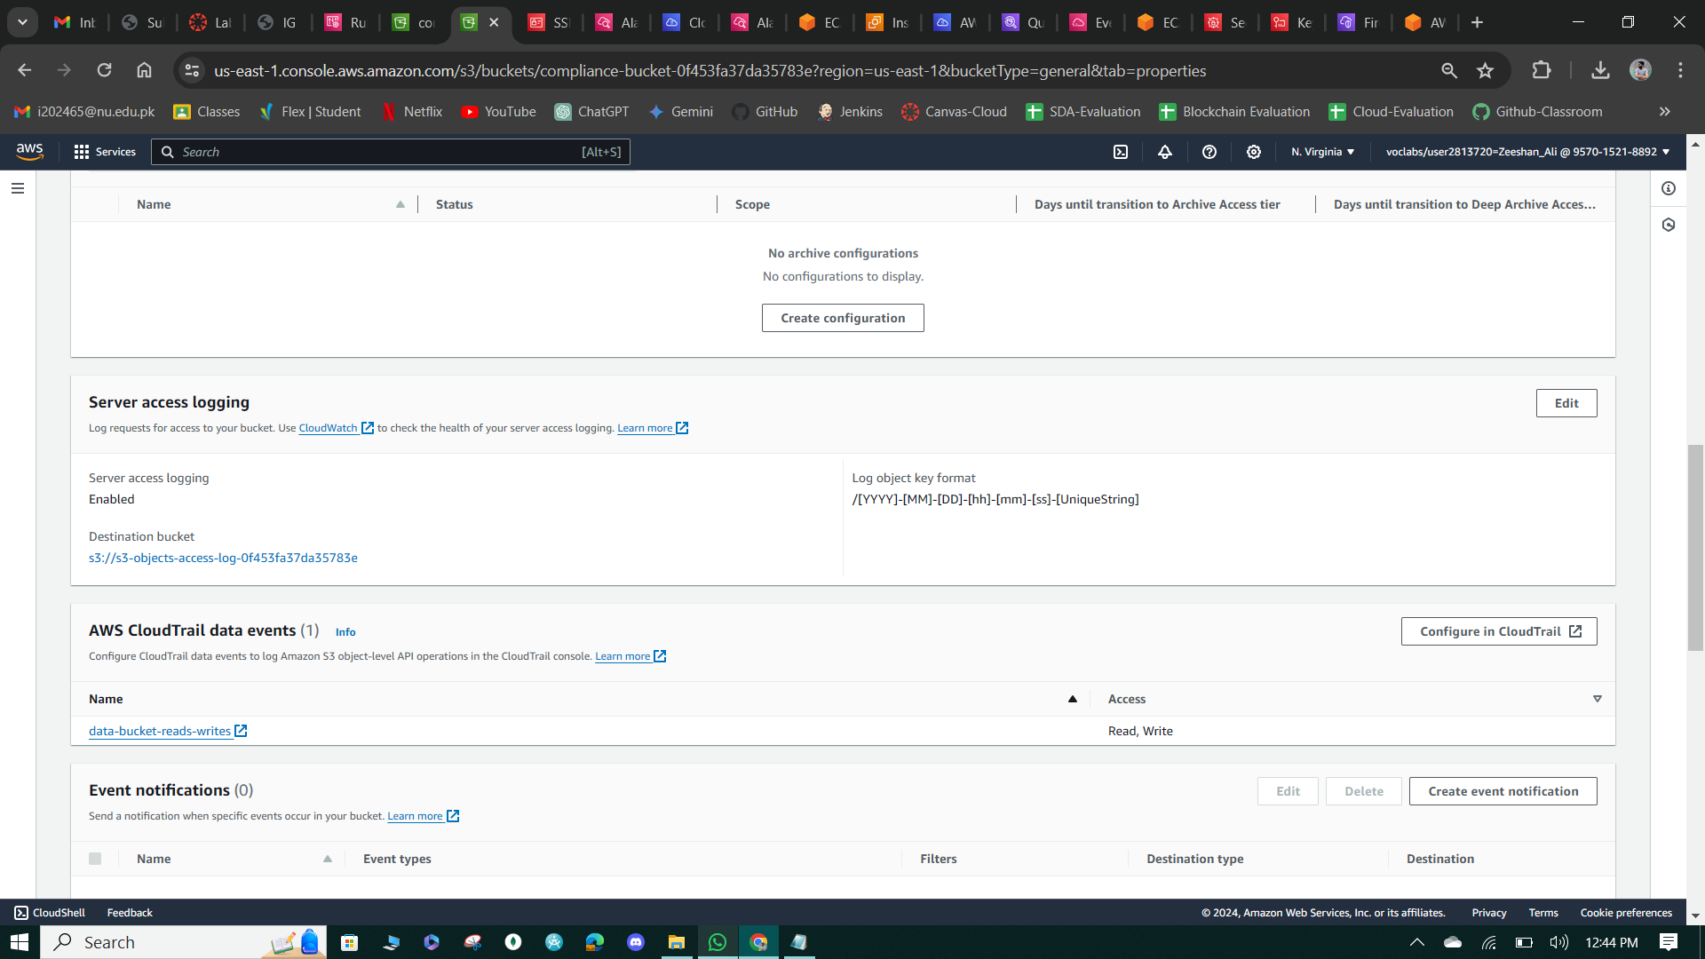

**Figure 127: Server Access Logs Enabled.**

**Cost assessment for monitoring and logging**

**Question:** In this lab, does your use of CloudTrail, CloudWatch, and AWS Config security features result in additional cost in the account? If so, how much do you estimate that it will cost?

**Answer:**

***CloudTrail*:** With CloudTrail, the paid tier has costs for CloudTrail Lake, CloudTrail Insights, and trails. Disregard costs that are associated with CloudTrail Lake and CloudTrail Insights because they aren't used in this project. For trails, the following costs are incurred in this solution:

* **Management events delivered to Amazon S3:** Costs are incurred for each 100,000 management events that are delivered.
* **Data events delivered to Amazon S3:** Costs are incurred for each 100,000 data events that are delivered. An example of a data event is when students uploaded the customer-data.csv file to a bucket.

**CloudWatch:**With CloudWatch, the paid tier has costs for custom alarms and logs, and the solution uses these resources. The following costs are incurred:

* **Alarms:** Alarm costs are incurred by the hour, from the first hour in which your alarm exists. Metric alarms incur costs for each metric that you list in the alarm metric expression (up to 10 metrics using metric math). This is a cost for metrics listed directly in the alarm, per alarm, per month.
* **Logs:** You incur charges when logs are transferred out of CloudWatch Logs to Amazon S3. You’re not charged for data transfer in.

***AWS Config:*** With AWS Config, the paid tier has costs for the number of configuration items that are recorded, active AWS Config rule evaluations, and conformance pack evaluations in your account. This lab project doesn’t use conformance pack evaluations.

* **Configuration items:** A configuration item is recorded when a resource undergoes a configuration change or a relationship change. The resource could be an AWS, third-party, or custom resource. A relationship defines how a resource is related to other resources within an AWS account. As a result, even when no new resources are created (such as when a security group is attached to an EC2 instance), a configuration item can be recorded.
* **AWS Config rules:** we have charged based on the number of AWS Config rule evaluations that are recorded. A rule evaluation is recorded every time a resource is evaluated for compliance against an AWS Config rule. Rule evaluations can be run in detective mode or proactive mode, if available. If you’re running a rule in both detective mode and proactive mode, you will be charged for only the evaluations in detective mode.